Student Radiographer Manual

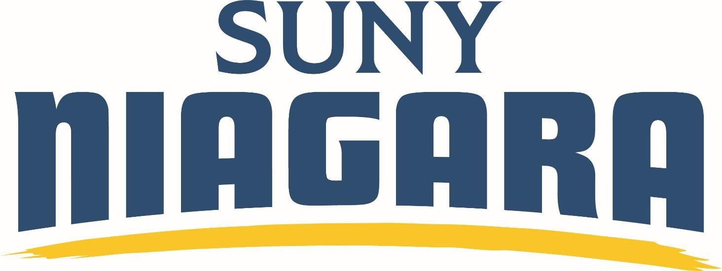

2026-2027

TO THE STUDENT:
The following Student Radiographer Manual has been prepared to help the student have all current policies and procedures for SUNY Niagara’s Radiologic Technology Program. It is the student’s responsibility to maintain this book for the entire length of the program, to ensure the student has the policies to follow.
It consists of two sections: General Guidelines and Clinical Requirements. All sets of guidelines must be adhered to. Failure to comply may lead to dismissal from the program. The student is also responsible for observing college rules and regulations as stated in the College Catalog and Student Handbook.
These guidelines, didactic instruction, laboratory and clinical experiences will prepare you to become a competent, dedicated health care professional.

Michele Burke, MS, R.T. (R)(ARRT)
Program Coordinator (716) 614-6416

Danielle Gonser, MA, R.T. (R)(ARRT)
Clinical Coordinator (716) 614-4873

1

INDEX

GENERAL GUIDELINES
- Student Information 7-8
- Mission Statement/Goals/Student Learning Outcomes 9-10
- Academic Policies… 12-14
- Curriculum & Graduation Requirements… 15-17
- Course Descriptions… 18-19
- Academic Integrity Policy… 20
- Drug and Alcohol Policy………………………………………………………21-22
- Lecture Attendance, Lecture Make-Up Exams and Course Grading Policies.22
- Laboratory Grading Policy… …22- 23
- Laboratory Attendance Policy …23
- Electronic Grade Book Policies………………………………………………..24
- Dismissal, SUNY Niagara Academic & Student Policies, Cell Phone……...25
- Computer Usage, Accessibility Services, Social Media Policy……………..25-27
- Pregnancy Policy 28-30
- Academic and Non-Academic Grievance Procedure 31-32
- Complaint Resolution Policy… 33
- Disciplinary Policy… 32
- Confidentiality… 33
- Certification & License Requirements… 34
- Program Effectiveness Data… 34
- Transfer Policy………………………………………………………………35
- Professional and Student Organizations……………………………………..36
- Awards and Scholarships 36

CLINICAL GUIDELINES
- Standards of Ethics Policy & NYS Unethical Definition…………………...40
- Eligibility 41
- Clinical Education Regulations 42-47
- Student Incident Reporting Procedure 48
- Health Requirements… 49-54
- Reporting Communicable Diseases 55-56
- Vacation, Holiday, Travel Ban, Jury Duty, Military Leave Policy… 57
- Dress Code…………………………………………………………………..58-59
- Image Repeat Policy 60
- Direct & Indirect Supervision… 61
- Radiation Safety Policies 62-66
- Infection Control Policy……………………………………………………..67
- Standard Precautions 67
- Student Acknowledgment of Receipt of Guidelines… 69

EXTRA INFORMATION
Attachment A - Academic Grievance Policy… 73
Attachment B - Student Services… 77-79
Attachment C - New York State Department of Health… 83-91
Attachment D – Additional Information –
Hepatitis B Vaccine 95-96
Code of Ethics 97
Example of Radiation Dosimetry Report 98

G E N E R A L G U I D E L I N E S

SUNY NIAGARA
RADIOLOGIC TECHNOLOGY PROGRAM

PLEASE PRINT

GRADUATING CLASS OF TODAY'S DATE

LEGAL NAME: SSN
Last First Middle Initial

BIRTH DATE: GENDER Assigned at Birth (M/F):

HOME OR LEGAL ADDRESS

STREET CITY COUNTY

STATE ZIP PHONE NUMBER MAILING ADDRESS (IF DIFFERENT FROM ABOVE)

STREET CITY COUNTY

STATE ZIP PHONE NUMBER YEAR AND HIGH SCHOOL GRADUATED FROM OR GED # & YEAR.

DID YOU GRADUATE FROM A HIGH SCHOOL OUTSIDE OF NEW YORK STATE? YES NO

MAIDEN NAME

IF YOU HAVE EVER BEEN CHARGED WITH OR CONVICTED IN COURT OF A MISDEMEANOR OR FELONY, INCLUDING CONVICTION OF A SIMILAR OFFENSE IN A MILITARY COURT-MARTIAL, YOU WILL HAVE TO GO THROUGH AN ETHICAL REVIEW BEFORE YOU CAN BE CERTIFIED BY THE AMERICAN REGISTRY OF RADIOLOGIC TECHNOLOGISTS OR LICENSED BY THE NEW YORK STATE DEPARTMENT OF HEALTH.

THESE DO NOT INCLUDE ANY OF THE FOLLOWING:

- JUVENILE OFFENSES AND CONVICTIONS PROCESSED IN JUVENILE COURT
- SPEEDING AND PARKING TICKETS THAT DID NOT RISE TO THE LEVEL OF A MISDEMEANOR OR FELONY AND DID NOT INVOLVE DRUGS OR ALCOHOL
- CHARGES THAT WERE DISMISSED IF THERE WERE NO COURT CONDITIONS REQUIRED
- SEALED OR EXPUNGED CASES WITH COURT DOCUMENT

FOR ADDITIONAL INFORMATION OR GUIDANCE, VISIT WWW.ARRT.ORG AND SEARCH FOR THE ETHICS REVIEW CHECKLIST FOR HONOR CODE VIOLATIONS OR CALL 651-0048, EXT. 8580.

NAME
PRINT

NAME
SIGNATURE

DATE

MISSION STATEMENT
The mission of SUNY Niagara is to provide a teaching and learning environment dedicated to excellence. SUNY Niagara is committed to maintaining the hallmarks of student centeredness, accessibility, comprehensiveness, collegiality, community partnership and life-long learning.

Our College nurtures and empowers its students in ways that recognize and value our common humanity as well as the richness of our diversity. SUNY Niagara offers high-quality academic programs leading to degrees and certificates, which are supported by outstanding student services. SUNY Niagara provides a variety of cultural, social and international experiences, as well as community education and workforce development that supports economic development programs, which positively impact the quality of life. The college operates through a collegial model of shared governance and is accountable to meet the highest standards of professionalism and integrity.

The mission of the SUNY Niagara Radiologic Technology Program is to provide students with educational experiences to become competent, entry-level technologists within the healthcare field.
Goal 1: Students will demonstrate clinical competence Student Learning Outcomes:
Students will exhibit proper positioning skills Students will select technical factors Students will practice radiation protection
Students will exhibit quality patient care skills
Goal 2: Students will develop critical thinking skills Student Learning Outcomes:
Students will perform non-routine procedures Students will perform image analysis
Goal 3: Students will demonstrate effective communication skills Student Learning Outcomes:
Students will demonstrate written communication skills Students will demonstrate oral communication skills
Goal 4: Students will display professionalism Student Learning Outcomes:
Students will demonstrate professional behavior Students will recognize ethical values

Reviewed and approved by Radiologic Technology Advisory Committee 4/2026

STUDENT LEARNING OUTCOMES REQUIRED FOR GRADUATION

- Use oral and written medical communication.
- Perform basic mathematical functions.
- Demonstrate knowledge of human structure, function and pathology.

- Anticipate and provide basic patient care and comfort.
- Apply principles of body mechanics.

- Demonstrate professional behavior.

- Operate radiographic imaging equipment and accessory devices.
- Position the patient and imaging system to perform radiographic examinations and procedures.

- Modify standard procedures to accommodate for patient condition and other variables.
- Acquire radiographs, in both Indirect and Direct Radiography systems.

- Determine exposure factors to obtain diagnostic quality radiographic images with minimal radiation exposure.
- Adapt exposure factors for various patient conditions, equipment, accessories and contrast media to maintain appropriate radiographic quality.

- Practice radiation protection for the patient, self and others. (ALARA)
- Recognize emergency patient conditions and initiate first aid and basic life-support procedures.

- Evaluate radiographic images for appropriate positioning and image quality.

- Evaluate the performance of radiographic systems, know the safe limits of equipment operation, and report malfunctions to the proper authority.

- Demonstrate knowledge and skills relating to quality assurance.
- Apply and be knowledgeable of standard precautions.

- Exercise independent judgement and discretion in the performance of medical imaging procedures.
- Perform clinical competencies in areas of diagnostic radiography.

- Demonstrate knowledge and understanding of the New York State Licensure Law and Code.
- Complete all radiologic technology and biology course work with a passing grade of C.

ACADEMIC POLICIES

GRADING POLICY: The Radiologic Technology course, RAD 100 has two components: Lecture
(theory) and College Laboratory. A student must earn a minimum "C" grade in Lecture (didactic),
and a satisfactory, "S" grade in the College Laboratory. If a student is not successful in both
components, the resulting grade will be a "F" for the course.

The Radiologic Technology clinical courses (RAD 103, 104, 202, 204, 205) have three components: Lecture (theory), College Laboratory and Clinical Education. A student must earn a minimum "C" grade in Lecture (didactic), and a satisfactory, "S" grade in the College Laboratory, and Clinical Education components. If a student is not successful in each component, the resulting grade will be a "F" for the course.
A minimum C grade is required for Radiologic Technology non-clinical courses (RAD 100, 101, 112, 201, 203, 212, BIO 246, MAT 199).
MINIMUM GRADE IN ANATOMY AND PHYSIOLOGY FOR RADIOLOGIC TECHNOLOGY
STUDENTS: A minimum C grade in anatomy and physiology lecture and lab (BIO 213/213L, 214/214L) must be obtained for successful progression and completion of the Radiologic Technology program. Successful completion of BIO 213/BIO 213L (grade of C or better) by start of second semester in program and successful completion of BIO 214/BIO 214L (grade of C or better) by start of second year in the program. Failure to obtain a grade of C or higher will result in loss of matriculated status. Students who have had a grade of less than passing (C grade) in two of the same required BIO courses (BIO 213/213L, 214/214L) at SUNY Niagara or other institutions are not eligible to progress in the Radiologic Technology program.

REPEAT POLICY: Any Radiologic Technology courses (RAD 100, 101, 103, 104, 112, 201, 202, 203, 204, 205, 212, BIO 246, MAT 199) a student who fails (F grade) may repeat only one course in the program. A student who is failing at the time of withdrawal from a clinical course (W grade) or withdrawal from the College (X grade) may repeat only one course in the program. This policy does not affect a student who is passing a Radiologic Technology course at the time of withdrawing from the course or the College.
All prerequisite and corequisite Radiologic Technology courses must be successfully completed before progressing to the next sequential Radiologic Technology course.
STANDARD OF ETHICS POLICY: Please see pages 13-14

FIVE YEAR POLICY: If a student has taken any course with a RAD or BIO prefix five or more years before enrolling in a subsequent RAD or BIO course, the Program Coordinator of the Radiologic Technology Program shall have the right to request that the RAD/BIO course(s) be repeated. This course must be repeated for a minimum grade of C, no other grade will be accepted: ie: S, J, U grade. The student will be allowed to do so as a recognized exception to the general college policy that students may only repeat courses in which they have received grades of D, F or U.

MATRICULATED POLICY: Failure or withdrawal from RAD 100, 101, 112, MAT 199, 103, 104,
201, 202, 203, 204, 205 or 212 or any prerequisite and co-requisite courses that are necessary for continuing in the Radiologic Technology program will result in loss of matriculated status in the Radiologic Technology program. The student will be advised of his/her options.

READMISSION INTO THE RADIOLOGIC TECHNOLOGY PROGRAM: Readmission depends
on space availability, GPA (2.0+), and clinical site availability (if beyond first semester). If student is
interested in returning, all students must reapply. Applications are accepted in the order of date of when
student reapplies and therefore, the following year’s program could be full already. No preferential
acceptance will be given for previously admitted students. There is no guarantee of readmission
into the program.
*Students are required to be CPR/BLS certified AND have clearance from the Health & Wellness Center to attend the clinical portion of the Radiologic Technology program. Students are required to have both completed as a requirement of RAD 100. Proof of CPR/BLS certification and proof of clearance from the Health & Wellness Center must be given to the instructor for RAD 100 to receive a grade for that course.

Certification in Basic Life Support (BLS) must include: Adult, Infant and Child. This is required prior to entering RAD 103 and must remain current throughout the remainder of the program. This requirement can be fulfilled through successful completion of HED 214 or an equivalent program offered by the following:

- American Heart Association: Basic Life Support (BLS Provider)
- American Red Cross: CPR/AED for the Professional Rescuer
- Canadian Red Cross: Level HCP for the Health Care Professional.
- National Safety Council: Basic Life Support (BLS for the Health Care Provider)

On-line certification is not acceptable.

STANDARD OF CONDUCT/ETHICS
STANDARD OF ETHICS POLICY: When a student is unable to provide safe patient care and/or does not meet the ethical standards of the Radiologic Technology profession, in either the Academic or Clinical Education environments, the Radiologic Technology Program Coordinator, upon recommendation from the Radiologic Technology Faculty, will remove said student from the Radiologic Technology course and this action may result in dismissal from the Radiologic Technology program. Unsafe care is defined as "placing the patient and/or family in clear and present danger". This may include, but is not limited to: radiographic exposure of the wrong patient or body part, unsafe patient transfer, any form of inappropriate or non-consensual touching of a patient, peer, or staff member, violations or infractions of ALARA (As Low As Reasonably Achievable), breaches of the Health Insurance Portability and Accountability Act (HIPAA) and violations of the Student Conduct Code. The student is not eligible for re- admission into the Radiologic Technology program.

NEW YORK STATE DEFINITION OF UNETHICAL CONDUCT

In New York State, unethical care by a radiologic technologist is defined as unethical conduct, which represents behavior indicating unfitness to practice radiologic technology.

According to 10 NYCRR 89.1 and NYS Public Health Law, this includes, but is not limited to (Please note: this list is edited for space. Full listing of 10 NYCRR 89.1 can be found at: https://regs.health.ny.gov/content/section-891-definitions):

- Immoral Conduct: Immoral behavior while practicing or any conduct indicating unfitness to practice.
- Falsification/Theft: Willful falsification, theft, or destruction of patient records or property.
- Patient Misconduct: Physically or verbally abusing, harassing, or intimidating a patient.

Additional NYS Misconduct Definitions
Under NYS Education Law and Board of Regents rules, unprofessional conduct also includes:

- Scope Violations: Practicing beyond the authorized scope of the license or performing tasks without competence or adequate supervision.
- Unlicensed Practice: Aiding or abetting an unlicensed person to practice.
- Supervision Failure: Applying radiation without the necessary supervision of a licensed practitioner.

Discipline Policies: See Student Rights and Responsibilities Code of Conduct Handbook on SUNY Niagara’s website.

C U R R I C U L U M

YEAR I

First Semester

- BIO 213 - Human Anatomy and Physiology I 4 Cr. *
- BIO 213L - Human Anatomy and Physiology I Lab 1 Cr.
- Computer Technology (CIS) selected through advisement 1 Cr.
- RAD 100 - Introduction to Radiologic Technology 4 Cr. *
- RAD 100L - Introduction to Radiologic Technology Lab 0 Cr.
- RAD 101 - Radiologic Technology I 5 Cr. *
Total Credit Hours: 15

Second Semester

- BIO 214 - Human Anatomy and Physiology II 4 Cr.
- BIO 214L - Human Anatomy and Physiology Lab II 1 Cr.
- RAD 112 - Radiologic Technology II 4 Cr.
- MAT 199- Gen Ed Math for Rad Tech 1Cr.
- RAD 103 - Radiographic Procedures I 6 Cr.
- RAD 103C - Radiographic Procedures I Clinic 0 Cr.
- RAD 103L - Radiographic Procedures I Lab 0 Cr.
Total Credit Hours: 16

Summer Session I

- RAD 104 - Clinical Education I 2 Cr.
Total Credit Hours: 2

Summer Session II

- RAD 205 - Clinical Education II 2 Cr.

Total Credit Hours: 2

YEAR 2

Third Semester

- ENG 101 - Writing I 3 Cr. *
- SOC 101 – Introduction to Sociology 3 Cr.
- RAD 201 - Radiologic Technology III 4 Cr.
- RAD 202 - Radiographic Procedures II 7 Cr.
- RAD 202C - Radiographic Procedures II Clinic 0 Cr.
- RAD 202L - Radiographic Procedures II Lab 0 Cr.

Total Credit Hours: 17

Fourth Semester

- BIO 246 - Radiation Biology/Protection 2 Cr.
- General Education approved Elective that meets COMO 3 Cr.
- RAD 203 - Radiologic Technology IV 4 Cr.
- RAD 204 - Radiographic Procedures III 7 Cr.
- RAD 204C - Radiographic Procedures III Clinic 0 Cr.
- RAD 204L - Radiographic Procedures III Lab 0 Cr.
- RAD 212 - Seminars in Radiologic Technology 1 Cr.

Total Credit Hours: 17

TOTAL CREDITS FOR GRADUATION – 69

MINIMUM GRADUATION REQUIREMENTS
Radiologic Technology Associate in Applied Science

- A total of at least 69 hours with a minimum curriculum grade and point average of 2.0. Academic Foundations courses do not count toward the degree.
- Radiology Technology: A minimum of 46 credit hours to include: RAD 100 Introduction to Radiologic Technology
RAD 101 Radiologic Technology I RAD 112 Radiologic Technology II RAD 103 Radiographic Procedures I RAD 104 Clinical Education I
RAD 201 Radiologic Technology III RAD 202 Radiographic Procedures II RAD 203 Radiologic Technology IV RAD 204 Radiographic Procedures III RAD 205 Clinical Education III
RAD 212 Seminar in Radiologic Technology
- Biological Science: A minimum of 12 credit hours to include: BIO 213 E Human Anatomy & Physiology I
BIO 213 L Human Anatomy & Physiology Lab 1 BIO 214 E Human Anatomy & Physiology II
BIO 214 L Human Anatomy & Physiology Lab 11 BIO 246 Radiation Biology/Protection

- Computer Technology: A minimum of 1 credit hours, selected through Advisement.
- Humanities: A minimum of 6 credit hours to include ENG 101 Writing I
A Gen Ed approved Elective that meets COMO, selected through Advisement
- Social Sciences: A minimum of 3 credit hours to include SOC 101 Introduction to Sociology
- Mathematics: A minimum of 1 credit hour to include MAT 199 Gen Ed Math for Rad Tech
- A minimum grade of C in all RAD and BIO courses.

COURSE DESCRIPTIONS – RADIOLOGIC TECHNOLOGY
BIO 246 RADIATION BIOLOGY/PROTECTION 2 Credits

Radiation protection procedures related to diagnostic use of radiation and the concept of As Low As Reasonably Achievable (ALARA), Effective Dose (EfD), Negligible Individual Dose (NID), Deterministic and Stochastic effects. Radiation effects on biological molecules and organisms and factors affecting biological responses. Acute and chronic effects of radiation are discussed. Regulatory agencies will be identified and agency involvement in radiation protection will be discussed.
2 Lecture Hours Per Week

RAD 100 E/L INTRODUCTION TO RADIOLOGIC TECHNOLOGY 4 Credits

The positioning and topographic landmarks of upper and lower extremities, chest, abdomen, and contrast studies. Basic radiation protection is presented.
3 Lecture Hours, 3 Laboratory Hours Per Week

RAD 101E RADIOLOGIC TECHNOLOGY I 5 Credits

An introduction to radiography including orientation, patient care, medical terminology, professional ethics, hospital law and digital imaging systems to include accessories and supplies. 5 Lecture Hours Per Week

RAD 112E RADIOLOGIC TECHNOLOGY II 4 Credits

Advanced study of the factors contributing to the radiographic image and basic fundamentals of radiographic physics.
4 Lecture Hours Per Week

MAT 199 GENERAL EDUCATION MATH FOR RAD TECH 1 Credit
Advanced study of the factors contributing to the radiographic image and basic fundamentals of radiographic physics.

RAD 103 E/L/C RADIOGRAPHIC PROCEDURES I 6 Credits

Instruction, demonstration and practice in radiographic positioning of the axial and appendicular skeleton along with exposure techniques. Drug administration is also presented. Observation and clinical experience are provided for the development of competency in an affiliated hospital or health care facility.
1 Lecture Hour, 3 Laboratory Hours, 12 Clinical Hours per week

RAD 104C CLINICAL EDUCATION I 2 Credits
Clinical experience for development of competencies involving general radiographic procedures in an affiliated hospital or health care facility. (90 Clinical Hours Total)

RAD 205C CLINICAL EDUCATION II 2 Credits

Clinical experience for development of competency for an entry-level radiographer. (90 Clinical Hours Total)

RAD 201E RADIOLOGIC TECHNOLOGY III 4 Credits

Physics of radiographic equipment including fundamental electronics, x-ray production, the x- ray tube, image intensification, digital fluoroscopy and related circuitry and preventative maintenance.
4 Lecture Hours Per Week

RAD 202 E/L/C RADIOGRAPHIC PROCEDURES II 7 Credits

Instruction and practice in positioning techniques involving the skull, facial bones, and advanced radiographic procedures. Clinical application of advanced positioning techniques with emphasis on the skull and facial bones. CT will be introduced.
1 Lecture Hour, 3 Laboratory Hours, 15 Clinical Hours Per Week RAD 203E RADIOLOGIC TECHNOLOGY IV 4 Credits
Presentation of the various medical and surgical diseases and their relationship to radiographic procedures. Introduction to radiographic examinations involving surgical procedures and specialized equipment.
4 Lecture Hours Per Week

RAD 204 E/L/C RADIOGRAPHIC PROCEDURES III 7 Credits

Principles and techniques of quality assurance testing through emphasis on laboratory experiments. Major emphasis on digital radiography and computed radiography imaging systems providing minimal patient exposure along with optimal radiographic information presented. Radiation protection procedures related to diagnostic use of radiation. Clinical assignments devoted to the application of radiographic procedures in an affiliated hospital or health care facility
1 Lecture Hour, 3 Laboratory Hours, 15 Clinical Hours Per Week

RAD 212S SEMINARS IN RADIOLOGIC TECHNOLOGY 1 Credit
Preparation of the technical report and its organization for both written and oral presentation. Readings in current literature and journals involving trends in radiography. General topics include mammography, surgical radiography, pediatric radiography, trauma, magnetic resonance imaging (MRI) and career placement in radiography.
1 Lecture Hour Per Week

ACADEMIC INTEGRITY POLICY
Honest participation in academic endeavors fosters an environment in which optimal learning can take place and is consistent with the mission of SUNY Niagara. Academic misconduct is destructive to the spirit of an educational environment and, therefore, cannot be condoned.

The following definitions will apply:

- The term “cheating” includes, but is not limited to, use of any unauthorized assistance in taking quizzes, tests or examinations; including all assessment tests, unless prior permission has been given (this assistance includes but is not limited to smartphones, smart watches, smart glasses, tablets, and other electronic devices); dependence upon the aid of sources beyond those authorized by the instructor in writing papers, preparing reports, solving problems or carrying out other assignments; the acquisition without permission of tests or other academic materials belonging to a member of the college’s faculty.
- The term “plagiarism” includes, but is not limited to, the use by paraphrase or direct quotation, of the published or unpublished work of another person without full and clear acknowledgment. It also includes the unacknowledged use of materials prepared by another person, by an agency engaged in the selling of term papers or other academic materials, or the use of artificial intelligence.
- Using AI tools is considered a form of academic dishonesty and will result in a zero grade for the assignment and possible disciplinary action. If you have any questions about what constitutes acceptable use of AI tools, please consult with the instructor before submitting your work.
- The term “academic misconduct” includes any or all forms of the above.

Unless an instructor has provided students with an alternative academic integrity policy at the start of the semester, the college policy that follows will apply:

For the first incident of academic misconduct in a course, the student will receive a grade of F (or zero) for the test, assignment or activity.

If there is a second incident in the same course, the student will receive a grade of F for the course.

The instructor who believes that an incident of academic misconduct has occurred will discuss it immediately with the student. If, in the judgment of the instructor, the student has committed an act of academic misconduct or if the student admits that there has been misconduct, the instructor will assess the appropriate penalty.

Instances of admitted or proven academic misconduct should be reported in writing to the Dean of Nursing, Physical and Allied Health. The purpose of this reporting will be to track individuals who have repeated offenses. If such a pattern of behavior is found, the Dean of Nursing, Physical and Allied Health will determine an appropriate sanction on a case-by-case basis.

Students who think they have been treated unfairly may invoke the Academic Grievance procedure, which is explained in the SUNY Niagara’s Student Code of Conduct Handbook.

DRUG & ALCOHOL POLICY

SUNY Niagara is committed to the elimination of drug and alcohol abuse for its students and employees. The unlawful manufacture, distribution, dispensation, possession, use of a controlled substance or alcohol is prohibited in and on SUNY Niagara owned or controlled property. Any SUNY Niagara student determined to have violated this policy may be subject to disciplinary action up to and including removal. No student will report to school/clinical under the influence of drugs that impairs functioning. Violation of these rules by a student will be reason for mandatory evaluation/treatment for a substance abuse disorder or for disciplinary
action up to and including removal. Excerpt from the SUNY Niagara Student Rights & Responsibilities Code of Conduct Handbook.

The use of alcohol or drugs while on SUNY Niagara owned or controlled grounds (or clinical space) is absolutely prohibited except when authorized by the College for approved College functions.

Additional Radiologic Technology Student Policy:
In addition, students must report to all classes, clinical or lab experiences in fit condition, physically and mentally. Fitness for duty is determined by effective job performance and absence of signs and symptoms of impaired practice. Observations noted that indicate impairment may include, but are not limited to:

A. inappropriate physical appearance
B. altered speech
C. uneven gait
D. uncommon changes in behavior
E. lack of judgment
F. decreased performance
G. smell of intoxicants on breath, offensive smoke odor on person
H. inappropriate actions
I. chronic absenteeism or patterns of absence/tardiness
J. accidents during class, college lab or clinical lab
K. impaired memory or attention
L. Witnessed alcohol or drug use
M. Somnolence
N. Emotional liability

When a student’s fitness for class, lab or clinic is in question, the designated person (i.e instructor/staff supervising tech/department manager) shall initiate an evaluation that takes place in accordance with the facility policy and procedure, and at a location that assures confidentiality of the student.

If the student is deemed unfit for duty, the student shall not be allowed to return to the workplace. The instructor must ensure the student’s safety while at school/clinical and enroute to the recommended destination. Arrangements for safe transportation will be made by the student and/or faculty/supervisor. This may include calling security or local law enforcement officials. The student will receive an Academic Integrity Contract for “failure to comply with regulations governing the practice of the profession,” be referred the Vice President of Student Services and other resources, such a counseling, as appropriate.

Any costs incurred related to any incident will be the students’ responsibility. All incidents will remain confidential and will be confined to a “need to know” basis. If a student refuses to comply with this radiologic technologic department policy, the student may be administratively removed from the program.

LECTURE ATTENDANCE POLICY
Attendance will be taken at the beginning of each class. Students will be expected to attend all classes and will be responsible for all assigned work. In the event of absence, it is the student's responsibility to contact the instructor on the day he/she returns to campus to initiate make-up work.

LECTURE MAKE-UP EXAMINATIONS
The instructor will notify the students when exams and/or quizzes will be given. Makeup examinations will be arranged with the instructor. Makeup exams will be scheduled at the end of the semester, NO EXCEPTIONS. Only one makeup exam is given per course per student.
Failure to take an exam will result in a zero (0) for that exam.

COURSE GRADING SYSTEM
Final grades are given at the end of each semester. Mid-semester deficiency letters may also be issued so that students will be aware of their standing in each course. Each instructor and class will have a grading system that is explained on the course syllabus.

Grading Scale for Radiologic Technology Courses

A - 95 -100 B- - 81 - 83
A- - 91- 94 C⁺ - 78 - 80
B⁺ - 87 - 90 C - 75 - 77
B - 84 - 86 F - Below 75

LABORATORY GRADING POLICY

This policy is based on a merit system. Each student will begin with 10 merits for junior students and 6 merits for senior at the beginning of each semester. One merit will be deducted for each of the following:

- Each failed competency (Repeat)
- Each competency requiring more than 10 minutes (Seniors) or 15 minutes (Juniors).

- Missed lab or tardy. If you are not present for roll call, you are considered tardy. *See
Laboratory Attendance on next page for more details
- Any action on the part of the student that can be construed as “helping”, “assisting” or cheating in the proper performance of a lab simulation. This includes verbal and nonverbal cues.
- Not having your OSL for lab.
- Failure to have assigned workbook pages checked off by the lab prior to corresponding unit positioning test.
- Coarse joking, inappropriate language and/or disruptive behavior will not be tolerated and may result in removal from lab/lecture. Removal from lab for these reasons will result in the loss of a merit.

The Final Competency is worth 4 merits for junior students and two merits for senior students. When you have 0 merits remaining you have failed lab. *In order to have two chances for final comp, you must have 5-10 merits (for juniors) or 3-6 merits (for seniors). Having 1-4 merits left (for juniors) or 1-2 merits left (for seniors), you have one chance for final comp. When you have 0 merits left, you have failed lab.

FINAL COMPETENCY EXAMINATION: The Final Competency Examination serves as the culminating assessment for the laboratory component of RAD 100, RAD 103, or RAD 205. Successful completion of this examination is mandatory for progression within the Radiologic Technology program. Failure to achieve a passing score will result in a grade of "F" for the laboratory component of the respective course, thereby impacting the student's academic standing and eligibility to continue in the program.

LABORATORY ATTENDANCE

Attendance is mandatory. If a student misses time in any of the labs, their practical ability will be in question, and the lab instructor will require the student to make up the prep lab at a time convenient for the instructor.

It is the responsibility of the student to contact the instructor within 24 hours of the missed lab to initiate make-up lab.

If a student misses lab, a merit will be deducted. However, there are some instances where a student may retain the merit for the missed lab. These absences include:

BEREAVEMENT LEAVE: Each student is allowed three (3) days of bereavement leave. This leave may be exercised in conjunction with the death of a spouse, child, brother, sister, parent, grandparent, grandchild, stepparent, stepchild, mother-in-law, father-in-law and legal guardian, or other as verified by SUNY NIAGARA Faculty. Verification must be provided to the lab instructor.

FUNERAL LEAVE: Each student is allowed one (1) funeral leave day. Verification must be provided to the lab instructor.

PERSONAL LOSS POLICY: If, due to circumstances beyond a student's control, e.g. fire, flood, natural disasters or accidents that completely destroy personal property, a student will be allowed to be excused for one day of lab, immediately following loss, to restore said possessions. Proof of disaster will be necessary to validate the absence.

Other excused absences may be considered on a case-by-case basis at the discretion of the instructor. An example of such an instance could include a motor vehicle accident that is not at the fault of the student. A speeding ticket delay would not be considered an excused absence.

*See Lab Grading Policy above.

ELECTRONIC GRADE BOOK FOR LABORATORY/CLINICALS
TRAJECSYS GUIDELINES

TIME TRACKING & ATTENDANCE
- Clocking In/Out: Students must use a site computer or a personal cell phone to clock in and out. If using a cell phone, location services must be enabled to verify the time and site.
- Device Restrictions: Signing in via iPad or tablet is strictly prohibited.
- Manual Adjustments: Students are permitted only two time-entry exceptions (forgotten punches/corrections) per semester. Any subsequent errors will result in a point deduction from the clinical grade.
- Cell Phone Charged/Functional: Students are responsible for ensuring their personal devices are charged and functional. Technical issues with a personal device do not exempt a student from the two-exception limit for time-tracking.
- Dishonesty: Account credentials must never be shared. Clocking in or out for another student, or allowing another person to log cases on your behalf, is considered academic dishonesty.

DAILY CASE LOGS & DOCUMENTATION
- Real-Time Logging: All clinical cases must be logged into the system daily before leaving the site.
- Dedicated Time: The final 15 minutes of the clinical shift are designated for completing these logs. Use of personal devices in patient care areas outside of this window is prohibited.
- Weekly Competency Sheets: Students must submit physical competency (comp) sheets to their clinical instructors weekly for system entry. Once comps are entered into the system, students must acknowledge these.

VERIFICATION & ACKNOWLEDGEMENT
- Grade Review: Students are required to review and digitally initial their weekly grades as an acknowledgement of the recorded marks.
- Competency Sign-off: Once an instructor enters competencies into the system, the student must sign off to verify that the entries are accurate and complete.
- Discrepancies: Discrepancies in weekly grades or logged competencies must be reported to the instructor within 48 hours of the entry. Corrections will not be made after this window has passed.

PATIENT PRIVACY & HIPAA COMPLIANCE
- Patient Privacy: Strictly no Patient Identifiable Information (PII) or photos may be entered into the grade book or stored on personal devices. Violation of HIPAA regulations through the digital tool will result in immediate disciplinary action.

FEES & MAINTENANCE
- Semester Access: Use of the electronic grade book tool incurs an additional fee each semester, which covers the digital platform and tracking services

DISMISSAL
A student must demonstrate discernible progress toward achieving a degree in a given program. If a student fails one or more courses in the major sequence as determined by the department, or has a GPA of 2.0 or less, the student will be dismissed from the program.

The major sequence includes all RAD courses, including clinical education, and Anatomy & Physiology I & II. Failure of the RAD courses, including Clinical Education, will be any grade less than a C or a grade of less than 2 in clinic. No D's will be given. Less than a C will result in an F. Anatomy & Physiology I & II in lecture and lab must be completed prior to entering the second year of the program with a minimum grade of C to remain matriculated in the program.

If all competencies for clinical education are not met, the student will fail the course. A student may continue at the college in another program if they meet the requirements and seats are available.

ACADEMIC AND STUDENT POLICIES
All academic and student policies/services are available to students in the SUNY Niagara Catalog which is available to all students on the SUNY Niagara website. This includes, but is not limited to, grievance policy, financial and current tuition information, transfer policy and student counseling services.

CELL PHONES
Cell phones must be turned off or put on vibrate or silence mode during class time, unless authorized by the instructor. If a student is using a cell phone during class time without authorization from the instructor, they will be asked to leave. No cell phone may be answered or text messages received or sent during class. Cell phone usage along with electronic devices, including Apple watches and similar “smart’ accessories, are prohibited in the lab, clinical settings or during lecture tests.

COMPUTER USAGE
Radiologic Technology courses will require students to use computers to access the campus wide Course Management System named Brightspace and/or utilize course specific software.
Computer usage will be required to deliver course content, support assignments, and enhance class communication. Students may use their home computers or the open access computers located in the Library. If a student requires support or training in the use of computers and/or the use of Brightspace, please contact the instructor the first week of classes to obtain information regarding training sessions for students.

ACCESSIBILITY SERVICES
Accessibility Services supports pregnant students and those with documented disability by providing reasonable academic adjustments and accommodations to remove barriers to academic success. If you would like to speak to the Accessibility Services Coordinator to determine eligibility, please call (716)614-6728 or go to Accessibility Services, room A-167, to make an appointment.

SOCIAL MEDIA POLICY
Social media is defined as user generated content that is shared over the internet via technologies that promote engagement, sharing and collaboration. It includes, but is not limited to social networking sites such as Tik Tok, YouTube, Facebook, Twitter, Instagram, LinkedIn, personal websites, news forums, chat rooms and blogs.
It is recognized that social media is an avenue for self-expression, but radiologic technology students must remember that they are personally responsible for the content they contribute and should use social media responsibly. Be mindful that what you publish/post may be public for a long time and that limiting access to postings through privacy settings is not sufficient to ensure absolute privacy.
The following are code of conduct guidelines regarding social/electronic media that must be adhered to:
- Be respectful. Students must not use any form of social media to harass, bully, coerce, intimidate or retaliate against any other student, college faculty or staff member, the SUNY Niagara Radiologic Technology program, clinical agency employee, or patient nor make degrading comments about the program, school or clinical agency.
- Students must recognize that they have an ethical and legal obligation to maintain patient privacy and confidentiality at all times.
- Students must not transmit by way of any electronic media any patient relationship information or image that is reasonably anticipated to violate patient rights to confidentiality or privacy or to otherwise degrade or embarrass the patient.
- Students must not share, post or otherwise disseminate any information (including images) about a patient or information gained in the technologist-patient relationship with anyone.
- Students must not take photos or videos of patients, staff or of anything on clinical agency property on personal electronic devices, including mobile devices.
- Students must promptly report any inappropriate postings, breach of confidentiality or privacy to the Radiologic Technology program or clinical coordinator, or the Dean of Nursing, Physical and Allied Health.
Behavior related to social media must comply with all SUNY Niagara policies, clinical agency policies, discrimination and harassment policies, HIPAA policies, FERPA regulations, and standards of radiologic technology practice.
Ultimately, you have sole responsibility for what you post or publish in any form of online social media. If your social media activity shows that you have exercised poor judgment in such activities, or if your activities violate any of the guidelines as stated in this policy, disciplinary action may be taken against you, which may include dismissal from the radiologic technology program. Violations could be construed as federal offenses with legal ramifications.

PREGNANCY POLICY
The National Council on Radiation Protection and Measurements (NCRP) recommends that the effective dose limits to the embryo-fetus from occupational exposure to the expectant mother should be limited to 5 mSv (500 mrem) for the entire gestation period or .5 mSv (50 mrem) for monthly dose equivalent limits. It is recommended by the NCRP that persons involved in the occupation should voluntarily notify the program/clinical coordinator as soon as pregnancy is suspected. Through proper instruction of all safety precautions and personnel monitoring and strict adherence to these precautions, it can be possible to limit all occupational exposure to under 5 mSv (500 mrem) for the entire gestation period.

- Declaration of pregnancy is voluntary. The program encourages the student to notify the program officials so the pregnancy policy can be reviewed with the student.

- Sign off on Declaration of Pregnancy Form.

- The following options are available, upon medical advice:
  - Immediate withdrawal from the program.
  - Continued full time status with no modifications.

- A student may withdraw the Declaration of Pregnancy at any time, in writing.

- Under the regulations, the dose received by the embryo/fetus due to occupational exposure is limited to 5 mSv for the entire gestational period of the pregnancy. Also, monthly exposure to the embryo/fetus cannot exceed .5 mSv. SUNY Niagara does provide a monthly monitoring device to monitor the fetal radiation dose.

If remaining full time status, you must abide by the following:

- Strict adherence to ALL safety precautions for protection purposes.
- Submit statements from your physician as to any changes or problems in your pregnancy and advisability of continuation full time.

- Wear 2 personnel monitoring devices, one on the collar and one on the abdomen for fetal monitoring. Readings will be monitored closely, and the student will be subject to immediate leave of absence from the clinical environment if at any point it is deemed necessary.

- At any time you feel you are working in an unsafe area or under conditions you feel detrimental to yourself or the fetus, stop immediately and report to the clinical instructor or clinical adjunct faculty.

- At no time and for no reason will the pregnant student place herself in the primary beam of radiation.

Withdrawal from clinical rotations with continued participation in didactic instruction:

- The student will be required, upon her return, to complete all clinical competencies and rotations missed or not completed prior to and during her maternity leave.

- Realize that the student must complete, upon her return, ALL requirements for graduation, including length of time in the program, required courses and clinical competencies and rotations. No degree will be issued until all requirements have been successfully met.

For students who withdraw from the Program, should they decide to come back and complete the Radiologic Technology Program, they must follow the Readmission Process or the Change of Curriculum Process. (Refer to respective policies in the College Catalog.)

SUNY NIAGARA RADIOLOGIC TECHNOLOGY PROGRAM

DECLARATION OF PREGNANCY
Pursuant to the 10 NYCRR part 16

I, , am making a declaration of pregnancy. (print name)

My expected due date is . I understand that this information is used to track the amount of radiation throughout my pregnancy.

I understand that I do not need to provide any medical proof in completing this form and that I may withdraw this declaration at any time.

I have been advised of and understand the limits on the dose to an embryo/fetus and I further understand that I will be given a badge whereby the school will monitor the dose to the embryo.

I have reviewed and understand the Pregnancy Policy initially provided to me in the Student Radiographer Manual.

Signature

Witness

Date

ACADEMIC GRIEVANCE PROCEDURE OVERVIEW

Informal — Faculty Member
The first discussions about an academic fairness issue should be between the student and instructor.

Program Coordinator
If the concern is not resolved, the student should meet with the Program Coordinator who will try to resolve the concern.

Dean of Nursing, Physical and Allied Health
If the concern is not resolved, the student should meet with the Dean of Nursing, Physical and Allied Health who will try to resolve the concern.

Office of Academic Affairs
If the problem is not resolved at the division/area level, the student should contact the Office of Academic Affairs to meet with a member of the Administrative staff who will convene appropriate individuals to further discuss and try to resolve the concern.

Formal Preliminary Hearing
If the informal steps do not resolve the concern, a representative from Academic affairs will assist the student to file an academic grievance. The purpose of the Preliminary Hearing is for the Academic Grievance Board to decide if the subject matter of the student’s concern(s) is grievable or not grievable. If the Academic Grievance Board decides the subject matter of the student’s concern(s) is grievable, the burden of proof to substantiate the existence of the unfair academic treatment shall rest with the student(s).

Academic Grievance Hearing
If the Academic Grievance Board decides the subject matter of the student’s concern(s) is grievable, an Academic Grievance Hearing will be scheduled. The purpose of the Academic Grievance Hearing is for the Academic Grievance Board to decide if the student received fair or unfair academic treatment. If the Academic Grievance Board decides the student received unfair academic treatment, the Board shall make a recommendation(s) to redress the treatment.

Sanction
The Vice President
Academic Affairs will decide to implement any recommendation.

Appeal
Either the student or instructor may appeal the decision of the Vice President of Academic Affairs to the President of the College.

President
The decision of the President is final and may not be appealed.

For a full description of the Academic Grievance Procedure, consult the Student Rights and Responsibilities Code of Conduct Handbook found on the SUNY Niagara webpage.

NON-ACADEMIC GRIEVANCE PROCEDURE
Non-academic concerns or complaints are resolved in the same manner as the Academic Grievance Procedure. The procedure begins as an informal process, first with the faculty member and continues through the process outlined in the Academic Grievance procedure, until the issue is resolved or finalized.

COMPLAINT RESOLUTION POLICY

In order to resolve potential problems, complaints, or allegations of noncompliance with the Joint Review Committee on Education in Radiologic Technology (JRCERT) Standards for an Accredited Educational Program (STANDARDS), the program provides several mechanisms. The Program will maintain any records of non-compliance with JRCERT STANDARDS.

The Program Coordinator and Clinical Coordinator maintain “open door” policies regarding student complaints, issues or problems.

All student concerns are treated seriously, confidentially, and respectfully. All concerns should be brought to faculty with the same degree of respect.

All concerns will be handled based on their severity. If the matter is of a serious nature, the Program Coordinator will consult with the Dean of Nursing, Physical and Allied Health and may consult with members of the Advisory Committee before making a decision.

All complaints should follow the grievance procedure outlined on the previous page and within the Student Rights and Responsibilities Code of Conduct Handbook.

After following the grievance procedure, if the student is dissatisfied with the decision, the student can contact the JRCERT at any time.

The STANDARDS for an accredited program are available on the JRCERT website: https://www.jrcert.org/ and upon request from the program coordinator. These STANDARDS are discussed during RAD 100. Students can confirm integrity of the program by reviewing criteria whenever in doubt. If the student feels that there is non-compliance with the STANDARDS after following the grievance procedure, the student can contact the JRCERT. The number for the JRCERT is 312-704-5300 or through the JRCERT website at: https://www.jrcert.org/. All allegations will be documented.

Students meet with faculty every semester and it is the desire and belief of program officials and faculty that all concerns, issues or complaints can be resolved on an informal basis. Additionally, students are represented at Advisory Board annual meetings. Their concerns or complaints may be presented at these meetings.

DISCIPLINARY POLICY
The Conduct Code, Prohibited Conduct and Disciplinary Procedures for students in the Radiologic Technology Program at SUNY Niagara are listed in the Student Rights and Responsibilities Code of Conduct Handbook. This code must be adhered to at the College and all clinical affiliations. It is the student's responsibility to be aware of the contents of this handbook and the disciplinary procedures outlined within.

It is essential that certain necessary regulations be established to serve as guidelines and to provide the best care possible to patients.

Academic Grounds for Immediate Dismissal
Academic grounds for immediate dismissal include:

- Failing grade in Radiologic Technology core courses, BIO 246, MAT 199 and/or a grade of C- or lower in BIO 213/214 Lecture and/or Lab. Students must pass all three components of the courses, lecture, lab, and clinic.

- Failure to accomplish all clinical competencies or unsatisfactory clinical behavior resulting in a grade below Two (2) for the Clinical Evaluation Tool. Accomplishment of clinical competencies does not insure satisfactory clinical behavior.

- Lab and clinical portions will be graded according to their respective grading rubrics. A grade of 2 or higher must be obtained for a passing grade.

*For behavioral grounds for immediate dismissal, please see Standard of Ethics Policy on pages 13 & 14 (repeated on page 40).

CONFIDENTIALITY

Health Insurance Portability and Accountability Act (HIPAA)
Students are required to keep all information concerning patients strictly confidential. All students are urged to refrain from gossiping, loud talking and any other activity that would be disturbing to the patients. Courtesy and cheerfulness are important at all times and make for a pleasant relationship with fellow students, staff, patients and the public.

Patients' charts are confidential and information concerning patients must not be discussed with the patient, the patient's family or visitors, or with anyone who is not directly concerned with the CARE AND TREATMENT OF THAT PATIENT.

As a member of the SUNY Niagara Radiologic Technology Program, you represent not only the College but the affiliating healthcare facility in your contacts with patients, visitors and members of the community. The impression you leave with each person is very important to the facility and all the people involved on the health care team as well as your fellow students.
A BREACH OF CONFIDENTIALITY WILL RESULT IN UNSATISFACTORY, OR A GRADE OF ZERO FOR THE STUDENT’S CLINICAL GRADE.

AMERICAN REGISTRY OF RADIOLOGIC TECHNOLOGISTS
Only upon successful graduation from the program (didactic and clinical) will the student be eligible to apply for the national certification examination "American Registry of Radiologic Technologists" (ARRT) http://www.arrt.org

LICENSE REQUIREMENTS FOR ALL OPERATORS OF

MEDICAL X-RAY EQUIPMENT
- Licensure is a requirement for all technologists to work in the State of New York. (Please refer to Attachment D pertaining to the New York State Department of Health.)
- Licenses may be obtained through the New York State Department of Health.
- Holders of ARRT Certification must also possess a current New York State License.
- Once a student passes the ARRT examination, they must submit a copy of their current ARRT card and application to the New York State Department of Health, Radiologic Technology Section.
NYS TEMPOARAY LICENSING

Students who successfully complete the Radiologic Technology program may apply for a New York State temporary license for an additional fee. Applications are distributed during class in the final semester. This temporary license is valid for a maximum of six (6) months and is non-renewable. For graduates who pass the ARRT registry exam within this six-month window, the state will waive the permanent NYS licensure fee, applying the temporary license fee toward the permanent credential.
Important Financial & Academic Caveats:
- No Refunds: Students who apply for the temporary license but do not successfully complete the final semester will not receive a refund from the state.
- Immediate Termination: The temporary license automatically expires immediately if the graduate fails the ARRT registry examination, regardless of how much time remains on the 6-month window.

STUDENT RADIOGRAPHERS AS SITE EMPLOYEES
Students, while employed in a hospital/outpatient clinical setting, in any capacity (office, aide, orderly, etc.), are prohibited from performing any radiographic procedures.

PROGRAM EFFECTIVENESS DATA
The program’s assessment and effectiveness data is available to the general public. Five-year average credentialing examination pass rate, five-year average job placement rate and annual program completion rate is available in the program office, on the Radiologic Technology Program’s web page or on the JRCERT website at: https://www.jrcert.org/.

POLICY FOR TRANSFER OF STUDENTS
INTO RADIOLOGIC TECHNOLOGY PROGRAM FROM OTHER RADIOLOGIC TECHNOLOGY PROGRAMS

Applicants who were previously unsuccessful in a Radiologic Technology program at another institution are not eligible for admission to the Radiologic Technology program at SUNY Niagara. Applicants must provide official documentation from their previous institution verifying that they are in good standing. Please note that SUNY Niagara does not accept transfer credits for courses specific to radiologic technology programs completed at other colleges.

TRANSFER ARTICULATION AGREEMENTS

SUNY Niagara graduates have successfully transferred to all of the SUNY colleges/universities and to countless other colleges throughout the U.S. and Canada. Upper-division and four-year colleges, both public and private, actively recruit SUNY Niagara graduates. Each college has unique policies regarding transfer. Some guarantee full junior status upon completion of the associate degree, while others evaluate transferability of credits on a course-by-course basis.

Transfer Agreements: Specific transfer (articulation) agreements have been developed with many colleges and universities. The purpose of these agreements is to facilitate the transfer process by outlining an optimal selection of SUNY Niagara courses to be taken prior to transfer. All transfer articulation agreements applicable to a curriculum are listed with the curriculum requirements in the catalog. Copies of agreements are available to students on the Admissions web page.

The Transfer Process: For students planning to transfer, Student Success Center offers a wide array of services that assist students with selecting a transfer college, selecting proper SUNY Niagara courses, and filing a transfer application. Early, careful planning will maximize transfer opportunities. Preparation for transfer should begin during a student’s first semester at SUNY Niagara.

Students should consult the catalog of the prospective transfer institution when choosing electives at SUNY Niagara. Students should also work closely with their faculty advisor and the Student Success Center at SUNY Niagara. Course transferability varies from college to college, and the final determination of transfer credit is made by the transfer institution. It is the responsibility of the student to be informed about transferability before selecting courses at SUNY Niagara.

SUNY Niagara Dual Admissions Program: Dual Admissions is a special transfer program developed in conjunction with the four-year colleges and universities listed in the Student Services, Transfer Counseling section. Students must apply prior to the completion of 30 credits. They are granted guaranteed admission to the four-year college upon graduation with an associate degree in the appropriate SUNY Niagara curriculum. Additionally, junior level is guaranteed along with all transfer credits. For further information, contact the Student Success Center.

SUNY Transfer Guarantee: An opportunity to continue full-time study at a four-year State University of New York college is guaranteed to all New York residents who transfer directly from SUNY Niagara with an AA or an AS degree. Acceptance to a specific college or academic program is not guaranteed. Strict deadlines and other rules are enforced to qualify for this program. For further information, contact Student Success Center.

PROFESSIONAL AND STUDENT ORGANIZATIONS
Students can join societies at state and national levels. The American Society of Radiologic Technologists (ASRT) http://www.asrt.org/ and the New York State Society of Radiological Sciences, Inc. http://www.nyssrs.org/ are recommended.

AWARDS AND SCHOLARSHIPS
There are several scholarships available to SUNY Niagara students. Scholarship deadline dates vary each semester. For more information, please visit the scholarship web page
at www.niagaracc.suny.edu/scholarships. The SUNY Niagara Scholarship Office is located within the Foundation Office, A-201 or by phone (716) 614-5910.

CLINICAL GUIDELINES

STANDARD OF CONDUCT/ETHICS
STANDARD OF ETHICS POLICY: When a student is unable to provide safe patient care and/or does not meet the ethical standards of the Radiologic Technology profession, in either the Academic or Clinical Education environments, the Radiologic Technology Program Coordinator, upon recommendation from the Radiologic Technology Faculty, will remove said student from the Radiologic Technology course and this action may result in dismissal from the Radiologic Technology program. Unsafe care is defined as "placing the patient and/or family in clear and present danger". This may include, but is not limited to: radiographic exposure of the wrong patient or body part, unsafe patient transfer, any form of inappropriate or non-consensual touching of a patient, peer, or staff member, violations or infractions of ALARA (As Low As Reasonably Achievable), breaches of the Health Insurance Portability and Accountability Act (HIPAA) and violations of the Student Conduct Code. The student is not eligible for re- admission into the Radiologic Technology program.

NEW YORK STATE DEFINITION OF UNETHICAL CONDUCT

In New York State, unethical care by a radiologic technologist is defined as unethical conduct, which represents behavior indicating unfitness to practice radiologic technology.

According to 10 NYCRR 89.1 and NYS Public Health Law, this includes, but is not limited to (Please note: this list is edited for space. Full listing of 10 NYCRR 89.1 can be found at: https://regs.health.ny.gov/content/section-891-definitions):

- Immoral Conduct: Immoral behavior while practicing or any conduct indicating unfitness to practice.
- Falsification/Theft: Willful falsification, theft, or destruction of patient records or property.
- Patient Misconduct: Physically or verbally abusing, harassing, or intimidating a patient.

Additional NYS Misconduct Definitions
Under NYS Education Law and Board of Regents rules, unprofessional conduct also includes:

- Scope Violations: Practicing beyond the authorized scope of the license or performing tasks without competence or adequate supervision.
- Unlicensed Practice: Aiding or abetting an unlicensed person to practice.
- Supervision Failure: Applying radiation without the necessary supervision of a licensed practitioner.

Discipline Policies: See Student Rights and Responsibilities Code of Conduct Handbook on SUNY Niagara’s website.

CLINICAL EDUCATION ELIGIBILITY

In order to be assigned to the clinical education courses and continue in these courses, the student must meet the following requirements:

- Be a matriculated student in the Radiologic Technology Program.

- Attend all preparatory laboratories.

- Demonstrate successful mastery of the proficiency examination in the preparatory laboratories.

- The student must maintain a minimum grade of C in Radiologic Technology courses and required Biology courses.

- Meet physical requirements, (Technical Standards). Students cannot attend clinic with medical restrictions. If a student is given medical restrictions while registered for a clinic course, it is the students’ responsibility to notify their clinic instructor and the clinical coordinator as soon as the student is able. The student will not be allowed to return to clinic until they are cleared from the Health & Wellness Center.

- Meet all the clinical competency evaluation requirements, weekly clinical evaluations, and performance evaluations in order to remain in or progress to subsequent clinical education courses.

- Adhere to all policies for clinical education.

- Present a copy of your current CPR/BLS card which must be given to the clinical coordinator one month prior to the start of the clinical experience. It is the student’s responsibility to make a copy of the card. If a current CPR/BLS card is not on file, the student will not attend clinic and will be considered absent.
- All students must be registered for all courses when they begin the semester. This includes all summer courses. The student must be registered by the first day of Summer Session I & II. It is the responsibility of the student to be sure this is completed. If this is not done, students will be removed from clinic and lose clinical time until they are registered.

- Students temporary New York State licenses are only given in person to the licensee.

STUDENT INSURANCE REQUIREMENT
Personal health insurance must be in place for each student enrolled in the Radiologic Technology Program. No student will be allowed to attend clinical rotations without insurance in place. Professional liability insurance is provided. A copy of the certificate is available in the Program Coordinator's office.

CLINICAL SITE PLACEMENT REGULATIONS
Students will be assigned at random to all clinical education facilities according to academic needs. No exceptions. Please be aware that you may be required to drive to facilities throughout Niagara, Erie, Orleans, Genesee, and Wyoming counties. Student clinical placement can be changed at any time due to educational need, as deemed by the Program/Clinical Coordinator. No one is exempt.

CLINICAL HOURS REQUIREMENT
The JRCERT requires the program to provide a competency-based clinical education. The completion of clinical competencies are necessary for completion of the program. The Radiologic Technology Program is based on a two-year curriculum. Students are required to successfully complete all competencies required for clinical education. Students will not exceed 10 hours per day in a clinical assignment or 40 hours per week for clinical and didactic activities.

CLINICAL EDUCATION HOURS
The basic clinical education hours for students are 7:00 A.M. to 6:00 P.M. Students will be scheduled for a five to ten hour period by their Clinical Instructor according to educational needs. This will be done in a fair and equitable way for all students. Any variations to these hours are subject to approval by the Program Coordinator and/or Clinical Coordinator.

CLINICAL ROTATIONS

Students will be rotated throughout a variety of facilities to offer students an ample variety and volume of radiologic procedures. Students are responsible for travel expenses to and from their clinical sites.

The rotation schedule will be made by the Clinical Instructor and posted at the clinical site and must be adhered to by all students. The following facilities are utilized as clinical affiliates:

- Bertrand Chaffee Hospital
- Buffalo General Medical Center
- Buffalo Medical Group (Buffalo, Orchard Park, Williamsville
- DeGraff Medical Park
- Erie County Medical Center
- Excelsior Orthopaedics (Amherst, East Amherst, Niagara Falls)
- Great Lakes Medical Imaging (Amherst, Orchard Park)
- Lockport Memorial Hospital
- Millard Fillmore Suburban Hospital UBMD Orthopaedics & Sports Medicine
- Mt. St. Mary's Hospital
  - Niagara Falls Memorial Medical Center
  - Orleans Community Health
  - Seton Imaging
  - Summit Health Plex
  - Trinity Imaging (Amherst, North Tonawanda)
  - United Memorial Medical Center
  - VA Western NY Healthcare System Buffalo
  - Windsong Radiology (Amherst, Hamburg, Lancaster, Niagara Falls, Snyder, Williamsville)
  - Wyoming County Hospital

Some clinical affiliations are geographically dispersed from the main campus. These affiliations include:

Bertrand Chaffee Hospital – Springville, NY United Memorial Medical Center – Batavia, NY Wyoming County Hospital – Warsaw, NY

CLINICAL ORIENTATION GUIDE

In order to provide the best clinical education experience possible, new students should be oriented to the radiology (imaging) department, as well as the health care facility.

- The students should be introduced to technologists, radiologists, and personnel in all imaging areas.
- Students must be informed of the clinical policies, procedure books, reference materials, specific regulations concerning safety, hazards (fire, electrical chemical) emergency preparedness, medical emergencies, HIPAA and standard precautions. (These may include, but are not limited to fire exits/alarms/ extinguishers, MSDS manuals, hospital codes for cardiac arrest, fire disaster, etc., infection control, parking and confidentiality).

- A tour of the imaging department and facility should be conducted. The following should be identified and discussed:
supply areas
emergency equipment and supplies bulletin boards
schedules
dressing areas/changing booths file room (if applicable)
imaging requisitions, procedures and protocols reception area
imaging areas, including control area, CT, Ultrasound, MRI, Nuclear Medicine, and any other modalities available
locker room cafeteria
facility areas, such as Intensive Care Unit (ICU), Emergency Room (ER), Surgery, Nursery, Urology, Gastrointestinal Unit (GI) etc..

CLINICAL ATTENDANCE REGULATIONS

The student is subject to all the rules and regulations of the clinical affiliation(s).
Students are required to attend each scheduled clinical education experience. There will be no deviation from the scheduled dates without the expressed permission and prior approval by the Program and/or Clinical Coordinator.

If you are ill and unable to attend clinic on a given day, you must contact your Clinical Instructor and the clinical site immediately. All missed clinic time must be made up. Clinical instructors can be contacted between 6:30 A.M. to 8:00 P.M.

The student is required to be in the imaging department at all times except when directed to, or given permission to, leave by the clinical instructor. Failure to comply will result in course failure.
Students must have completed a physical examination and full written clearance by their physician and the Health & Wellness Center at SUNY Niagara prior to attending clinical education experiences. Failure to do so will result in being denied access to a clinical facility.

An up-to-date CPR with Basic Life Support card is required for each clinical experience.
Malpractice/liability insurance is provided through SUNY Niagara by the County of Niagara. A copy of this is available in the Program Official’s office.

Students must report to clinic in proper uniform and be ready for their assigned duties. Tardiness will not be tolerated.

CLINICAL ATTENDANCE/TARDINESS GRADING POLICY
Attendance at clinical sites is mandatory for the successful completion of courses RAD 103 E/L/C, 104C, 202 E/L/C, 204 E/L/C, 205, in accordance with the procedures set forth in the Student Radiographer Manual. Students are also expected to be ready for assignments promptly at the assigned time in the clinical setting. However, in the instance an unexcused absence does occur, the following grading procedure will be utilized when evaluating a student’s clinical performance in the Clinical Evaluation Tool:

Juniors and Seniors*: Any unexcused absence from clinic will be documented in the Tracjesys system. An explanation of concern for successful completion of the course in the comment section of the Student Clinical Evaluations tool. Students are not allowed to be absent for more than the equivalent of one week of clinical time.
          - Juniors = 12 clinical hours – Spring semester
          - Juniors = 90 clinical hours total (per session) – Summer sessions
          - *Seniors = 15 clinical hours – Fall & Spring

All excused absences will receive an “EA” documentation for the appropriate date. Proper documentation must be submitted to the Clinical Instructor and Clinical Coordinator verifying the excused absence.

Grading for the clinical evaluation tool is based upon the summative evaluation of a student’s overall clinical performance and is at the discretion of the clinical instructor.

*Senior students at a clinical site that attend clinic for two long days (rather than 3 short days) may not have the same clinical hours completed as other students at the same site. Ex: if student attends clinic on Tuesday and Thursday for 7.5 hours each day, and there is a Thursday holiday (ex: Thanksgiving) the student would have Thursday off and would not count against or need to make this time up. If the student would like and they have extra make-up days, the student can attend a make-up day if they would like. Attendance of a make-up day for this reason is optional. If another student attends clinic at the same site and attends clinic on Tuesdays and Wednesdays. This student still needs to attend their regular days of clinic. No extra time off clinic will be award due to holidays/school closings to students who are not regularly scheduled on this day of clinic.

STUDENTS REQUIRED TO REMAIN AT CLINICAL SITE
Students of the Radiologic Technology program for SUNY Niagara are required to stay at their clinic site department for the duration of their clinic time. Students are not allowed to return to their cars, leave the site for lunch, etc. If student has a lunch break it must be done on site. Students must remain in their assigned area of the facility unless otherwise authorized by clinic instructor or a supervising technologist they are working with. Unapproved leaving of the designated area and or clinic site will result in students having to make up this time during make-up week or result in disciplinary action.

Students are not allowed to attend clinic on days the College is closed (holidays, snow days), nor on days not assigned by their clinic instructor. If student attends clinic on a day not assigned/College is closed, this clinic time would not count towards their total time and or/any make-up days needed.

ABSENTEEISM
1. In cases of absence from clinical assignments, it is the student's responsibility to call the clinical instructor and the clinical site to report their absence. The hours to contact clinical instructors/clinical coordinator/program coordinator for any reason are: 6:30
A.M. to 8:00 P.M, unless otherwise specified by the individual. Lack of notification will lead to unsatisfactory clinical behavior.

- Imaging Department Phone Numbers:
Bertrand Chaffee Hospital 716-592-8169
Buffalo General Medical Center 716-859-3840
Buffalo Medical Group (Buffalo, Orchard Park, Williamsville) 716-630-1000
DeGraff Medical Park 716-690-2249
Erie County Medical Center 716-898-3416
Excelsior Orthopaedics (Amherst, Niagara Falls, Williamsville) 716-250-9999
Great Lakes Medical Imagine (Amherst, Orchard Park) 716-836-4646
Lockport Memorial Hospital 716-419-0400
Millard Fillmore Suburban Hospital 716-568-6400
Mt. St. Mary’s Hospital 716-298-2277
Niagara Falls Memorial Medical Center 716-278-4341
Orleans Community Health 585-798-8054
Summit Health Plex 716-298-5872
Trinity Imaging (Amherst, North Tonawanda) 716-633-8675
UBMD (Amherst, Orchard Park) 716-204-3200
United Memorial Medical Center 585-344-5444
VA Western NY Healthcare System, Buffalo 716-862-7820
Windsong Radiology in Amherst 716-691-1200
Windsong Radiology in Hamburg 716-648-5900
Windsong Radiology in Lancaster 716-668-4600
Windsong Radiology in Williamsville 716-631-4051
Wyoming County Hospital 585-786-1256

- A student missing two (2) consecutive days of clinical education must produce a doctor's excuse to re-enter the clinical experience or SUNY Niagara Health & Wellness Center permission to re-enter clinical assignments.
- BEREAVEMENT LEAVE: Each student is allowed three (3) days of bereavement leave. This leave may be exercised in conjunction with the death of a spouse, child, brother, sister, parent, grandparent, grandchild, stepparent, stepchild, mother-in-law, father-in-law and legal guardian, or other as verified by SUNY Niagara Faculty. Verification must be provided to the clinical coordinator.

- FUNERAL LEAVE: Each student is allowed one (1) funeral leave day. Verification must be provided to the clinical coordinator.

- PERSONAL LOSS POLICY: If, due to circumstances beyond a student's control, e.g. fire, flood, natural disasters or accidents that completely destroy personal property, a student will be allowed to be excused for one day of clinic assignment, immediately following loss, to restore said possessions. Proof of disaster will be necessary to validate the day.

ELECTRONIC GRADE BOOK FOR LABORATORY/CLINICALS

Please see page 24, regarding the rules for electronic grade book for clinicals.

ADDITIONAL ITEMS REQUIRED FOR CLINICAL EDUCATION
A photo ID badge will be required from SUNY Niagara Security for clinic. A student cannot attend clinic without one. Right and left markers must be purchased by the student. Markers must be right- red and left- blue in color. Markers must include students 3 initials, unless student does not legally have a middle name. The cost is approximately $20.00-$25.00 per set. Students are able to purchase sets of markers online. If markers are lost, it is the student's responsibility to notify the Clinical Coordinator and their Clinical Instructor immediately, and another set must be ordered and paid for by the student.

Name tags and radiation monitoring devices (OLS) must be worn by the student at all times while at their clinical assignment. Markers must be with the student at clinical assignments. The student will be asked to leave the clinical site if any of these items are not with the student, which will result in unsatisfactory clinical behavior.

EXTRA FEE NOTICE

Students are responsible for the cost of their clinical attire and supplies, including a set of markers and scrubs (please note that color requirements vary by clinical site). Additionally, students must cover the fees for Trajecsys, which is utilized in clinical settings and beginning in Spring 2027, within the laboratories as well. The price of Trajecsys is subject to change based on total program enrollment. Finally, students are responsible for providing their own transportation to and from all clinical rotations.

SUNY Niagara Radiologic Technology Program

INCIDENT REPORTING

APPROPRIATE ACTION AFTER AN INCIDENT:

During an affiliation at a clinical site, if a student is involved in an incident involving a patient or injury to themselves, whether reportable or not, the following guidelines must be followed.

- The incident must be reported to the SUNY Niagara instructor and clinical adjunct faculty immediately.

- Oral reporting, with a follow up written incident report worksheet, is expected to be completed by the student.

- The SUNY Niagara instructor and student will then follow through with the facility’s policy & procedure regarding reporting of the incident. The instructor is also responsible to see that all appropriate documentation and reporting is completed.

- The Program Coordinator and Clinical Coordinator will be notified, as soon as possible, following the incident, by the SUNY Niagara instructor and student, that an incident has occurred and what course of action has been taken.

- If approached by an individual for questioning regarding the incident at any time, the student or involved individual, must consult with the SUNY Niagara instructor, Clinical or Program Coordinator prior to providing any written or oral information.

- Financial charges incurred because of the incident are the responsibility of the student.

SUNY NIAGARA WELLNESS CENTER

MEMO TO: Radiologic Technology Students
FROM: Cheri Yager MSN, BSN, RN
Supervisor of College Nursing Services/Wellness Center
SUBJECT: Physical Requirements for Clinical Rotations

As per SUNY Mandates, COVID shots are required for all students in order to be allowed to register for, and attend, on campus classes. Please refer to the following link for more detailed information: Wellness Center - Niagara County Community College (suny.edu) Be sure, also, to frequently monitor your T- Wolves email and the Weekly Wolf for updated information and requirements.

In addition to the requirements of the New York State Public Health Laws, Allied Health students have the following requirements:

  - Please review the entire physical form before submitting to your Health Care Provider, taking note of the essential activities required for Radiologic Technology students listed in red on the bottom of the physician’s page.
  - Physical – must be on SUNY Niagara Physician’s Physical for Clinical Rotations form. Please be sure the physician has addressed all questions and signed all required areas. Make sure your
physician’s stamp is included on the bottom of BOTH the third and the fourth pages of the form.

** PLEASE NOTE: If your physician identifies a health problem/issue, we may ask for additional information from a specialist for personal and client safety purposes.**
  - Proof of immunity to Measles, Mumps, and Rubella is required for all students regardless of age or disease history. Proof of two vaccinations or Titer results are acceptable to meet this requirement. (Note: A copy of the titer report submitted with the physical form.)

  - Proof of a two-step Tuberculosis skin testing (TST) is required with the initial physical. The second TST is to be given between 7-21 days after the first one. The date given, date read, result in mm, and MD/PA/NP/RN signature are required. The TST is then updated on an annual basis.
**(Please Note: TST read by LPN’s are NOT acceptable)
    - Quantiferon Gold TB Plus blood test results are acceptable in lieu of a TST. A copy of the report must be submitted with the physical form.
A chest x-ray and a physician’s statement indicating no signs or symptoms of Tuberculosis disease is required for a positive skin test. (No further TST’s are to be done after a positive skin test.)
  - Proof of Diphtheria Tetanus (NOT Tetanus Toxoid) within the last 10 years. (Tdap is requested as a one time update, rather than TD, if not already received.)

  - Hepatitis B vaccination is STRONGLY recommended. Please review the Hepatitis B Vaccine Information Sheet so that you may make an informed decision regarding this important immunization.

For your convenience, you may view your immunization information on file by:
- Logging in to Banner Web – Personal Information – Immunization Data Display
** (Please Note: Compliance refers to the Public Health Laws – NOT Clinical Compliance)

Please submit the above information to the Wellness Center 1 MONTH PRIOR TO CLINICAL ROTATIONS to avoid any delay or restriction regarding your attendance for clinical rotations. Please allow at least 5 business days for your forms to be processed.

Students will be cleared for clinical rotations by one of the Registered Nurses in the Wellness Center after ALL requirements have been satisfied. It is NOT the responsibility of the Support Staff to advise you of the status of your clinical clearance. If you have any questions or need assistance, please contact a Nurse in the Wellness Center, call (716) 614-6275.
Please make hard copies of all forms for your records prior to submitting them to the Wellness Center.

4-6-2023

SUNY NIAGARA WELLNESS CENTER
RADIOLOGIC TECHNOLOGIST STUDENT CHECKLIST

IMPORTANT

Submit the Radiologic Technologist Student Checklist with the SUNY Niagara “Physician’s Physical for Clinical Rotations” to the Wellness Center.

  - Forms will only be accepted by the Wellness Center after ALL items on both
Part I and Part II of the checklist have been completed.

PLEASE NOTE:

- Only original SUNY NIAGARA “Physician’s Physical for Clinical Rotations” forms will be accepted. Faxed or copied physical forms are not acceptable.

- Do not sign the front of the form until you bring it to the Wellness Center. Your signature must be witnessed by the staff in the Wellness Center.
  - 2a. Initial the paragraphs on the front of the form after reading and agreeing with the contents. Please do so in the Wellness Center with the staff member.

- You must obtain permission from the Supervisor of the Wellness Center to mail your forms. You must come to the Wellness Center as soon as possible, to have the staff witness your signature/initials on the front of the physical form as this is one of the mandatory requirements.
Please Note: You will not be cleared for clinical rotations until you have done this.
- Students are not permitted to write on the Physician pages, with the only exception being if signing the Hepatitis Declination Statement (back page).
  - Student sections are the front page and top area of the inner left page
  - Physician pages are the inner lower area on left page, right page and back page

*Mandatory: Please make hard copies of all forms for your records prior to submitting them to the Wellness Center.
** Note: It is your responsibility to provide documentation to facilities requesting your information.

***If you have questions or require assistance, please feel free to contact the Wellness Center at (716) 614-6275 and ask to speak to a Nurse.

4-11-2023

STUDENT CHECKLIST

Place an “X” in the boxes after completing each item. PART I :
Student Pages:

Front Page:
⁬ 1. Prior to submission of form, read the front page
    - Refer to Note #2 and #2a
    - If mailing forms, refer to Note #3

Inside Left Page:
⁬ 2. Year/semester entering college
⁬ 3. Student ID number
⁬ 4. Student name, address, date of birth and phone
⁬ 5. Allergies
⁬ 6. Explain Allergies
⁬ 7. Latex Allergy/Symptoms
⁬ 8. Limitations
⁬ 9. Explain Limitations
⁬ 10. Emergency contact name, relationship, phone numbers
⁬ 11. Signature/Date

PART II:

Physician’s Pages:
** Before leaving the doctor’s office, be sure these sections of the checklist are
complete.

Inside Left Page:
⁬ 1. Height
⁬ 2. Weight
⁬ 3. Blood Pressure
⁬ 4. Pulse
⁬ 5. Personal medical history – check all that apply

⁬ 6. Each box of physical exam is addressed

Inside Right Page:
⁬ 7. Student Name
⁬ 8. Student Date of Birth
⁬ 9. Evidence of anxiety/problems requiring treatment
⁬ 10. Medications (Prescription and Over the Counter)
⁬ 11. Reason/Condition for Medications
⁬ 12. Pregnant/EDD
⁬ 13. Allergies with Explanation
⁬ 14. Professional opinion regarding physical demands
⁬ 15. Professional opinion regarding emotional demands
⁬ 16. Explanation of Restrictions/Limitations
⁬ 17. Health care provider:
⁬ - Signature
⁬ - Date
⁬ - Stamp with address and phone

Back Page:

⁬ 19. Name, Date of Birth
⁬ 20. Proof of immunity to Measles, Mumps and Rubella
⁬ 21. Tetanus/Diphtheria (Tdap recommended if update is needed)
⁬ 22. Tuberculosis (TB) screening:
- Signs of active TB
- History of BCG
- TB skin test (Refer to Rad Tech Student Memo #4)
TB Skin Test (TST) is required with the initial physical and is then updated on an annual basis
**If provided separately -- Must state: Date Given, Date Read, Results, and MD/PA/NP/RN signature**

***Note: TST readings by an LPN are NOT acceptable***
- Chest x-ray: Required if tuberculin skin test is positive -- (Attach Copy of Report)
- Treatment plan if indicated
⁬ 23. Chicken Pox (Not Mandatory for this program):
⁬ A. Disease history
OR
⁬ B. Varicella titer (Attach Copy of Report)
Titer is Mandatory Regardless of Chicken Pox History
OR
⁬ C. Two (2) Varicella immunizations

⁬ 24. Hepatitis B: (3 dose series)
⁬ A. Vaccination dates
⁬ B. Titer: Hepatitis B Surface Antibody, Quantitative – (Attach Copy of Report)
OR
⁬ C. Declination statement (student signature and date)
⁬ 25. Health care provider:
⁬ - Signature
⁬ - Date
⁬ - Stamp with address and phone

PROCEDURE FOR REPORTING COMMUNICABLE DISEASES BY STUDENTS

It is the student's responsibility to report: 1) exposure to, or 2) contraction of a communicable disease directly to the Program Coordinator immediately.

The Program Coordinator will direct the student to the SUNY Niagara Health & Wellness Center.
The student, upon returning, will bring a note from their physician clearing them to return. The student will report to the Health & Wellness Center with the note.

The Health & Wellness Center will respond to the Program Coordinator if the student has clearance or is restricted from didactic or clinical education. Any missed clinical time must be made up to achieve all competencies and fulfill requirements.

REQUIREMENTS FOR HEALTH CARE STUDENTS TO ATTEND CLINICAL SETTING

ANNUAL PHYSICAL TO INCLUDE:

DIPHTHERIA TETANUS (EVERY 10 YEARS) TECHNICAL STANDARDS FORM
TB
HBV FORM

IT IS THE RESPONSIBILITY OF THE STUDENT TO COMPLETE THESE REQUIREMENTS OR THE STUDENT WILL BE REMOVED FROM CLINIC. STUDDENTS ARE GRANTED A ONE WEEK GRACE PERIOD FOR RENEWAL OF PHYSICAL FORMS. AFTER THIS TIME, STUDENTS ARE NOT ALLOWED TO ATTEND CLINICALS AND THIS TIME WOULD NEED TO BE MADE UP.

CONTACT THE HEALTH & WELLNESS CENTER, AT 716- 614-6275 IF YOU HAVE ANY QUESTIONS.

EXEMPTIONS

Q. Are there any exemptions for immunizations?
A. Medical contraindications recognized by ACIP will be permitted. These ACIP contraindications and precautions will be posted on the NYSDOH website to guide determinations made by individual practitioners as to the existence of a medical contraindication.

Q. Doesn’t the state have to allow religious exemptions to vaccination?
- There is no legal requirement to allow religious exemptions to influenza and other vaccinations. Health care personnel who care for ill patients have a responsibility to protect their patients from the inadvertent transmission of a communicable disease. HCP with direct patient care are required to show immunity to measles and rubella and undergo annual screening for tuberculosis, which is usually carried out by a skin test injection, as a condition of employment, without religious exemptions permitted. Only medical exemptions to vaccines and tuberculosis screening are permitted.

VACATION/HOLIDAYS/SNOW DAYS/JURY DUTY/MILITARY LEAVE

VACATION AND HOLIDAYS

Accumulated vacation in order to shorten the length of the program will not be permitted. All holidays observed by the College will be honored for clinical education. Students are not allowed to attend clinic on days the College is closed (holidays, snow days), nor on days not assigned by their clinic instructor. If student attends clinic on a day not assigned/College is closed, this clinic time would not count towards their total time and or/any make-up days needed.

SNOW DAYS

When the campus is closed due to inclement weather, students will not be required to attend clinical education. It is the student’s responsibility to look or listen for announcements for cancellations from a reputable source.

TRAVEL BAN POLICY

Students traveling from their home to their clinic sites that involves crossing a Travel Ban, do not have to report to clinic that day. They do not get charged an absence nor do they need to make this time up. This is for Travel Bans only (not Travel Advisories, no unnecessary travel, school closings, etc.).
The only school closings affecting clinical assignments would be when SUNY Niagara closes. Students need to refer to a reputable source for complete closings.

JURY DUTY/MILITARY LEAVE POLICY
Students attending clinic who are selected to serve jury duty/military service will be excused from clinic for the day and do not need to make this time up. Proper verification (submitting proof) must be provided. Students are allowed to miss one day (this means a total of six hours for juniors and five hours for seniors (or if at a senior site completing two long days, then 7.5 hours can be missed)). Longer time spent serving for jury duty/military service would require clinic days to be made-up.
AWARD/SCHOLARSHIP WINNERS POLICY
Students attending clinic that are winners of a scholarship or award may miss clinic time for attending the corresponding ceremony. The amount of time off from clinical will be granted on a case by case situation. Students would not need to make this time up. Proper documentation is required as proof. Please submit requests for time off for this to the Program Coordinator.

DRESS CODE
The personal appearance and demeanor of Radiologic Technology students at SUNY Niagara reflect both the College and Program standards and are indicative of the students' interest and pride in their profession. All students are expected to present a professional appearance at all times.

- Maintain body hygiene by washing and by the use of deodorants - Refer to attachment E.

- Hair will be neat at all times. Students will tie back long hair (for both men and women) and keep it off the face and off the shoulders. Mohawks and rainbow color hair is not acceptable. Hair rollers, curlers, scarves and large barrettes or bows will not be worn. Discreet use of make-up will be required. Heavy eye shadow, mascara and blush will be avoided. Beards, mustaches, and sideburns must be well trimmed. NOTE: Some clinic sites may not allow beards due to N95 mask fit requirements.

- CDC, “Health care personnel should avoid wearing artificial nails and keep natural nails less than 1/4 of an inch long." All students' fingernails will be short, neat and clean. Only soft pastel shades of nail polish will be accepted. Artificial nails including but not limited to; bindings, tips, wrappings, tapes, gels, jewelry decorations, sculptured and acrylic are not permitted.

- Perfume and aftershave lotions should be used in moderation or not at all. Strong scents, such as smell of smoke, which may irritate patients or staff with respiratory issues, must be avoided.

- Students are permitted to wear wedding, engagement or class rings and non-smart watches. Jewelry in excess (rings on all fingers or body parts, necklaces, pins, medallions) shall not be worn, especially long, dangling type. No earrings, or rings on faces, tongues, nose or head are permitted.

- Clean sneakers are the only acceptable footwear for clinic. High-top sneakers, sandals (any open-toe shoe), crocs, boots and high heels are forbidden.

- Scrub top and pants are required for clinic. Certain prints/colors are required at various clinic sites.

- Surgical garb is not allowed in lieu of uniforms, unless authorized by the clinical instructor or clinical coordinator.

- Undergarments must not be visible through white uniforms.

- Unacceptable attire includes, but is not limited to:
  - Jeans, including skirts, white jeans
  - Mini skirts/ bare legs
  - Low cut blouses
  - Short tops which expose bare midriff
  - Sweatpants
  - Sweatshirts
  - Hoodies
  - Tee shirts
  - Spandex/tight knit pants/stirrup/stretch pants
- There can be no evidence of tattoos. Tattoos must be covered at all times.

- Not adhering to the Dress Code will result in unsatisfactory (score of less than two given for clinical grade) clinical behavior.

IMAGE REPEAT POLICY
ALL unsatisfactory radiographic images shall be REPEATED ONLY IN THE PRESENCE OF A QUALIFIED RADIOGRAPHER, REGARDLESS OF THE STUDENT'S LEVEL OF COMPETENCY. Failure to comply with this regulation will result in unsatisfactory clinical performance and possible removal from the site/program.

DIRECT/INDIRECT SUPERVISION
Students must be aware that a qualified radiographer must directly supervise any procedure that is performed before a competency is obtained for that procedure.
Direct supervision is defined as:

- A qualified radiographer reviews the request for the procedure in relation to the student's achievement.

- A qualified radiographer evaluates the condition of the patient in relation to the student’s knowledge.

- A qualified radiographer is physically present during the performance of the procedure.

- A qualified radiographer reviews and approves the procedure and images.

After a competency has been achieved a student will be indirectly supervised for that specific procedure.

* All surgical, portable, or mobile fluoroscopy procedures must be performed under direct supervision. Students are not permitted to independently perform these procedures at any time, regardless of demonstrated competency in these studies.

Indirect supervision is defined as:
- A qualified radiographer must be "immediately available" to assist students regardless of the level of student achievement.

- A qualified radiographer who is immediately available is physically present in an adjacent room or location to where the student is performing the radiographic procedure. This availability applies to all areas where ionizing radiation equipment is in use on patients.

- A qualified radiographer reviews and approves the procedure and images.

It is the mutual responsibility of the clinical coordinator, clinical instructors, clinical staff, and student to be sure proper supervision is taking place. Therefore, any difficulty in adhering to this policy on supervision should be reported to the Program Coordinator.

RADIATION SAFETY POLICY
Radiation Safety is an integral part and a long-range goal of the Radiologic Technology program therefore, it is imperative that students become aware of radiation protection rules that are required to be followed by students.

The ALARA (As Low As Reasonably Achievable) concept will be followed regarding SUNY Niagara radiation safety policies. This concept was developed by the National Council on Radiation Protection and Measurements and is accepted by all regulatory agencies. This concept is for radiologic technologists, students, and radiologists to share the responsibility to keep occupational and non-occupational absorbed doses below their allowable maximum levels, which can be achieved through the employment of proper radiation control procedures.

RADIATION PROTECTION & MONITORING

The ALARA concept will be adhered to. A student is expected to exercise sound radiation protection practices at all times. At no time should a student participate in a procedure that exhibits unsafe protection practices.

RADIATION PROTECTION RULES GOVERNED BY ALARA

- NEVER hold a patient or image receptor for a radiographic procedure, while an exposure is made.

- Always wear a radiation monitoring dosimeter.

- The radiation monitoring dosimeter is worn at collar level.

- The radiation monitoring dosimeter is worn outside the lead apron at collar level during fluoroscopy procedures.

- Never leave the radiation monitoring dosimeter in the radiographic room.

- Never wear the radiation monitoring dosimeter if you are having medical or dental radiographs taken of yourself.

- Always stand behind the protective barrier when making an exposure.

- Always use collimation.

- Never make an exposure while the door to the radiographic room is open.

- Never enter a radiographic room without knocking to be sure an exposure is not in progress.

- Follow the appropriate rules for radiation safety set by each clinical affiliation.

RADIATION MONITORING DEVICE

- Optically Stimulated Luminescence (OSL) Dosimeters. SUNY Niagara will provide separate OSL service to all students for the laboratory and clinical experience.

- No student will be allowed to participate in activities in the campus laboratory or clinical affiliation if: (1) they are not wearing an OSL dosimeter, or (2) they are wearing an outdated OSL dosimeter.

- The student is responsible for changing OSL dosimeters at the required time. Failure to turn in an OSL dosimeter within 1 week of the assigned date will result in the inability to attend lab or attend clinic.

- Each student must see and initial the written OSL reports.

- Any accidents with the OSL dosimeter or loss of the OSL dosimeter must be reported immediately to the Clinical Instructor and Clinical Coordinator.

- Should an OSL dosimeter be exposed or a radiation monitoring incident occur, please report to the Clinical Instructor and Clinical Coordinator so accurate records may be maintained.

- At the completion of the program, a termination report will be available to graduates upon request. This will help maintain accurate personal records.

- The student has full responsibility for having the radiation OSL dosimeter with them at the clinical site and at school for all laboratory classes. No student will be allowed at a clinical site or be allowed to participate in lab without an OSL dosimeter.

STUDENTS ARE NEVER TO HOLD PATIENTS OR IMAGE RECEPTORS DURING RADIOGRAPHIC EXAMINATIONS.

DOSE LIMIT POLICY

Step 1 – The (OSL) Optically Stimulated Luminescence Dosimeter Reports are reviewed by the Clinical Coordinator, Clinical Instructor and student.

Step 2 – If a dose exceeds .5 mSv (50 mrem) per month, (1.5 mSv (150 mrem) for 3 months) it is brought to the Radiation Safety Officer’s attention.

Step 3 – The Radiation Safety Officer reviews it and then contacts the Consultant Physicist.

Step 4 – The Physicist meets with the student or instructor who has exceeded the dose limit and discusses what possibly caused the incident. Once the issue has been discussed and a final conclusion arrived at, all parties involved document the issue

RADIATION SAFETY OFFICER
Faculty and students should be aware of SUNY Niagara's Radiation Safety Officer (Michele Burke) and all clinical affiliation's Radiation Safety Officers.

USE OF ENERGIZED LABORATORY
Student utilization of the energized laboratory must be under the supervision of a qualified radiographer who is readily available. If a qualified radiographer is not readily available to provide supervision, the radiation exposure mechanism must be disabled and the laboratory locked. Students cannot practice in the energized laboratory without appropriate supervision. Students must wear OSL dosimeter to participate in the laboratory setting.

WITNESS CONSENT AND PREGNANCY STATEMENTS AT CLINIC
Students are not allowed to sign as witness to consent forms or pregnancy statements. These doctrines need to be witnessed by a registered/licensed technologist or the clinical instructor assigned to the facility.

Signature of these forms in no way holds the clinical instructor responsible for the examination, but serves to witness the patient's signature and affirmation of understanding.

INFECTION CONTROL POLICY

Student Practices - General

    - Students exhibiting signs of infection or communicable disease must not have direct patient contact.

    - Radiography students entering surgery must garb appropriately for the surgical suite.
      - Shoe covers must be removed before leaving the surgery areas and new ones applied when re-entering.
      - A lab coat must be worn over scrub attire if required by the clinical facility.

    - Hand washing
      - Hands must be washed before and after each patient contact.
      - The use of gloves does not eliminate the need for washing hands.

Sterile Procedures in Radiology

    - The degree of invasiveness shall determine whether sterile gowns, caps and masks must be worn.

    - For any skin-puncture procedure (CT scans, arteriograms, liver or other biopsies, cyst puncture, lumbar punctures, myelograms, insertion of pacemakers etc.):
      - Sterile technique must be used.
      - The area involved should be shaved only if necessary.
      - The skin surface must be prepared with an antimicrobial agent.
      - The area must be draped with sterile drapes before beginning the procedure.
      - The physician must wear sterile gloves.
      - Pacemakers, cystoscope instruments, catheters, etc., must be sterile prior to each patient's use.
      - Any injected contrast media must be certified sterile.
      - Only those personnel essential to the procedure shall be in the room.
      - Specific sterile procedures:
        - Voiding cystogram
          - Catheterization done by the nurse or physician using aseptic technique.
          - Sterile contrast media shall be aseptically introduced into bladder via catheter.
        - Pacemaker insertion
          - Sterile collimator cover must be using during the procedure.
          - Masks must be worn by all personnel in room.
        - Interventional procedures.

Nonsterile Procedures in Radiology

    - Measures to prevent cross contamination between patients must be followed.

      - Specific nonsterile procedures:
        - Barium enema
          - Disposable enema bags must be used.
          - Barium suspension must be freshly prepared each morning.
          - Any spills must be wiped up immediately with disposal cloths and an antimicrobial agent.

Materials

    - Routine equipment cleaning methods:
      - Tube head, collimator, x-ray table must be wiped down by using a germicide solution.
      - X-Ray table sheet and pillowcase must be changed between each patient.
      - All blood spills must be appropriately handled according to the protocol of the clinical affiliation site.

    - Portable x-ray equipment must be wiped daily with a germicide solution.
      - If portable equipment is used in isolation rooms, it must be decontaminated as it leaves the room. This must also be done when portable equipment is used in the morgue. Every surface must be wiped or sprayed with a germicide solution, and the wheels rolled over to reach all surfaces.
      - Surgery use of portable machine:
        - Mobile C-Arm is stationed in surgery and is wiped with disinfectant by housekeeping staff daily and following use on an infected case.
        - Prior to entering OR, accessible areas of machine will be sprayed with disinfectant spray.
      - Nursery use of portable machine:
        - Portable machine will be taken to just outside of nursery with arm extending in. If baby cannot be moved and entire machine must enter nursery, the accessible areas of the machine will be wiped with alcohol.
        - No disinfectant spray containing phenol will be used prior to entering newborn nursery!

    - All enema bags, IV sets, catheters, bedpans, urinals, emesis basins, etc., are considered contaminated after each patient's use. If they are disposable, they must be placed in the appropriate disposal areas. If they are not disposable, they must first be superficially decontaminated in the Imaging area by using an appropriate disinfectant, and then sent to the central service area for resterilization.
      - Since disposable urinals are used, the patient's name will be written on the urinal and returned to the nursing unit with them.

    - After use, nondisposable sterile trays and instruments must be returned to central service for processing, after they have first been superficially decontaminated in the Imaging area by using an appropriate disinfectant.

    - Disposable items must be used when possible.
      - Inventory rotation and expiration dating must be reviewed daily.
      - Disposable items must be handled in accordance with the manufacturer's instructions.
      - Disposable items must be considered contaminated when opened, and not resterilized.

    - Sterile supplies must be rotated in a fixed pattern, checked for expiration date, and this must be documented.

Environment

    - Work areas must be kept free from extraneous materials.

Housekeeping

    - All work surfaces and the floor must be cleaned daily with a germicide agent by the housekeeping department.

INFECTION CONTROL AND STANDARD PRECAUTIONS
Prior to the start of the first clinical affiliation, all students will complete coursework on Infection Control and Standard Precautions. This will be performed in RAD 101E. Facilities will be notified that students have successfully completed Infection Control and Standard Precautions education.

Listed below are the minimum requirements recommended during controlled situations, to protect the student radiographer from potentially infectious agents. This list is not all inclusive, so judgement is required on the part of the student radiographer to assess the need for additional barrier protection in less controlled situations. If a student has an open cut or abrasion on their hands, they are responsible for protecting it through the use of gloves. Sterile technique is to be used during sterile procedures.

LEGEND: | X | - ROUTINELY
 | S | - IF SOILING LIKELY
 | ** | - IF SPLATTERING LIKELY

RADIOLOGY INFECTION CONTROL | HAND WASH | GLOVES | GOWN/ PLAS.  APRON | MASK | EYE PROT.
NON-INVASIVE PROCEDURES:  Skull, extremities, chest, spine, abdomen, pelvis radiography, etc. | X
GASTRIC RADIOGRAPHY: Air  contrast barium enema Routine barium enema, upper GI series, etc. | X | X | S
INVASIVE PROCEDURES: Vascular  interventional procedures, cerebral, pulmonary, visceral, peripheral, etc. (Inside sterile field) (Outside sterile field  with blood/body subst.contact) | X | X | S | ** | **
INVASIVE PROCEDURES: Drip  infusion pyelography, IVP, voiding cystograms, (all kidney/urinary radiography) myelograms, venograms, arthrograms, lymphangiograms, etc. | X | X | S
CONTACT WITH DRAINING  WOUNDS: abscess drainage, biopsies, fistula/sinus tract, aspirations | X | X | S | ** | **

SUNY NIAGARA

Radiologic Technology Program

3111 Saunders Settlement Road SANBORN, NEW YORK 14132

I have received a copy of the Student Radiographer Manual. The Policies and Procedures have been explained to me and I understand them. I agree to abide by the policies therein.

Print name

Signature of student Date

ATTACHMENT A

ACADEMIC GRIEVANCE POLICY

REFER TO SUNY NIAGARA CATALOG

Academic Grievance Policy

As a public higher education institution, SUNY Niagara shall afford each student due process regarding an academic concern. As it is difficult to indicate the specific type of concern for which a student could legitimately institute an academic grievance, each concern shall be handled on an individual basis. All students are entitled to fair treatment.

No adverse action shall be taken against a student for filing a complaint about an academic concern.

See the SUNY Niagara Student Rights and Responsibilities Handbook for the entire Academic Grievance policy and procedure.

ATTACHMENT B STUDENT SERVICES
REFER TO SUNY NIAGARA CATALOG

Student Services Policies - Confidentiality of Student Records FERPA - Notification of Rights
The Family Educational Rights and Privacy Act (FERPA) afford eligible students certain rights with respect to their education records. (An “eligible student” under FERPA is a student who is 18 years of age or older or who attends a postsecondary institution.) These rights begin once a student is enrolled in coursework and include:

- The right to inspect and review the student’s education records within 45 days of the day the college receives a request for access.

Students should submit to the registrar, vice president, head of the academic department, or other appropriate official, written requests that identify the record(s) they wish to inspect. The college official will make arrangements for access and notify the student of the time and place where the records may be inspected. If the records are not maintained by the college official to whom the request was submitted, that official shall advise the student of the correct official to whom the request should be addressed.

- The right to request the amendment of the student’s education records that the student believes is inaccurate, misleading, or otherwise in violation of the student’s privacy rights under FERPA. Students may ask the college to amend a record that they believe is inaccurate. They should write the college official responsible for the record, clearly identify the part of the record they want changed, and specify why it is inaccurate.

If the college decides not to amend the record as requested by the student, the college will notify the student in writing of the decision and advise the student of his or her right to a hearing regarding the request for amendment. Additional information regarding the hearing procedures will be provided to the student when notified of the right to a hearing.

- The right to provide written consent before the college discloses personally identifiable information (PII) contained in the student’s education records, except to the extent that FERPA authorizes disclosure without consent.

The school discloses education records without a student’s prior written consent under the FERPA exception for disclosure to school officials with legitimate educational interests. A school official is a person employed by SUNY Niagara and/or the State University of New York - SUNY in an administrative, supervisory, academic, research, or support staff position (including law enforcement unit personnel and health staff); a person serving on the board of trustees; or a student serving on an official committee, such as a disciplinary or grievance committee. A school official also may include a volunteer or contractor outside of the college who performs an institutional service of function for which the school would otherwise use its own employees and who is under the direct control of the school with respect to the use and maintenance of PII from education records, such as an attorney, auditor, or collection agent or a student volunteering to assist another school official in performing his or her tasks. A school official has a legitimate educational interest if the official needs to review an education

record in order to fulfill his or her professional responsibilities for SUNY Niagara and/or the State University of New York - SUNY.

Certain directory information may be released without the student’s permission. SUNY Niagara has defined directory information to include: the student’s name, address (including email), telephone number, date and place of birth, major field of study, participation in officially recognized activities and sports, photograph, weight and height of members of athletic teams, dates of attendance, degrees and awards received, and the most recent previous educational agency or institution attended by the student. However, a student may prevent the release of such information by completing the appropriate form in the Registration & Records Office.

The right to file a complaint with the U.S. Department of Education concerning alleged failures by SUNY Niagara to comply with the requirements of FERPA. The name and address of the Office that administers FERPA is:

Family Policy Compliance Office U.S. Department of Education 400 Maryland Avenue, SW
Washington, DC 20202-5901

FERPA permits the disclosure of PII from students’ education records, without consent of the student, if the disclosure meets certain conditions found in §99.31 of the FERPA regulations. Except for disclosures to school officials, disclosures related to some judicial orders or lawfully issued subpoenas, disclosures of directory information, and disclosures to the student, §99.32 of FERPA regulations requires the institution to record the disclosure. Eligible students have a right to inspect and review the record of disclosures. A postsecondary institution may disclose PII from the educational records without obtaining prior written consent of the student.

- To other school officials, including teachers, within the college whom the school has determined to have legitimate educational interests. This includes contractors, consultants, volunteers, or other parties to whom the school has outsourced institutional services or functions, provided that the conditions listed in §99.31 (a)(1)(i)(B)(1) - (a)(1)(i)(B)(2) are met. (§99.31(a)(1))
- To authorized representatives of the U.S. Comptroller General, the U.S. Attorney General, the U.S. Secretary of Education, or State and local educational authorities, such as a State postsecondary authority that is responsible for supervising the College’s State- supported education programs. Disclosures under this provision may be made, subject to the requirements of §99.35, in connection with an audit or evaluation of Federal- or State- supported education programs, or for the enforcement of or compliance with Federal legal requirements that relate to those programs. These entities may make further disclosures of PII to outside entities that are designated by them as their authorized representatives to conduct any audit, evaluation, or enforcement or compliance activity on their behalf. (§§99.31(a)(3) and 99.35)
- In connection with financial aid for which the student has applied or which the student has received, if the information is necessary to determine eligibility for the aid, determine the amount of aid, determine the conditions of the aid, or enforce the terms and conditions of the aid. (§99.31(a)(4))

- To organizations conducting studies for, or on behalf of, the school, in order to: (a) develop, validate, or administer predictive tests; (b) administer student aid programs; or (c) improve instruction. (§99.31 (a)(6))
- To accrediting organizations to carry out their accrediting functions. ((§99.31(a)(7))
- To parents of an eligible student if the student is a dependent for IRS tax purposes. (§99.31(a)(8))
- To comply with a judicial order or lawfully issued subpoena. (§99.31(a)(9))
- To appropriate officials in connection with a health or safety emergency, subject to §99.36. (§99.31(a)(10))
- Information the school has designated as “directory information” under §99.37. (§99.31(a)(11))
- To a victim of an alleged perpetrator of a crime of violence or a non-forcible sex offense, subject to the requirements of §99.39. The disclosure may only include the final results of the disciplinary proceeding with respect to that alleged crime or offense, regardless of the finding. (§99.31(a)(13))
- To the general public, the final results of a disciplinary proceeding, subject to the requirements of §99.39, if the school determines the student is an alleged perpetrator of a crime of violence or non-forcible sex offense and the student has committed a violation of the school’s rules or policies with respect to the allegation made against him or her. (§99.31(a)(14))
- To parents of a student regarding the student’s violation of any Federal, State, or local law, or of any rule or policy of the school, governing the use or possession of alcohol or a controlled substance if the school determines the student committed a disciplinary violation and the student is under the age of 21. (§99.31(a)(15))
- The disclosure concerns sex offenders and other individuals required to register under section 17010 of the Violent Crime Control and Law Enforcement Act of 1994

FERPA ANNUAL NOTICE ADDENDUM:

As of January 3, 2012, the U.S. Department of Education’s FERPA regulations expand the circumstances under which your education records and personally identifiable information (PII) contained in such records - including your Social Security Number, grades, or other private information - may be accessed without your consent. First, the U.S. Comptroller General, the
U.S. Attorney General, the U.S. Secretary of Education, or state and local education authorities (“Federal and State Authorities”) may allow access to your records and PII without your consent to any third party designated by a Federal or State Authority to evaluate a federal- or state- supported education program. The evaluation may relate to any program that is “principally engaged in the provision of education,” such as early childhood education and job training, as well as any program that is administered by an education agency or institution. Second, Federal and State Authorities may allow access to your education records and PII without your consent to researchers performing certain types of studies, in certain cases even when we object to or do not request such research. Federal and State Authorities must obtain certain use-restriction and data security promises from the entities that they authorize to receive your PII, but the Authorities need not maintain direct control over such entities. In addition, in connection with Statewide Longitudinal Data Systems, State Authorities may collect, compile, permanently retain, and share without your consent PII from your education records, and they may track your participation in education and other programs by linking such PII to other personal information about you that they obtain from other Federal or State data sources, including workforce development, unemployment insurance, child welfare, juvenile justice, military service, and migrant student records systems.

ATTACHMENT C NEW YORK STATE
DEPARTMENT OF HEALTH


STATE OF NEW YORK

DEPARTMENT OF HEALTH

Flanigan Square, 547 River Street, Troy, New York 1.2180-2216
Antonia C. Novello, M.D., M.P.H., Dr.P.H.
Commissioner

Dennis P. Whalen
Executive Deputy Commissioner

October 12, 2005
Dear Program Directors:

We occasionally receive inquiries regarding individuals who do not have a Social Security number. We, therefore, wish to clarify the New York State Department of Health's (NYSDOH) policy with regard to Social Security numbers and individuals licensed by or applying for licensure to.the NYSDOH.

Section 5 of the New York State Tax Law requires all state agencies to gather Social Security numbers or federal employer identification numbers under the following conditions:

- The agency is granting, renewing, amending, supplementing or reinstating a license of any person, or

- The agency contracts to purchase or purchases goods or services or leases real or personal property.
The legislation defines "license" to inc1ude a permit, certificate, approval, registration or charter. Similar forms of permission to engage in a profession, trade, business or occupation are also included.
It is important to inform your students that a temporary permit cannot be issued if the student does not have a Social Security number. In addition, any student without a Social Security number will not be allowed to take the NYSDOH licensing examination. The nine digit number assigned by the American Registry of Radiologic Technologists (ARRT) cannot to be used in place of a Social Security number on the NYSDOH application for licensure. Using the ARRT number would constitute fraud and deceit as indicated in§ 3510 l(a) of the Public health Law.

If you have any questions, please call me at (518) 402-7580.

cc: Thomas W. Miller
ARRT Radiological Health Specialist
Bureau of Environmental Radiation Protection

OFFICE OF PUBLIC HEALTH
Sue Kelly
EX9CUlive Oepury Director
William N. Stasiuk. P.E.. Ph.D.
C,mrer Director

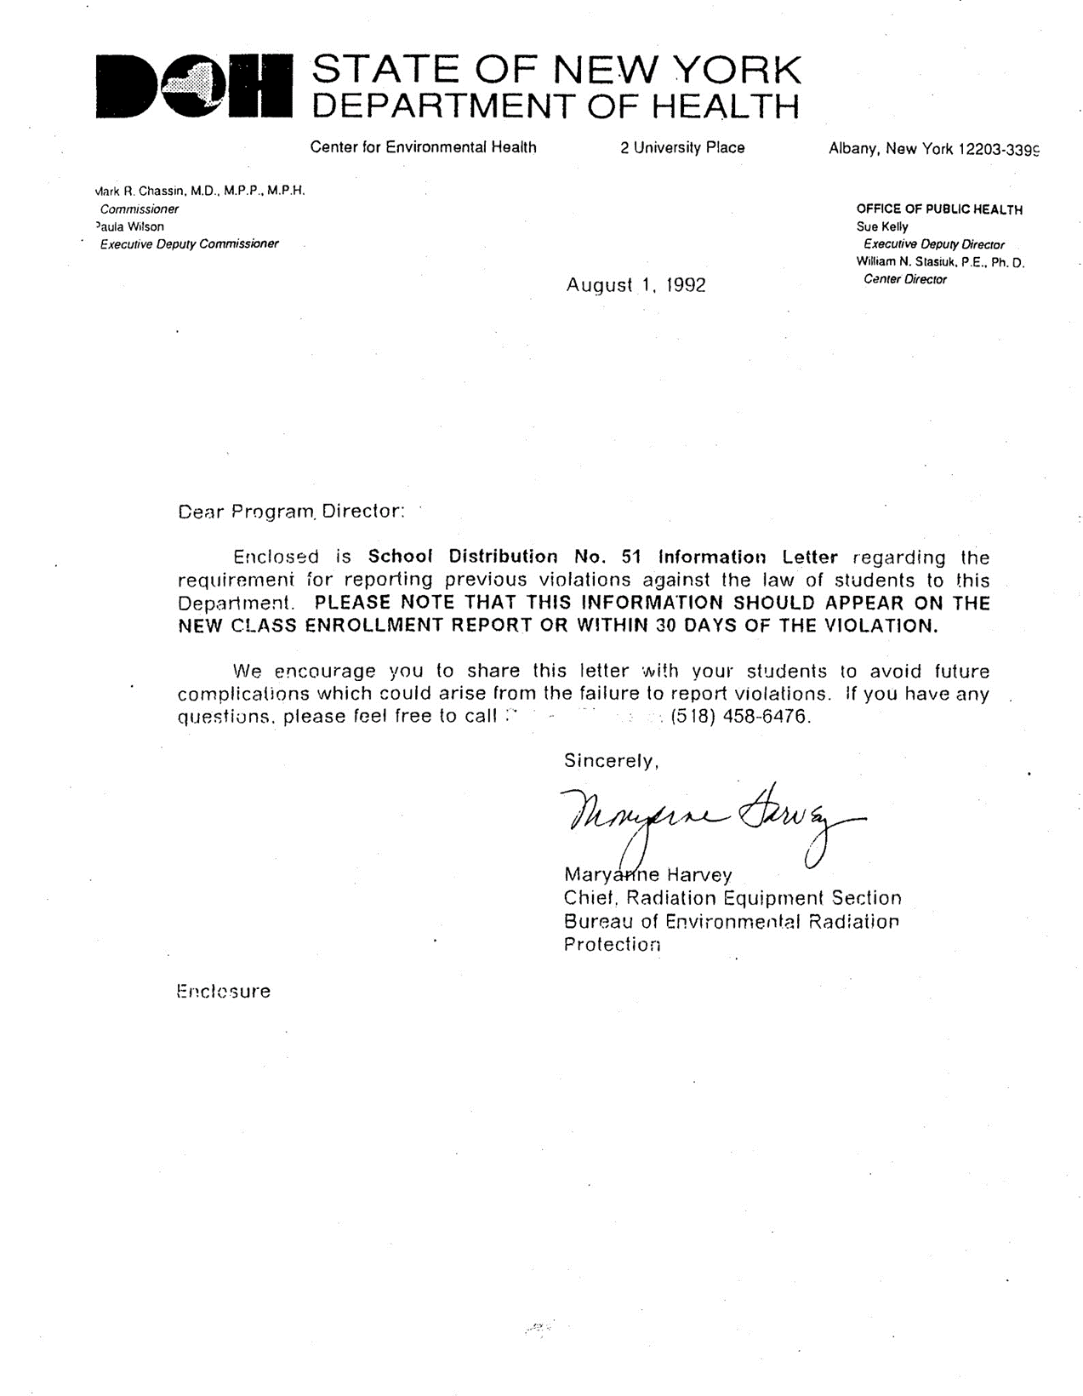

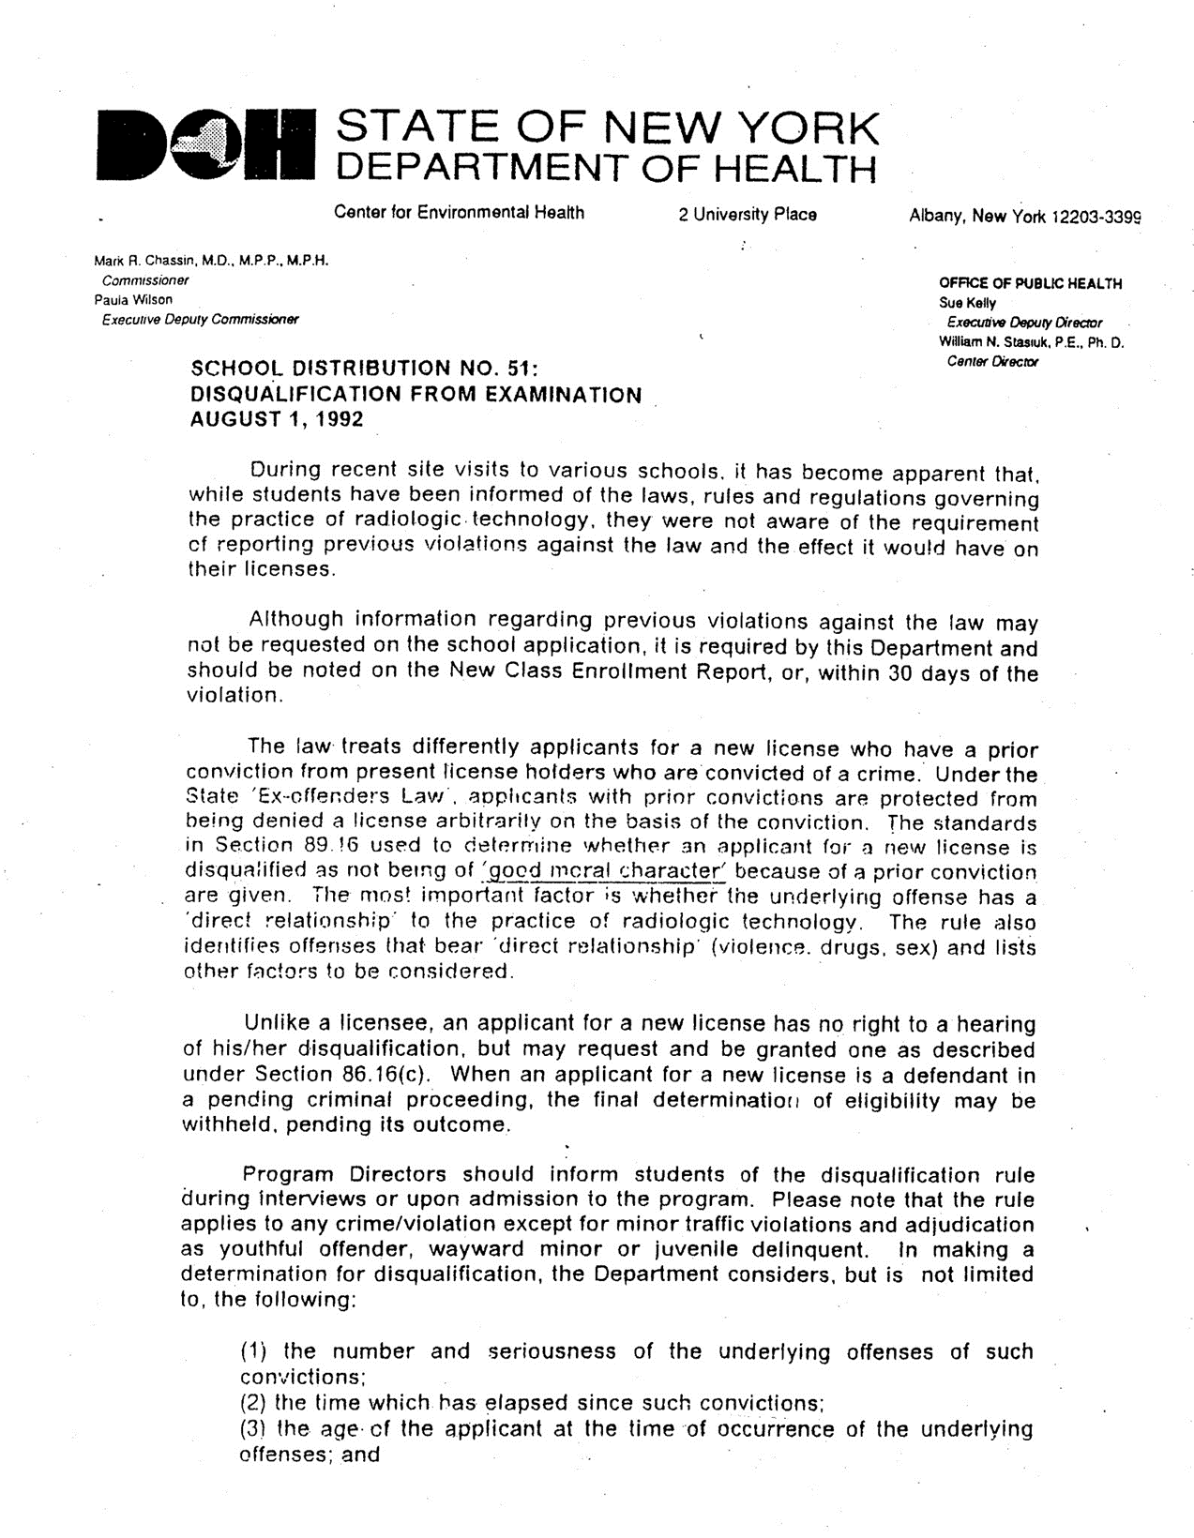

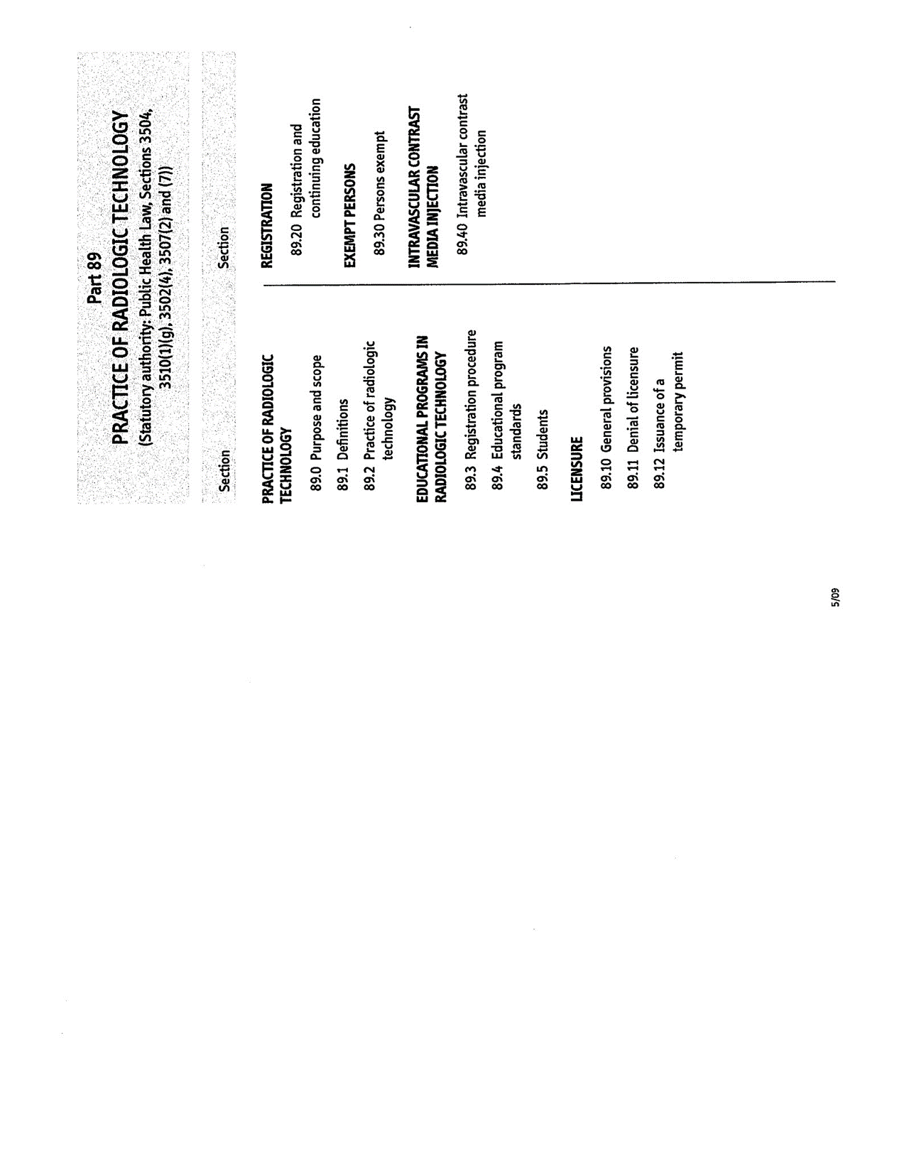
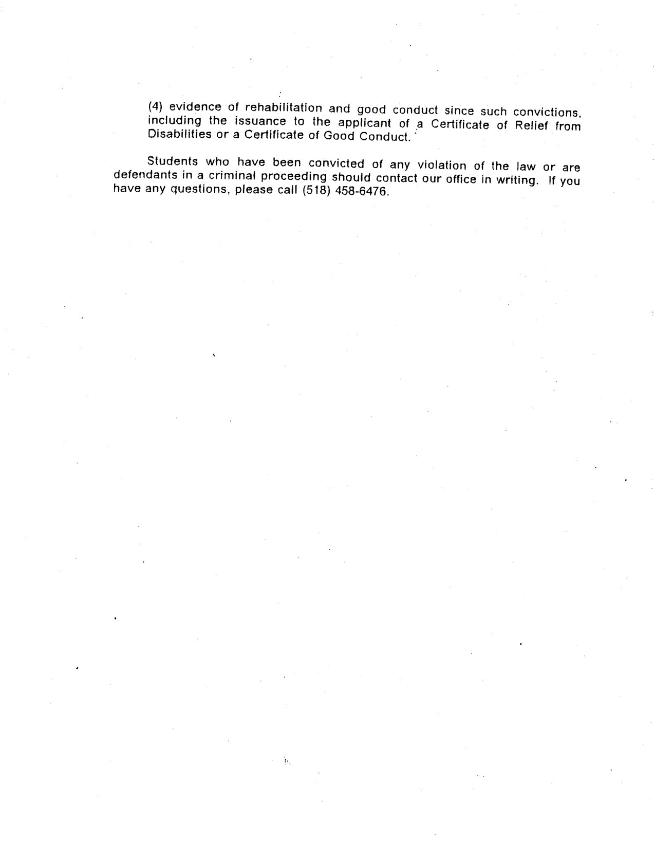

S/09

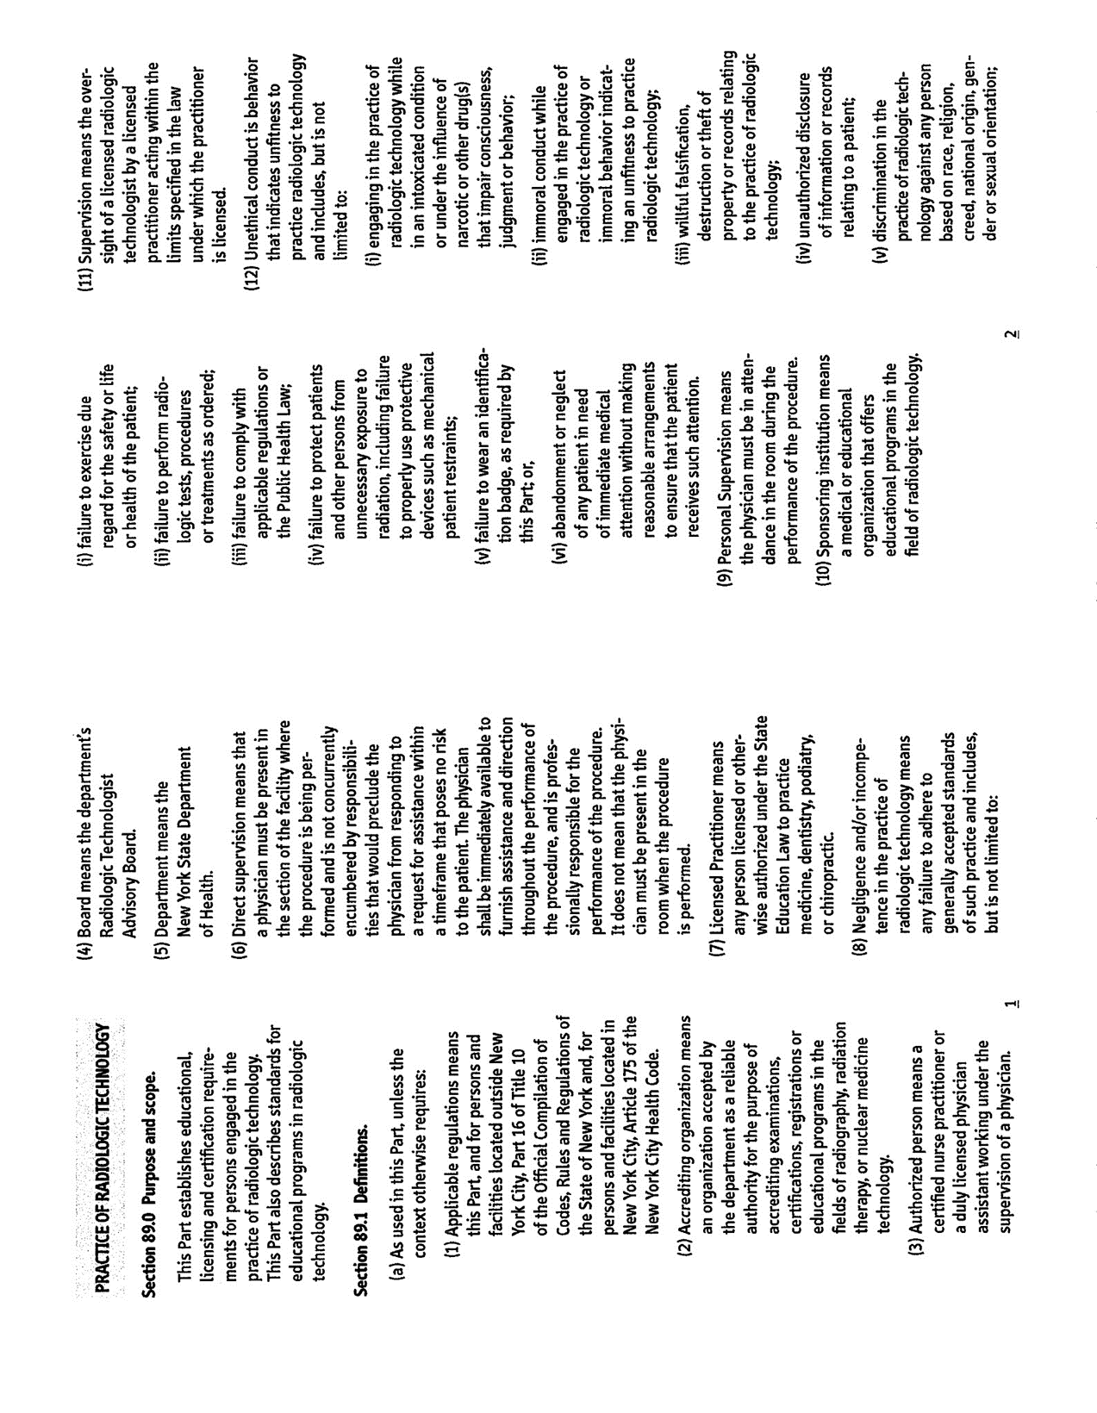
82
;

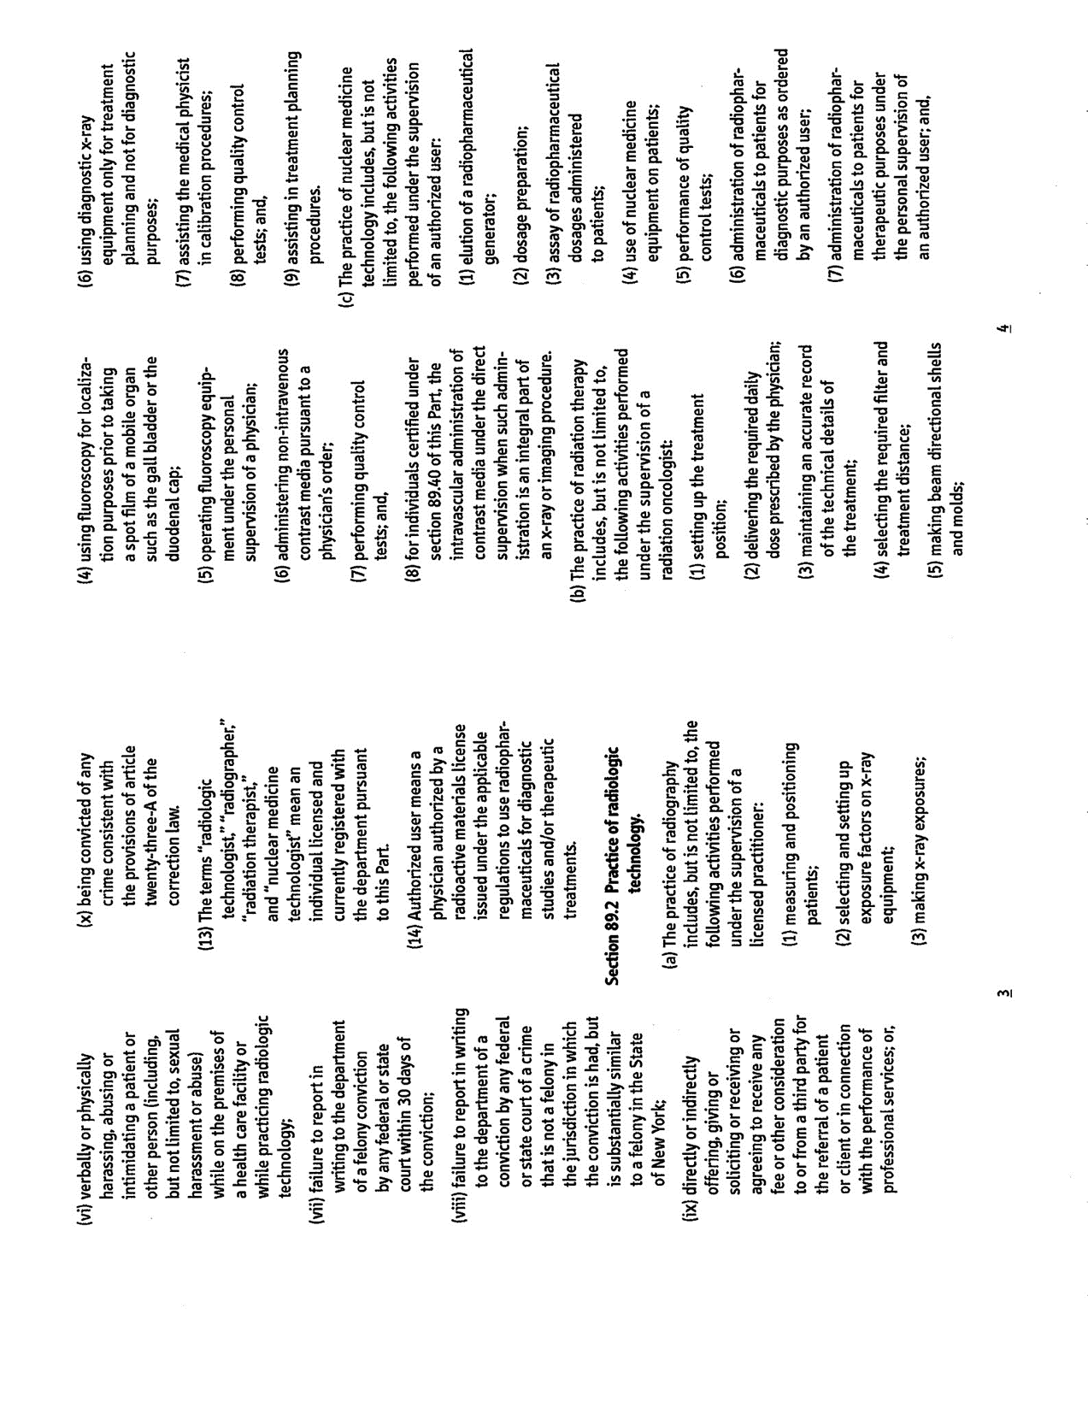
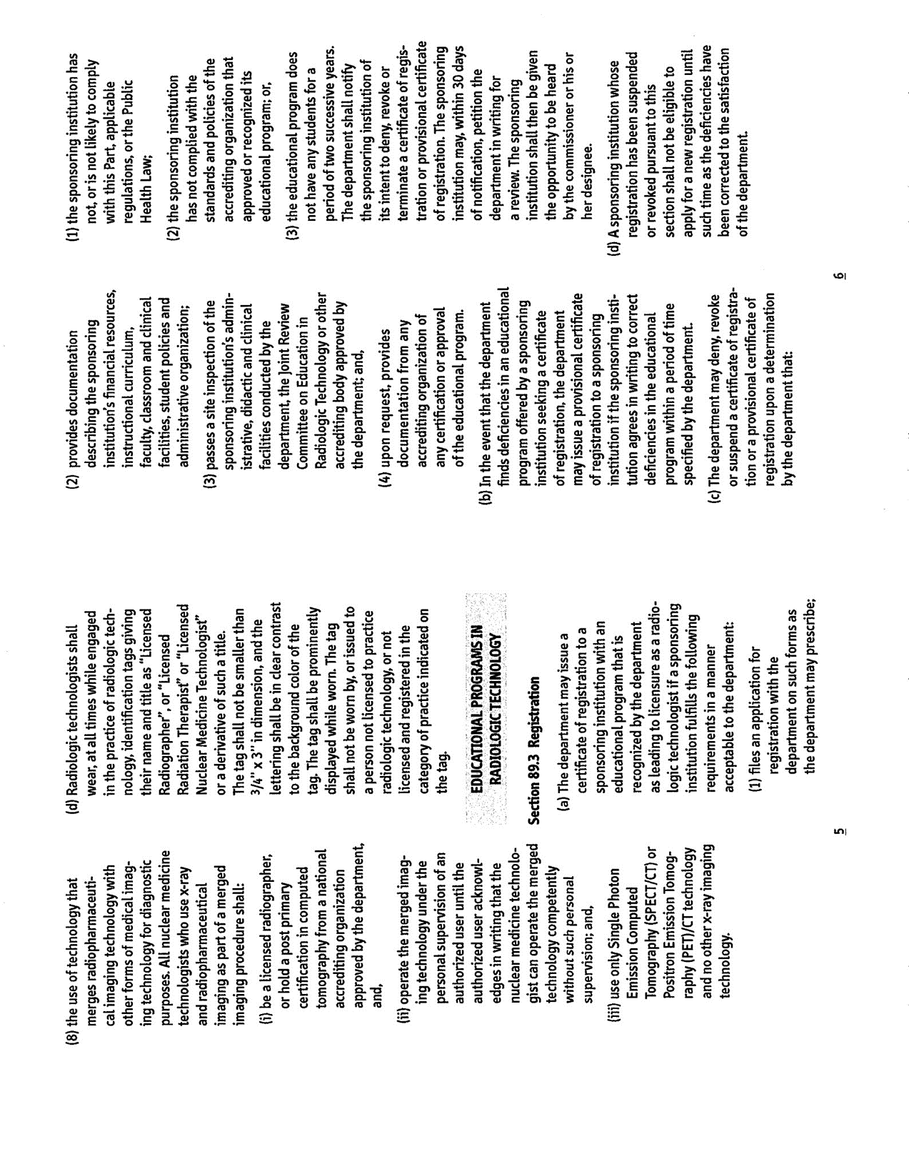
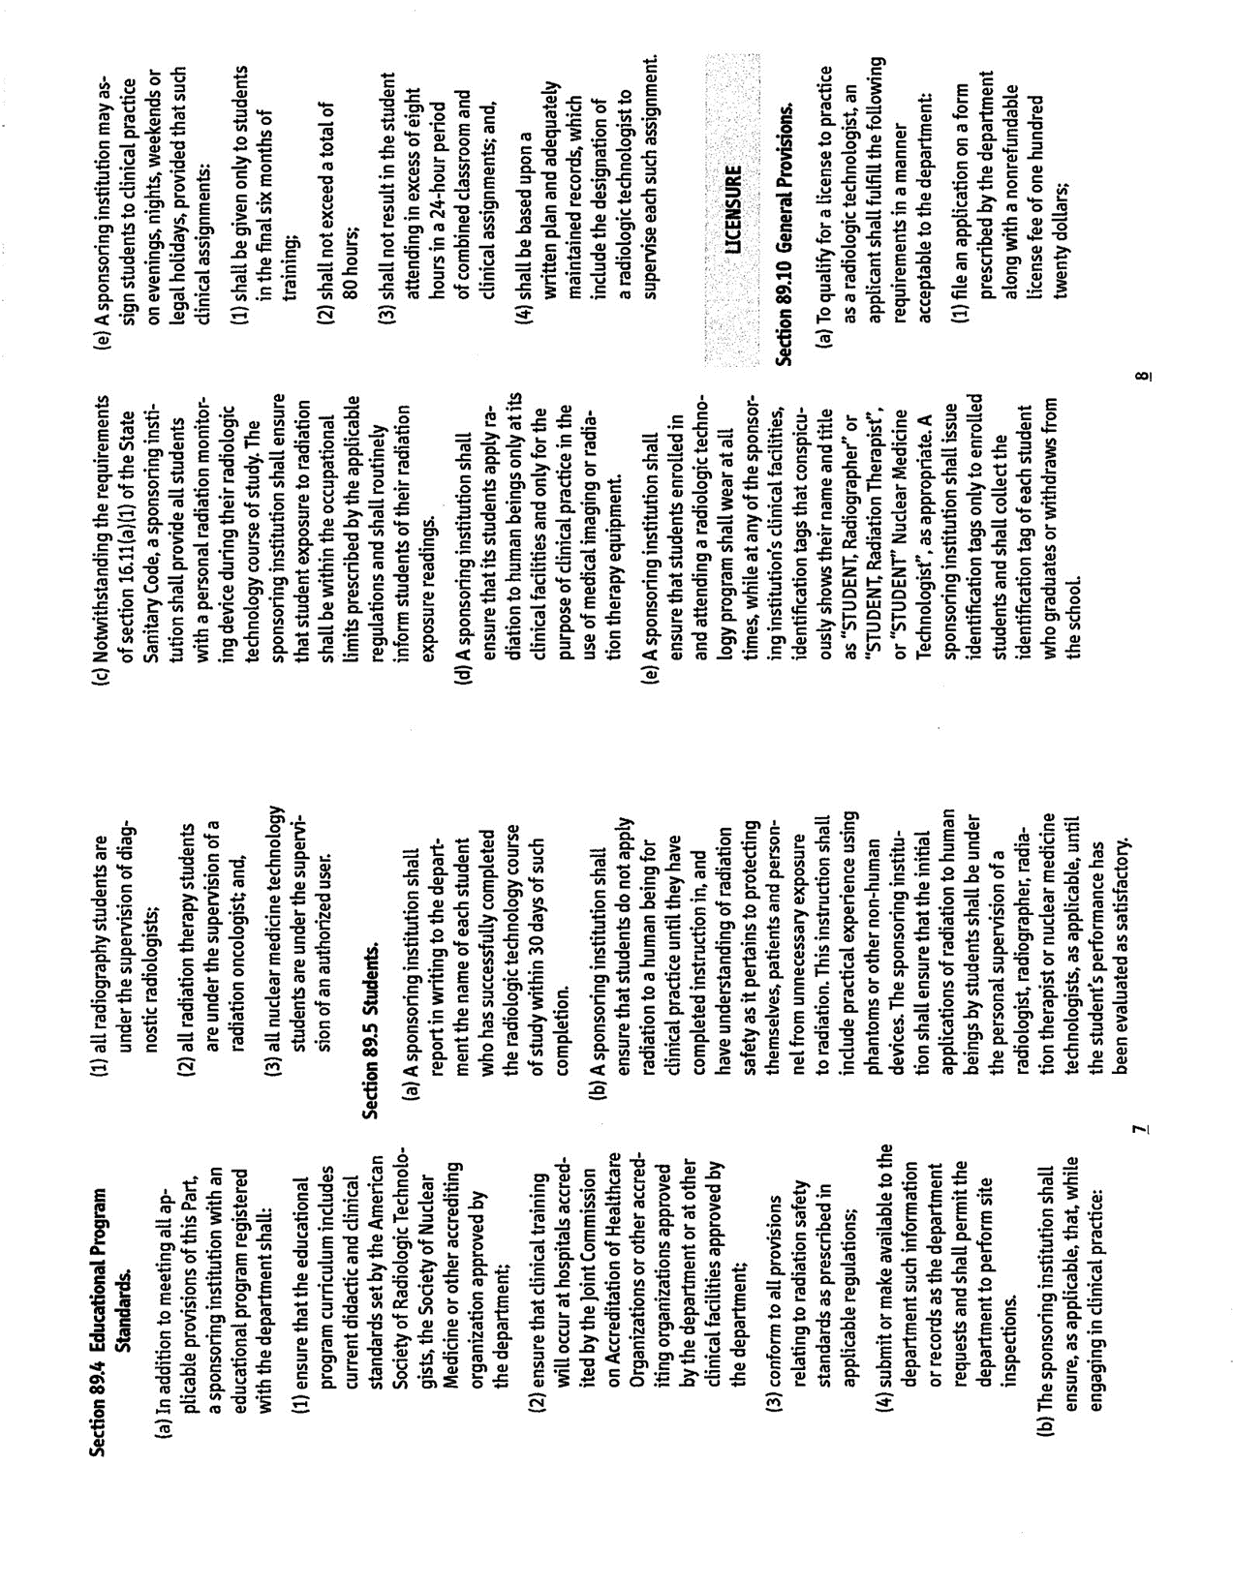
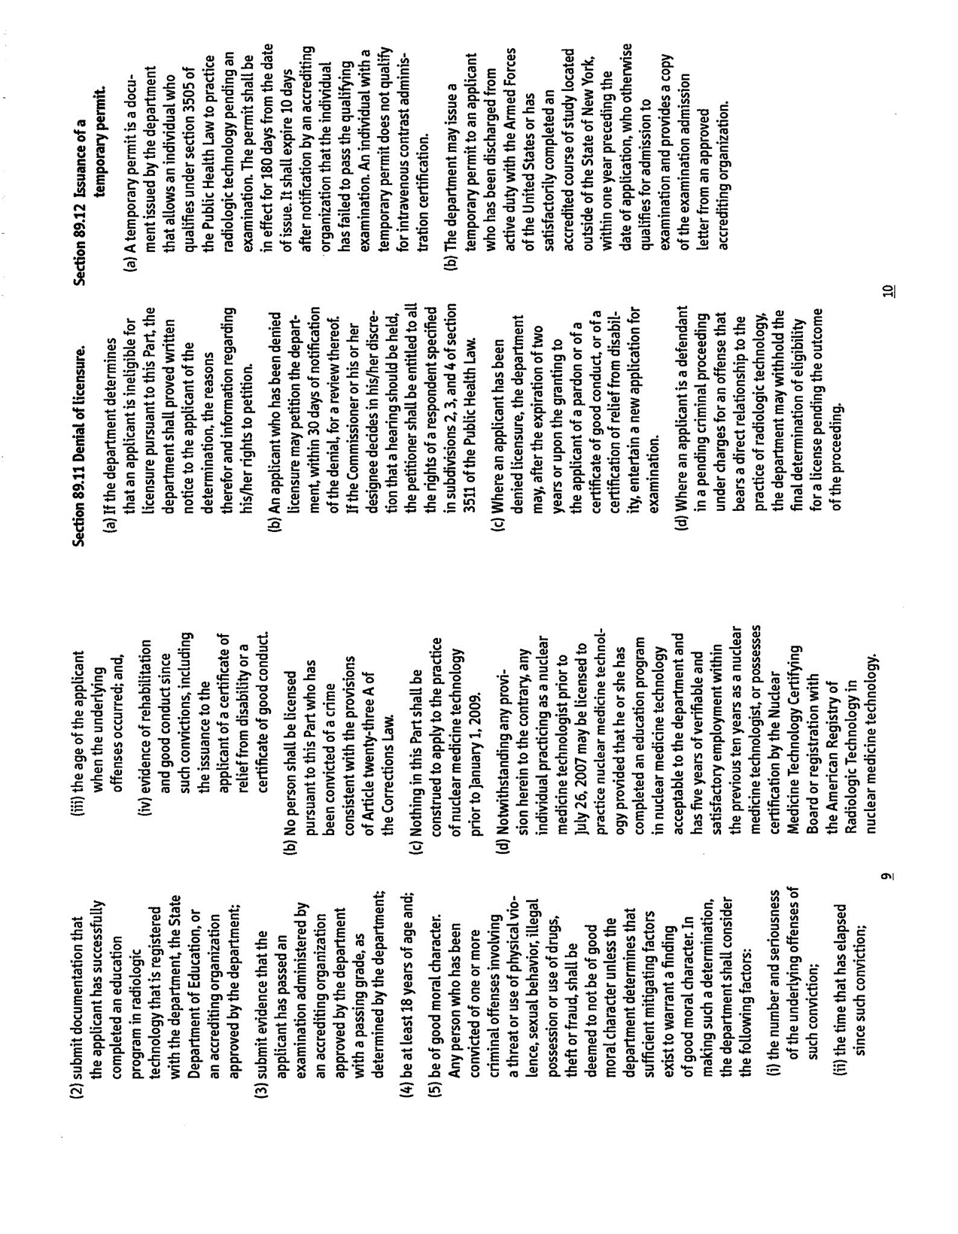

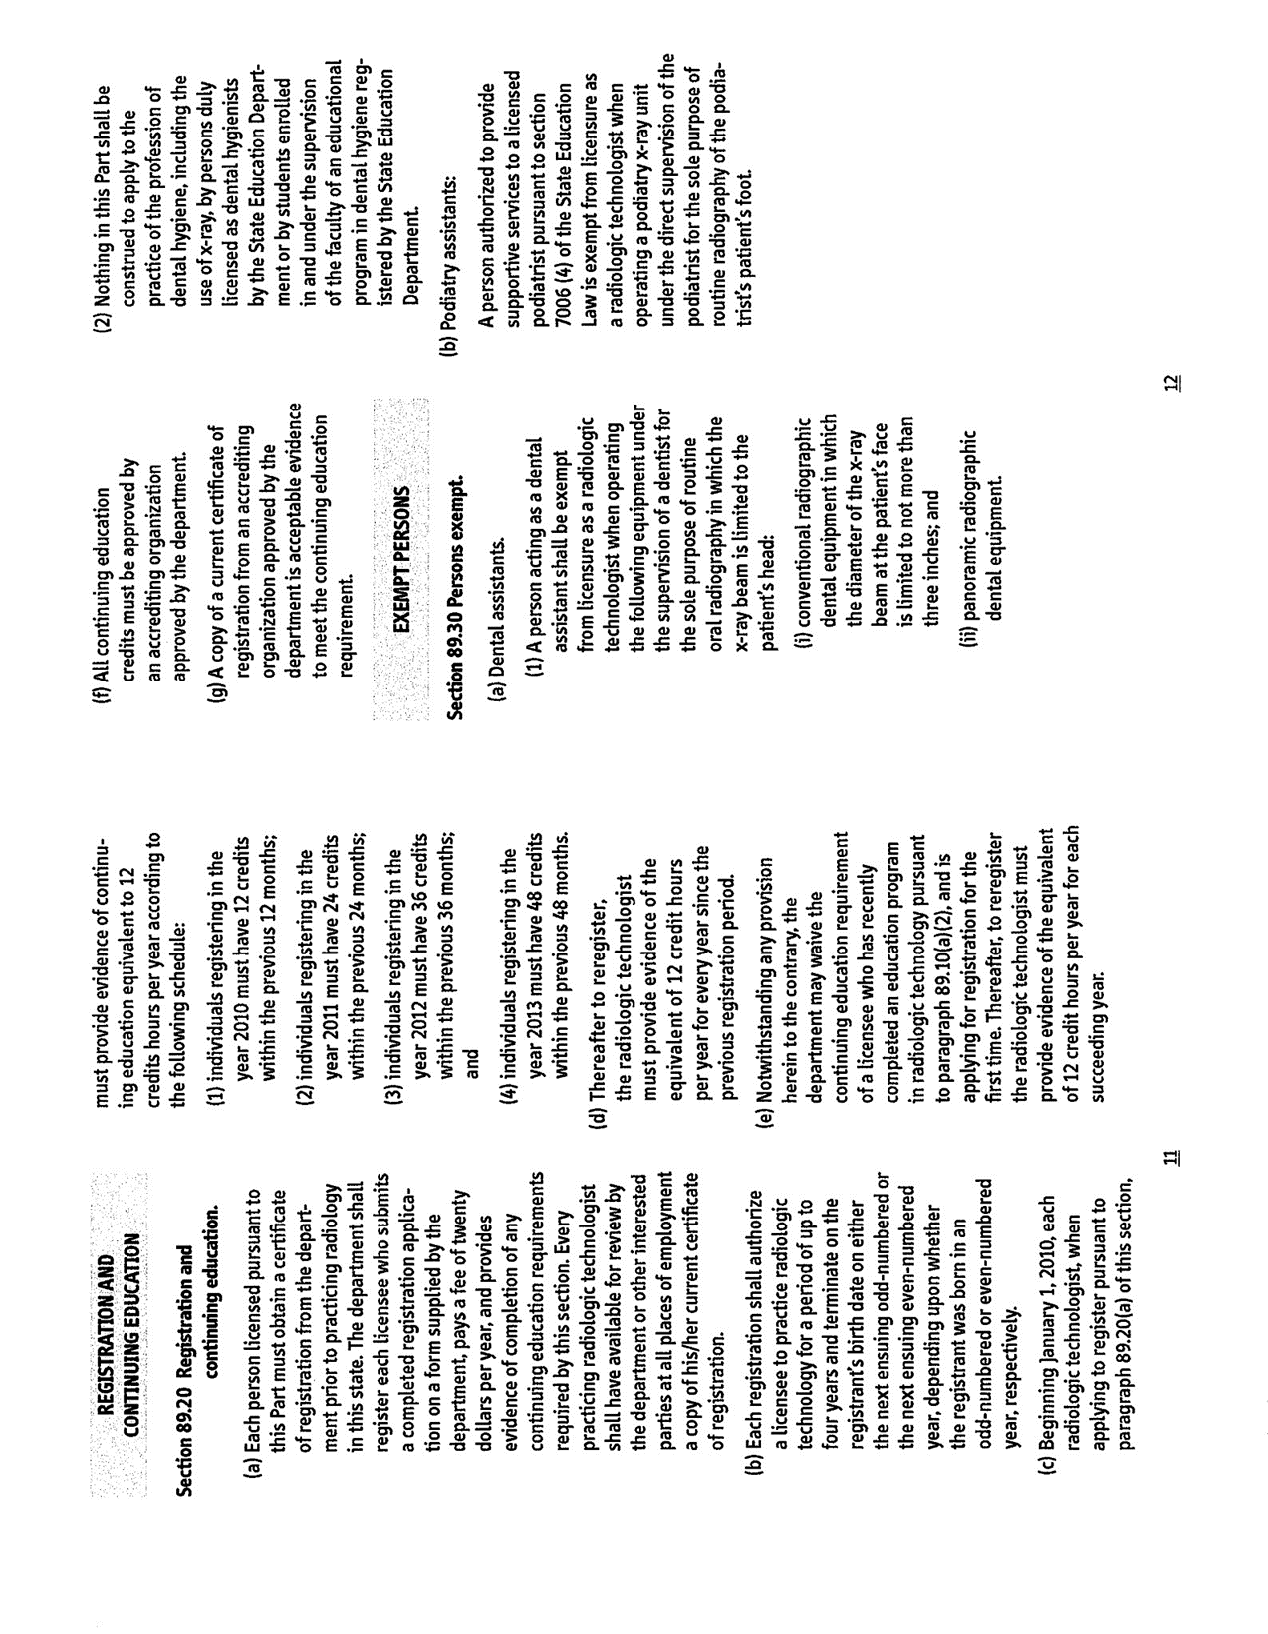

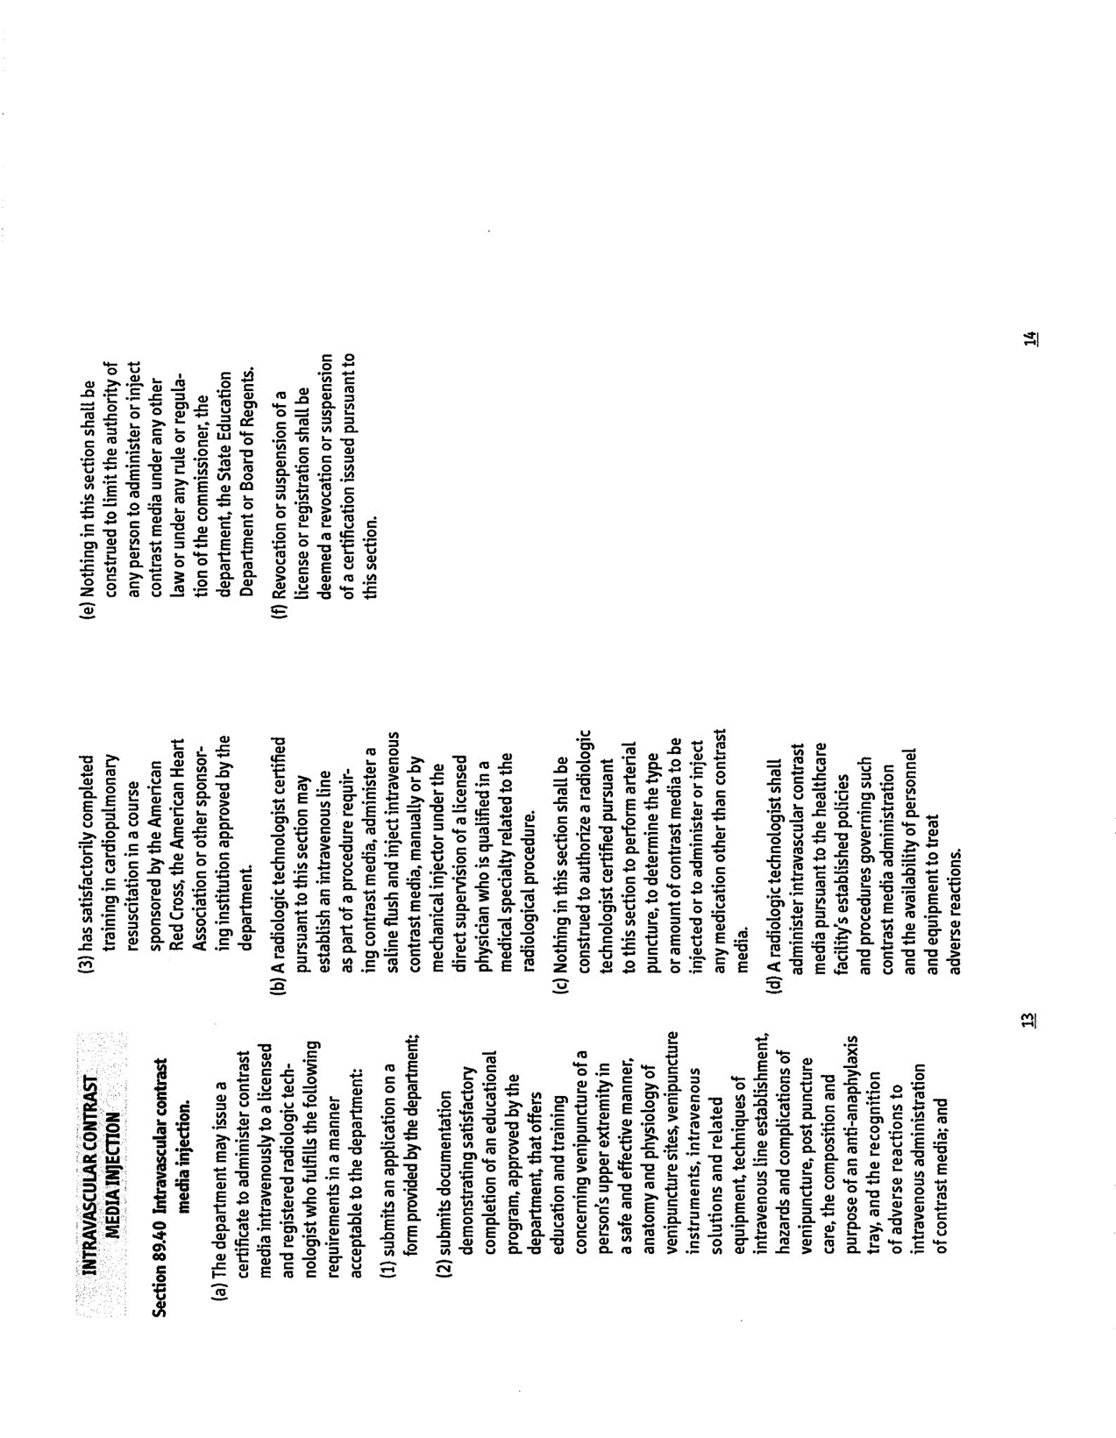


STATE OF NEW YORK

DEPARTMENT OF HEALTH

Flanigan Square, 547 River Stre t. Troy, New York 12180-2216
Antonia C. Novello, M.D., M.P.H., Dr.P.H.•
Commissioner •

Dennis P. Whalen .
Executive Deputy Commissioner

. December 11, 2006 .

Re: Recent legislation concerning Radiologic Technologists

Dear Program Director:
- The purpose of this communication is to inform you of changes to Article 35, of the Public Health Law, that impacts the practice of radiologic technology.
There are four major revisions of importance:
  - Injection of intravenous contrast media by certified radiologic technologists.
- As of January 22, 2007, radiologic technologists certified by this department, may inject intravenous contrast media under the supervision of a physician when it is part of an imaging study. A prototype application and attestation form for certification is included with this letter. It describes-the training and skills a radiologic technologist needs to inject these materials. • Applicati0ns will be available by December 2006. An individual interested in obtaining an application and attestation form should send a request to berp@health.state.ny.us. The note must include his/her name, radiologic-technology license number and current mailing address and a request for- the form. The fee for the certificate is $20 a year and will be calculated to coincide with their current registration period. Medical institutions, schools of radiologic technology and professional societies are encouraged to provide training in the required subject areas.
  - Licensing requirement for nuclear medicine technologists.
Only licensed individuals will be permitted t_o practice nuclear medicine technology after January I, 2009. Individuals who hold current certificates from the Nuclear Medicine Technology Certification Board or the American Registry of Radiologic Technologists in Nuclear Medicine should automatically qualify for a license. Individuals who do not hold these qualifications have until that date to become qualified. These individuals wil1 need to show completion of a course of study approved by the Nuclear Medicine Technology Certifying Board, the American
Registry of Radiologic Technology or other organization approved by the department. Also they will need a completed and signed attestation form listing active and satisfactory employment in
- nudear medicine during five of the previous ten years including competency in the administration of radioactive materials.

  - Continuing education requirements for-radiologic technologists.
Radiologic technologists must demonstrate continuing education credits to register their licenses starting in 2009. The continuing education program will parallel the requirements of the
. American Registry of Radiologic Technologists or the Nuclear Medicine Technology Certifying Board.
  - License and registration fees increased.
Fees for all radiologic technology licenses will be $120 and registration fees will be $20_a year beginning in July 2007. -
You may access the revised law by going to http://pubJic.leginfo.state.ny.us/menugetf.cgi, crolling down to PHL Public Health Law and clicking on the link. Questions may be sent to berp@health.state.ny.us. •
' '
Part 89, the regulations governing the practice of radiologic technology, are curre.ntly wider revision.
The revised Part 89 will provide additional information on these new requirements._
Thank you for your assistance in sharing this information with other interested persons in your • institution. •
  - Sincerely,
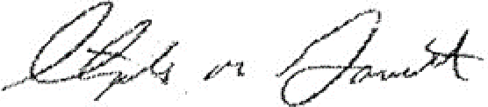
Stephen M. Gavitt, C.H.P.
Acting Director, Burt:au of Environmental Radiation Prot ction


STATE OF NEW YORK

DEPARTMENT OF HE.ALTH
Flanigan Square, 547 River Street, Troy, New York 12180-2216

Richard·F. D ines, M.D.
Commissioner

CORRECTION

April 23, 2007

Dear :Program Directors,

Please be advised that once a radiologic technologist is certified to perform intravenous contrast injections, the technologist and the supervising physician are not required_to complete another -injection certification application attesting to training and experience. This wilJ hold true as long as the technologist keeps his/her injection certification current. If the technologist lets his/her injection certification lapse then another injection certification application must be submitted to reinstate the technologist's injection certification. I apologize for the error. I look forward •to see you again soon.

    - Radiologic Health Specialist
Bureau of Environmental Radiation Protection

ATTACHMENT D

ADDITIONAL INFORMATION

