To transfer the cost of an employee’s time/overtime (OT) from their normal department’s budget line to the Facilities Usage budget line, employees must record hours worked on their timesheets (t/s), as they normally would. They must add a comment to their timesheet that would include:

* Event Code
* Date(s) worked on the event, and Time-in and Time-out

Add a comment using the “talk bubble” to the right of the pay period on your t/s

For example (see below):  
***Event A8428. Saturday, 4/5/25 from 3pm to 11pm***

***Click Save***

The time entry on your timesheet will have a lunch break detailed, if applicable.

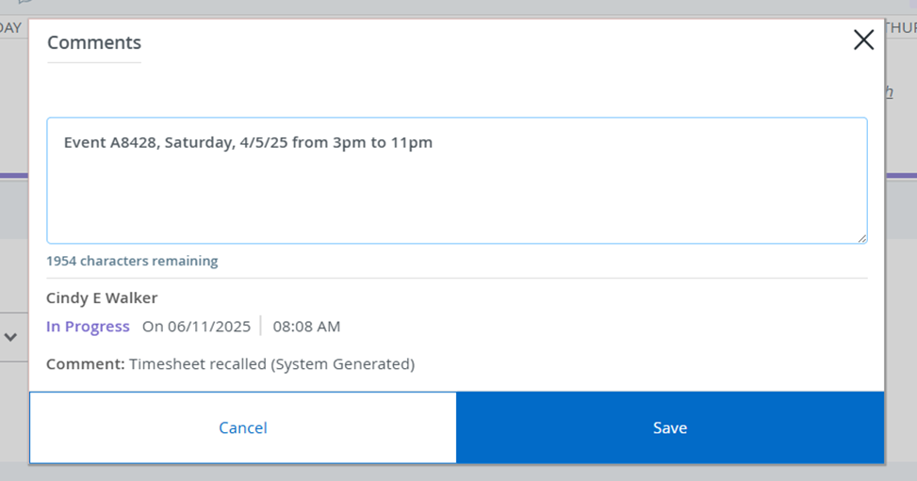

If this is done, the time will be charged to Facilities Usage during the payroll process

NOTE: If employee banks OT related to Facilities Usage, no cost will be transferred.

If this is not done during the pay period, the employee will be responsible for completing and submitting the Time Distribution Sheet, which is a fillable PDF form located on Banner Web > NEW – Employee Self Service Dashboard – SSB9 > My Activities.

Once this form is sent to the Payroll Office, the cost of labor will be transferred.

If this is done, the time will be charged to Facilities Usage during the payroll process.

NOTE: if the employee is banking the OT worked, there is no cost to transfer.

**Late Submission** - If the transfer is not noted on the employee’s time sheet in the current pay period, a Time Distribution Sheet must be completed and sent to payroll.

The Time Distribution Sheet Template, which is a fillable PDF form, is located on

Banner Web > Enter Secure Area > Employee > New – Employee Self Service Dashboard – SSB9 > My Activities.

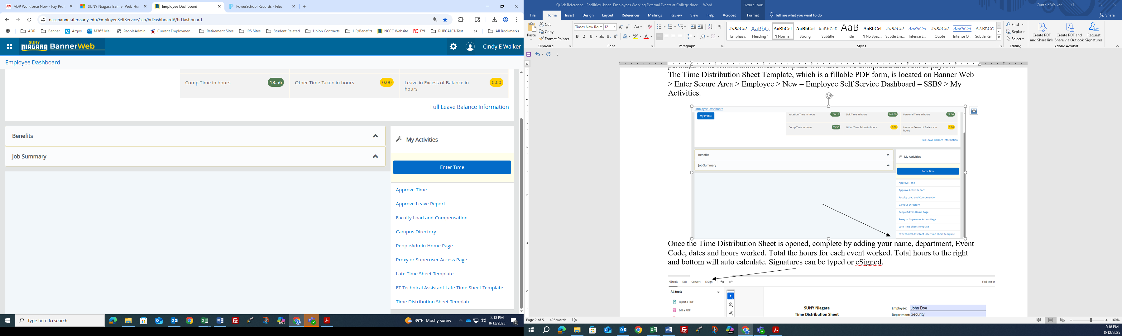

Right click the mouse on the Time Distribution sheet Template form, and choose “save link as”.

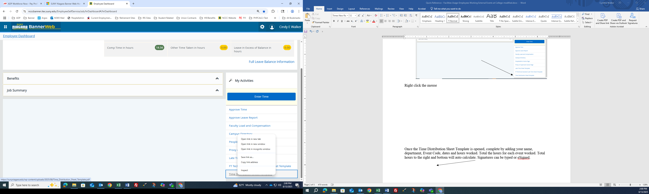

Save the PDF to your department’s drive for future use. You can name the PDF file “Time Distribution Sheet Template”.

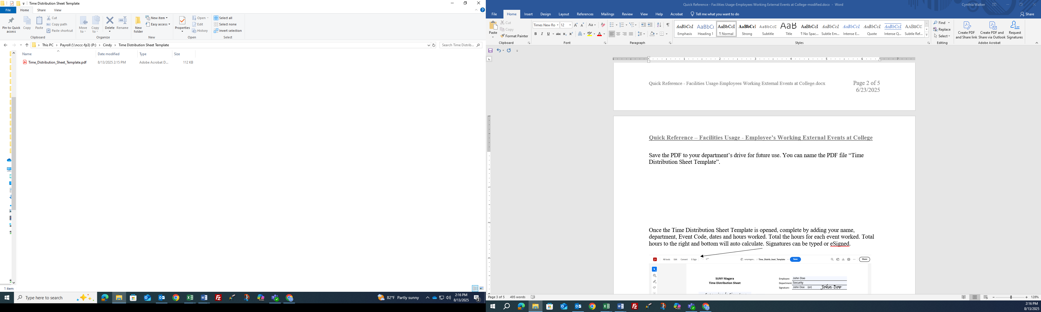

Once you save the template, you can open it and complete it when an external event is worked.

Double click on the file to open. Once open, complete the fillable areas such as:

* Employee name
* Department
* Employee Signature – you can type your name or E-Sign (see below)
  + To eSign, click E-Sign then Add signature. Type your signature and click “Apply”
  + Bring the curser to the Signature line on the Time Distribution Sheet, and left click to drop the signature in place

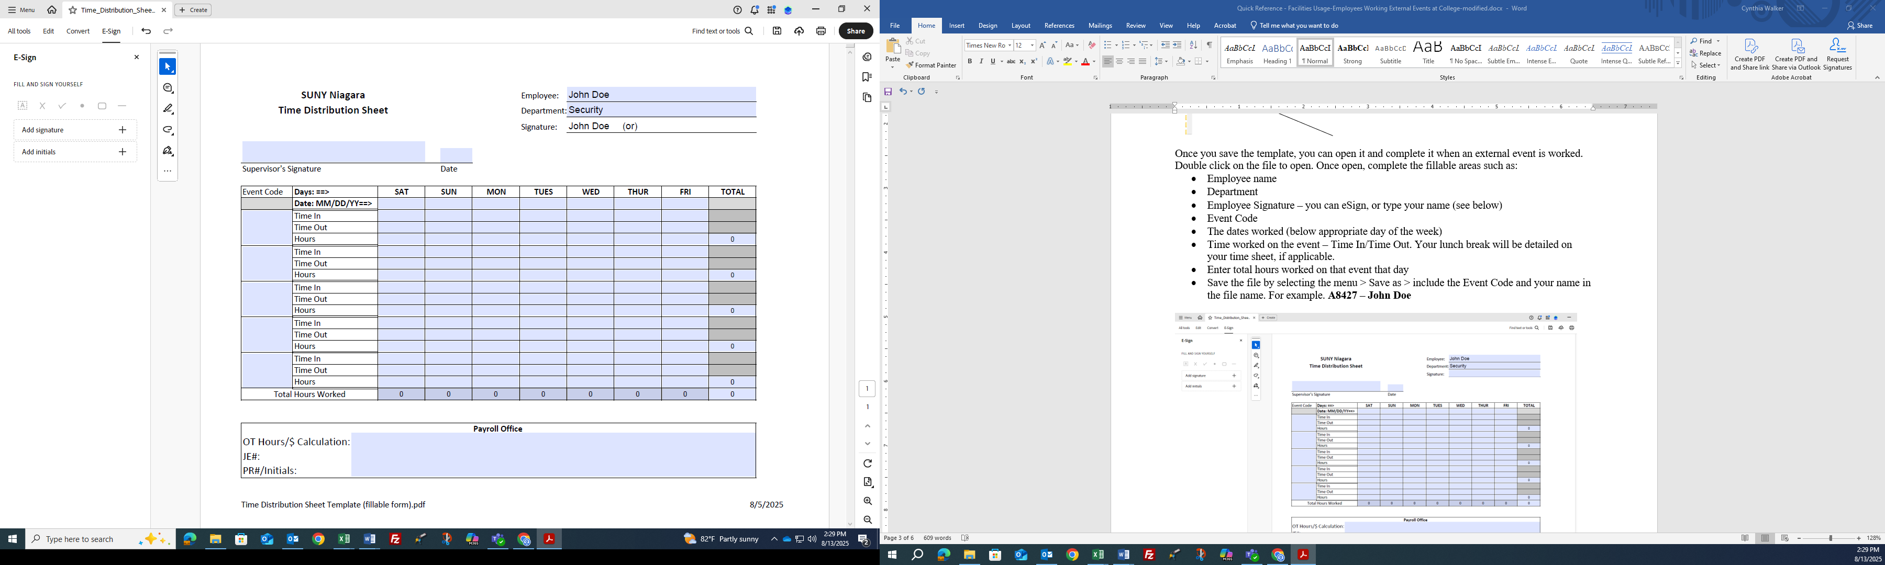

Continue completing the form by entering:

* Event Code
* The dates worked (below appropriate day of the week)
* Time worked on the event – Time In/Time Out. Your lunch break will be detailed on your time sheet, if applicable.
* Enter total hours worked on that event that day on the Hours line

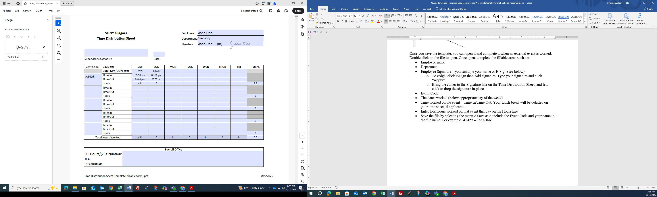

* 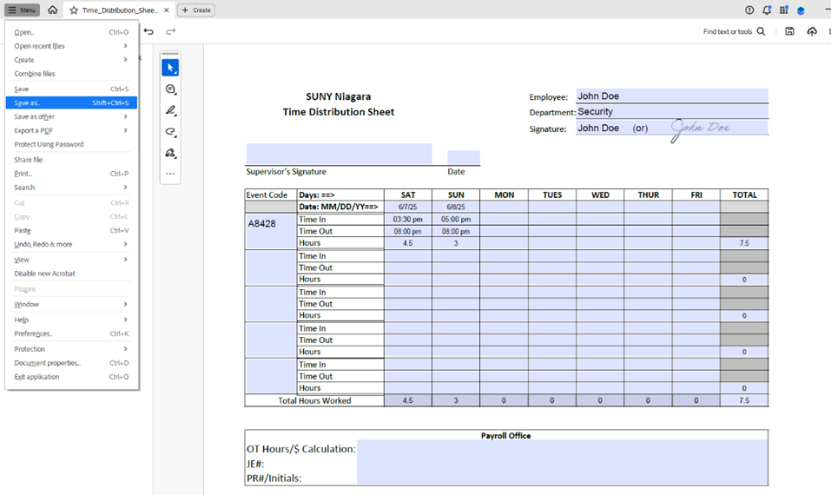Save the file by selecting the Menu > **Save as** > include the Event Code and your name in the file name. For example: **A8427 – John Doe**

Once the file is saved, your supervisor can then access the file and review the time records.

Supervisor should:

* Type or E-Sign their name
* Date the form
* Save the form and attach it in an email to the “Payroll Office” email.

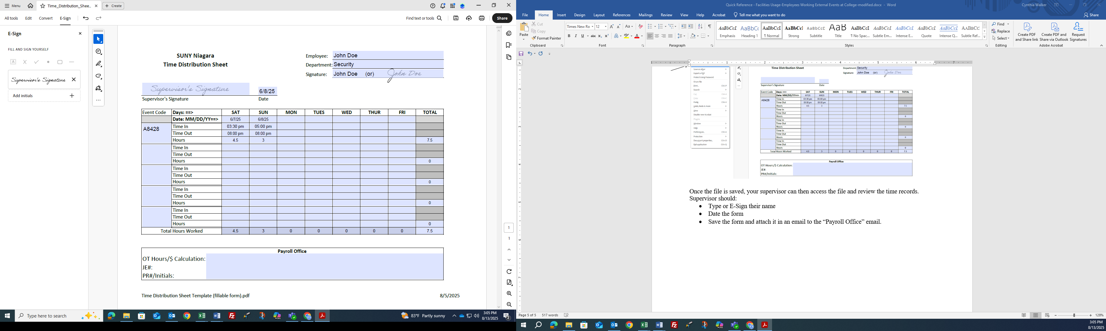

NO PAPER WILL BE ACCEPTED BY THE PAYROLL OFFICE.