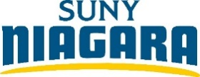
BOCES Articulation Agreement
College Acceleration Program
Welding Technology, A.A.S.

Overview
The Welding Technology curriculum includes coursework in welding that is designed to prepare the student for various welding certifications. In addition, the degree offers coursework in some of the soft skilled and tangible areas of liberal arts. This curriculum path takes advantage of affordable cost offerings and combines high school practical experience with college level classroom opportunities.

Careers see next page for more
Careers related to your program of study:
• Pipefitter
• Production Manager
• Welder
• Welding Manager
• Welding Procurement
• Welding Sales

*Articulation Agreement
Students receive transfer credit with 85% or higher grade average if attending SUNY Niagara within two years of high school graduation. No additional college cost required.
** College Acceleration Program (CAP)
Students register and pay for SUNY Niagara college credit at a reduced rate in senior year. Students are responsible for registration and payment prior to the deadline.
** You also have the option to take welding classes as an audit for additional fees, example being current in WLD certifications.

Program Requirements

Junior Year of High School Credits
*WLD 110/L - Electrical Arc Welding Process w/ Lab 4
*WLD 120/L - Thermal Cutting w/ Lab 2
*WLD 130/L - Welding Safety - OSHA w/ Lab 2
*WLD 140/L - Gas Metal Arc Welding Processes w/ Lab 2
*WLD 150 - Welding Metallurgy 3
Total Credit Hours: 13 Cr.

Senior Year of High School
**WLD 210/L - Tig Welding Processes w/ Lab 3
**WLD 220/L - Metal Fabrication w/ Lab 2
**WLD 230/L - Welding Inspections & Quality Control w/ Lab 2
**WLD 240/L – Adv. Electric Arc Welding Processes w/ Lab 4
**WLD 250/L - Welding Certification w/ Lab 4
**WLD 260/L - Capstone Project w/ Lab 2
Total Credit Hours: 17 Cr.

First Semester
TEC 105 - Basic Skills for Technology 3
WLD 100 - Introduction to Welding and Blueprints 3
ENG 101 - Writing I 3
MET 125 - Processes 3
CHE 100 - Fundamentals of Chemistry 3
CHE 101L - Fundamentals of Chemistry Lab 1
Total Credit Hours: 16 Cr.

Second Semester
MAT 110 - Intermediate Algebra 4
TEC 110 - Introduction to Technical Calculations 1
___ ___ - Diversity: Equity, Inclusion & Social Justice General Education elective that also fulfills a Liberal Arts elective 3
___ ___ - Communication – Oral General Education approved elective 3
ECO 102 - Microeconomics 3
Health/Physical Education elective 1
Total Credit Hours: 15 Cr.
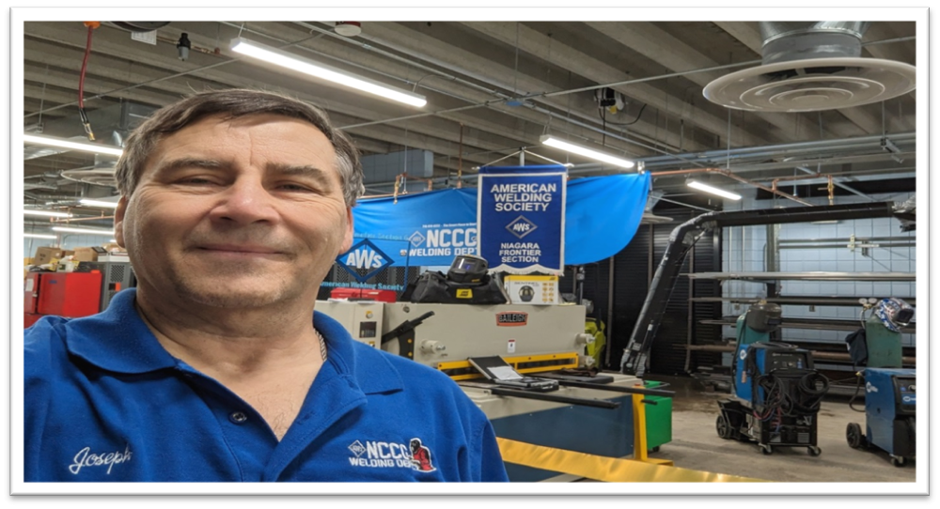
I Welcome All of You to Our New Home!
The Best Is Yet to Come!
“Together We Grow Hope For Your Future”
Professor: Joseph Schmidt
schmidt@niagaracc.suny.edu 716-614-5971
Coordinator of:
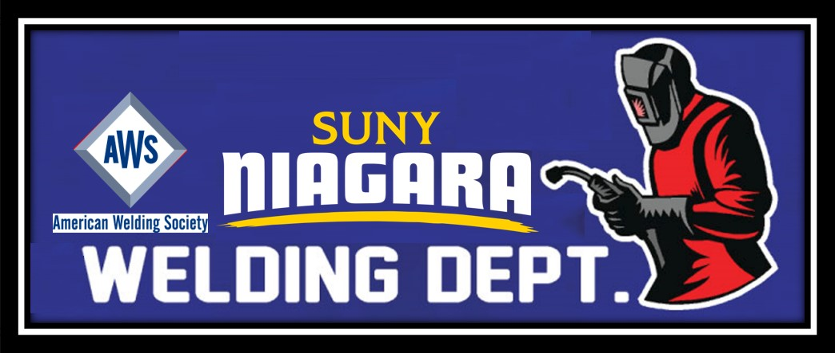
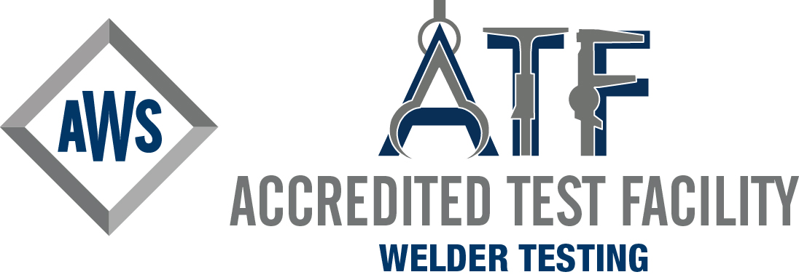
Welding @ SUNY Niagara
716-614-5971
&
AWS Niagara Section 6 Chairman
Joe

Other important contact information:

SUNY Niagara:
Main phone# 716-614-6222
Main website https://www.niagaracc.suny.edu/

CAP Registration website
https://www.niagaracc.suny.edu/academics/highschool/

Delaney Douglas: Assistant to VP Academic Affairs CAP program 716-614-6452
ddouglas@niagaracc.suny.edu

Cashiers Office: 716-614-6443
cashier@niagaracc.suny.edu

Scholarship Office: 716-614-5910
found@niagaracc.suny.edu

Admissions Office: 716-614-6290
How to Apply https://www.niagaracc.suny.edu/registration/

AWS [American Welding Society] How to join for free as a student.
https://www.aws.org/Membership/?step1=1&step2=11
AWS: main site aws.org

Welding can have many paths for success. You make the choice for your future. We are here to help you down that path.
“Together We Grow Hope For Your Future”

Iron Worker: Oil Rigs:
Sheet Metal Fabrication: Plumbing:
Pipe: Automotive:
Aerospace: Military:
DOT: Art:
CWI: CWE:
Sales: Education:
Repairs: Programming:
Codes /WP: Amusement Parks:
Entertainment: Maintenance Worker:
Underwater: Motorsports:
Shipyard & Maintenance: Boiler Maker:
Project Manager: Robotics:

Why consider SUNY Niagara’s Welding program:

Cost: We currently offer classes to BOCES Student @ approximately 1/3 the cost as for a traditional student.
BOCES Senior Student cost $86.00 per credit. 2024 / 25
Standard Student $214.00 per credit 2024 / 25

1 Year of school left to receive AAS 2-year degree, this can lead to further advancements down your career as a welder.

Our program has AWS backing as an ATF.
[Accredited Test Facility] there are only 12 locations in NYS & we are the Only College to hold such recognitions. https://aws-p-001-delivery.sitecorecontenthub.cloud/api/public/content/AWS-ATF-Domestic-Site-Listing
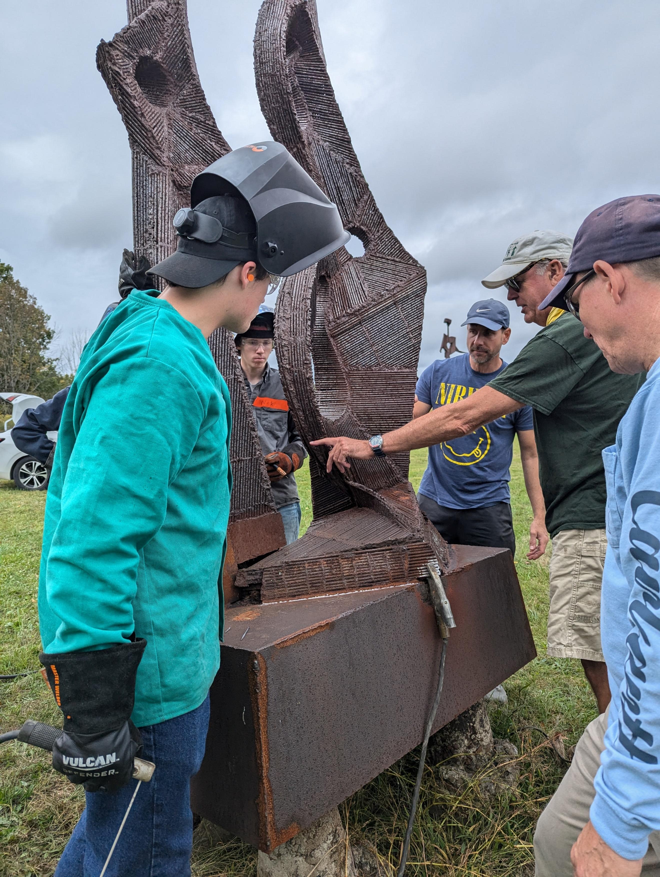
Become a Certified Welder CW!
We offer multiple Certified Welder [CW] Certifications through AWS and DOT: SMAW, GMAW, FCAW, and GTAW.

Small class sizes, only 10 students in the lab, with 10 welding booths. More personalized learning environment.

State of the art equipment! In metal fabrication and welding. Learn on the best equipment.

Professional instructors with years of experience. We also have our own CWI on staff.

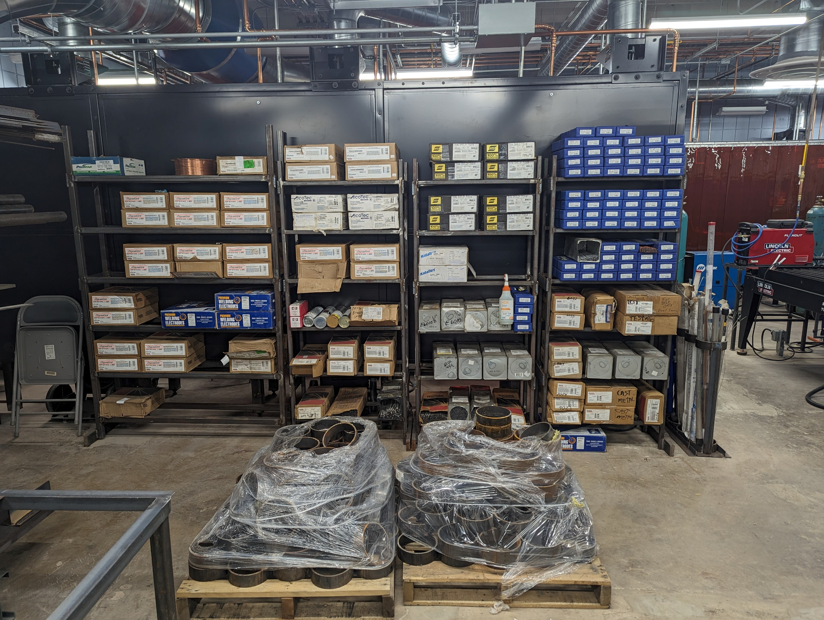
Our connection to AWS Niagara Section 6 chapter help you to make connections thru our monthly meetings. Join for free, become a member!!

Audit additional welding classes for an additional inexpressive fee, to dive further into various techniques in the welding / fabrication processes we offer here.
Receive your OSHA Certification Card with us.

We supply all equipment & materials, you supply helmet, gloves, jackets, work-boots and of course you and your dream of welding. To keep your cost $$$$$ down.

What is keeping you from joining us??
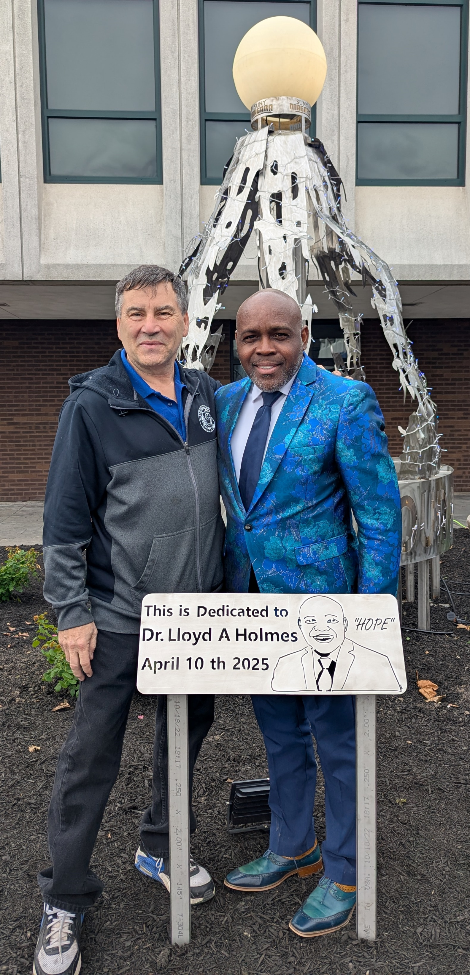
Come for a visit, see what we have that no other colleges have to offer you.
