Nursing Program

Technology Handbook

[](http://www.google.com/url?sa=i&rct=j&q=&esrc=s&source=images&cd=&ved=0ahUKEwjv-Jy_6JXVAhXKQSYKHelFDfYQjRwIBw&url=http://resources.examsoft.com/&psig=AFQjCNGyXZFJCSvOCead_wfSzgcUHIK7Yw&ust=1500569861130569)







Nursing Department Technology Handbook

LapTop requirement 4

Windows Minimum System Requirements 4

Mac Minimum System Requirements 5

Devices Not Supported 5

How to find info about your Windows computer 6

How to find info about your Mac computer 7

Set up your Microsoft Surface Pro to Run Windows 10 8

usernames and passwords 11

Wi-Fi: Connect to NCCC Secure 11

IN CASE OF AN EMERGENCY 12

office 365 software Download 13

Disabling Anti-Virus Software 14

Examplify 15

Examplify Reliability and Best Practices 16

Examplify installation 17

How to Log in to Examplify 18

Home Screen 20

Examplify Preferences 21

Downloading an Exam 22

taking an exam 23

Control/Tool Kit 24

Multiple Choice Questions 26

Fill in the Blank Questions 27

Hot Spot Questions 28

Drag and Drop Questions 29

Calculator Use 30

Highlighting Text 31

Zoom In/Out feature 32

Hide/Expand Question Stem 33

Post Exam actions 34

Update Examplify Version 36

Examplify Silent Updates 37

Windows: View Examplify Version 38

Mac: View Examplify Version 40

Remove a Downloaded Exam 41

ExamSoft Portal 42

How to Log In to ExamSoft Portal 43

SMS Notifications 44

Strength And Opportunities Report 45

ATI 48

HELP 55

Contact Information 55

ExamSoft/Examplify Log-In Issues 56

Clear your Browsers Cache: Google Chrome 57

Clear your Browsers Cache: Firefox 58

Clear your Browsers Cache: Safari 58

[](http://www.google.com/url?sa=i&rct=j&q=&esrc=s&source=images&cd=&ved=0ahUKEwjv-Jy_6JXVAhXKQSYKHelFDfYQjRwIBw&url=http://resources.examsoft.com/&psig=AFQjCNGyXZFJCSvOCead_wfSzgcUHIK7Yw&ust=1500569861130569)

**Laptop Requirement**

All students are required to have a laptop or tablet that meet the minimum standards outlined below, allowing for Examplify.

**Windows**

Examplify can be used on most modern Microsoft Windows-based computers (i.e., purchased within the last 3-4 years). Please see specific system requirements as noted below.

Examplify cannot be used on virtual operating systems such as Microsoft's Virtual Machine, Parallels, VMware, VMware Fusion or any other virtual environments

* Operating System: 32-bit and 64-bit Versions of Windows 10 and Windows 11.
* **Alternate versions of Windows 10, such as Windows RT and Windows 10 S, are NOT supported at this time.** *If you are using a Microsoft Surface device, please read important instructions on page 5 regarding Windows 10 “S mode” versus the standard Windows 10.  S mode is****not****compatible with Examplify.*
* Surface laptops that come with non-detachable keyboards are permitted. Non-Pro Surface devices are not supported for ANY institution.
* Only genuine, U.S.-English versions of Windows Operating Systems are supported. The versions of Windows 10 certified for use are 20H2, 21H1, 21H2, and Windows 11 21H2
* ExamSoft does not support Tablet devices other than Surface Pro as detailed above.
* CPU Processor:  Non-ARM based processor supported by your operating system
* RAM: 4GB required, 8GB or higher recommended
* Hard Drive: highest recommended for the operating system or 4GB of available space.
* Webcam: Integrated camera or external USB camera supported by your operating system. Virtual cameras and Microsoft Lifecam Series cameras are not supported.
* Microphone (no headphones, no virtual mics)
* For technical troubleshooting, account passwords, including BitLocker keys, may be required.
* Internet connection for Download, Registration, Exam Download, Upload, and some exam features.
* Examplify cannot be run within virtualized environments or environments that require persistent network (local or otherwise) connections during secure exams. This includes, but is not limited to, VMWare, Parallels, Citrix workspace, Virtual Disks, Streamed images, etc.
* Screen Resolution should be at least 1280x768 or higher. Scaling set to 100%.

**Mac**

Examplify Requirements for Mac Devices are listed below.

In order to use Examplify on your Apple Macbook, Macbook Air or Macbook Pro natively, you must have:

* Mojave 10.14.6 (and higher), Catalina (10.15.7 and higher) Big Sur 11.3 (and higher).
* For a better experience, we recommend that you take your exam on the same OS version that you have completed a recent successful mock exam.
* Only genuine versions of Mac operating systems are supported.
* CPU: Intel or M1 processor. Devices using Apple’s M1 processor and Apple Rosetta 2 are supported.
* RAM: 4GB required, 8GB or higher recommended
* Hard Drive: 4GB or higher available space
* Webcam: Integrated camera or external USB camera supported by your operating system. Virtual cameras and Microsoft Lifecam Series cameras are not supported.
* Microphone (no headphones, no virtual mics)
* For onsite support, and in order to backup the answer files to USB, a working USB port is required (Newer devices may require an adaptor)
* For technical troubleshooting, account passwords, including device passwords, may be required.
* Server version of Mac OS X is not supported
* This software cannot be used on virtual operating systems such as Microsoft's Virtual Machine, Parallels, VMware, VMware Fusion or any other virtual environments.
* Internet connection for Download, Registration, Exam Download, Upload, and some exam features.
* Examplify cannot be run within virtualized environments or environments that require persistent network (local or otherwise) connections during secure exams. This includes, but is not limited to, VMWare, Parallels, Citrix workspace, Virtual Disks, Streamed images, etc.
* Screen Resolution should be at least 1280x768 or higher. Scaling set to 100%.

**Devices Not Supported**

You may **NOT** use the following devices:

* iPad may have issues with exam review, but taking exams it is okay.
* Chromebook

**How to Find Information About Your Windows Computer**

1. Right-click the Windows button in the lower left corner of the screen.
2. Select **System**.

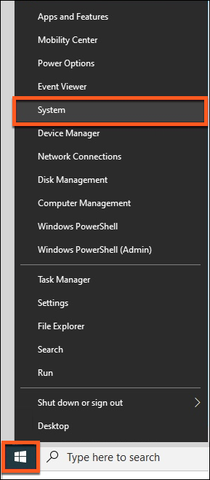

The About window displays the device information.

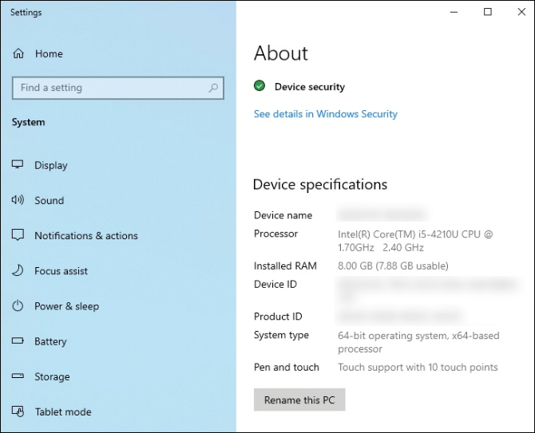

**How to Find Information About Your Mac Computer**

**How-To**

Select the Apple icon in the top left corner of the screen, and then select **About This Mac**.  
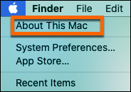

System information will appear.  
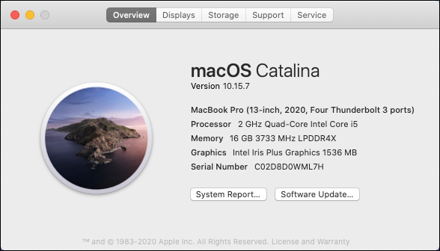

**Set Up Your Microsoft Surface Pro to Run Windows 10**

Examplify is compatible on Microsoft Surface Pro 4 or newer Microsoft Surface Pro devices when the device is running Microsoft Windows 10.  Microsoft Surface Pro devices are shipped with Microsoft Windows 10 S (S Mode) and only allow app downloads from the Microsoft Store.  To switch out of S Mode follow the steps below.

* Select the Windows icon (bottom left corner of your screen)
* Select Settings Icon
* Select Update & Security

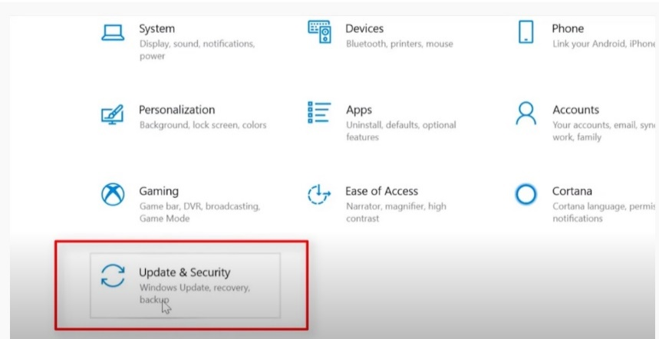

* Select Activation  
   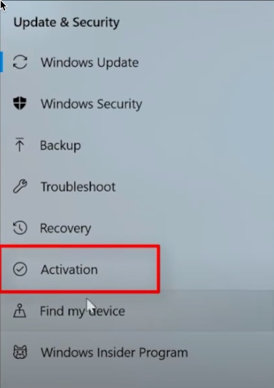
* The edition of Windows on your device is displayed and will show "S Mode" at the end.

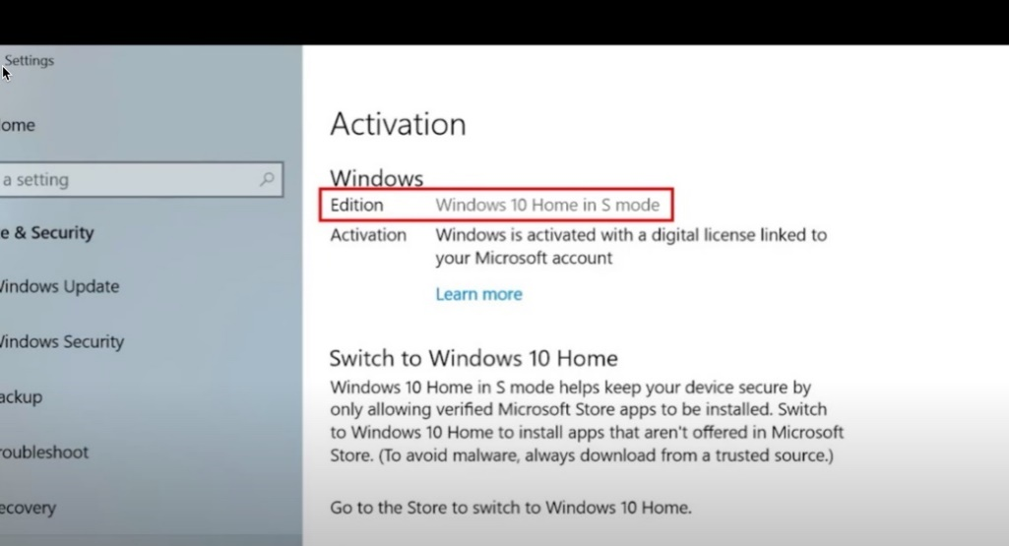

* ​​​​Select "Go to the Store"**.**

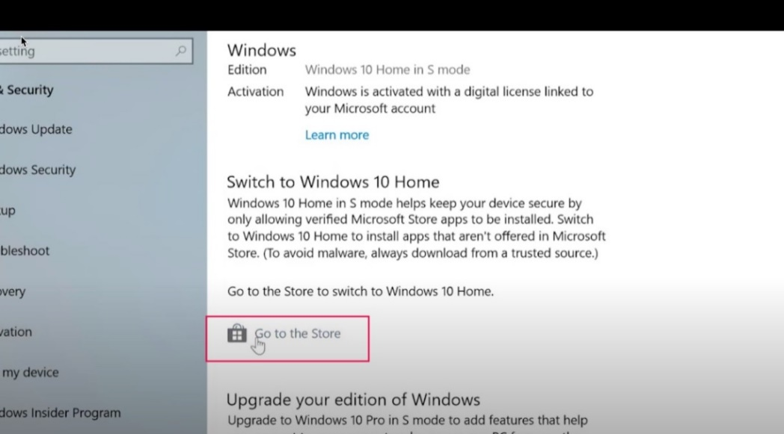

**NOTE: Do not select "Upgrade your edition of Windows".  This is not the selection to get your device out of S Mode**

* On the Switch out of S mode page, select the **Get** button

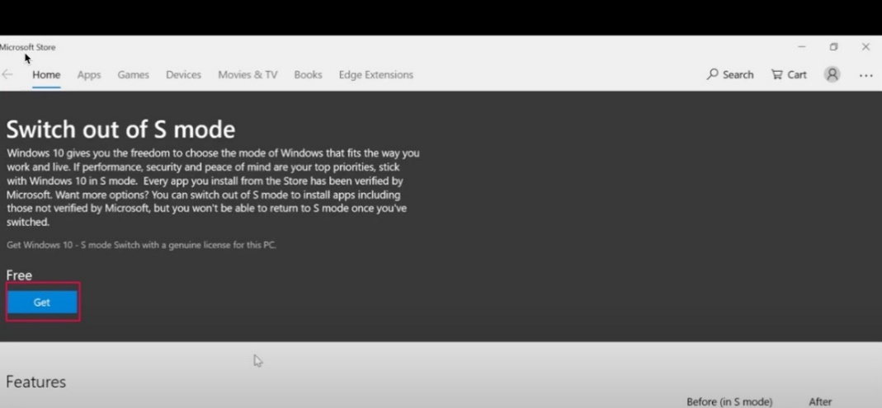

* Select Install button

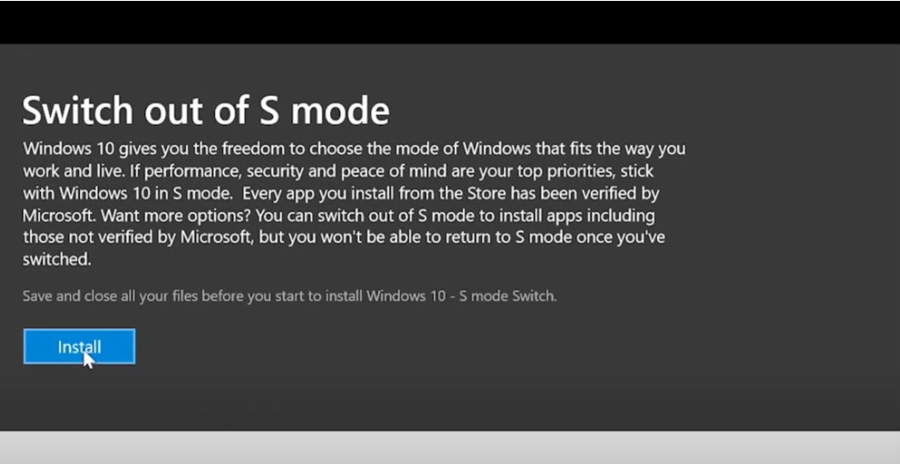

*Note:* On the Activation page, the edition of Windows no longer includes "in S Mode."  
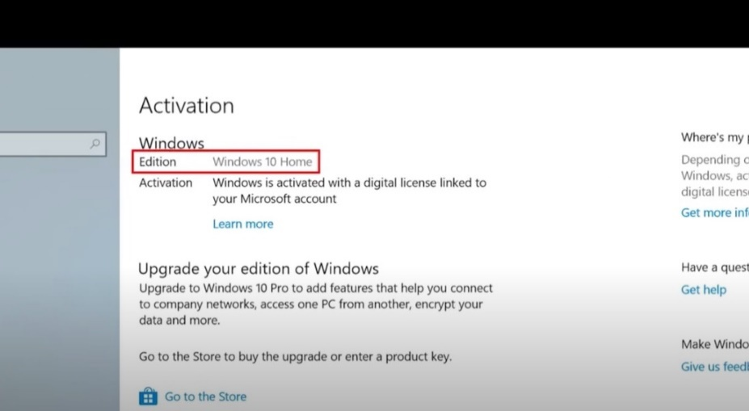



Niagara County Community College (NCCC) D2L/Bright Space Username and Password

NCCC Username: _________________________________

Password: ___________________________________________

ATI Username and Password

Username: _________________________________

Password: ___________________________________________



Wi-Fi: Connect to NCCC - Secure Wi-Fi

The online information to connect to NCCC-Secure.

1. In order to connect to the secure Wi-Fi, go to the **Wi-Fi settings** on your device and search for **available networks**.
2. *Choose* either TWolves or Nursing-Student.
3. *Enter* your NCCC username and password and *press* **enter**.
4. *Enter nursing2021 for Nursing-Student Wi-Fi*
5. *Accept* the Cisco certificate if asked.

# AlertsIn Case of an Emergency

**SUNY Alert-RAVE**

RAVE allows you to receive urgent messages in the case of an emergency at NCCC.

You choose how you want to receive alerts (phone, email, text message, etc.) by visiting <https://www.niagaracc.suny.edu/ems-students/>

**Exam Day Emergencies**

|  |  |
| --- | --- |
| User-added imageMid-Exam Evacuation (i.e. Fire Drill) | **Completely shut down your device to stop the timer.**   * **DO NOT** submit your exam. * Closing the laptop may only put the computer to sleep, rather than shut it down. If the computer is not shut down, the timer will keep running.   Upon returning, your instructor will provide you with another code to re-enter the exam.  All content prior to 60 seconds before shut down will be saved on your device. |
| User-added imageMid-Exam Computer Crash | Power down (hard shut down) your device immediately. **DO NOT** submit your exam. After the device has been powered down for 5 seconds, restart it. |
| User-added imageInternet Outage | Students will be able to enter and complete their exams without internet access. Their answer file will be saved and secure on their device until they are able to reconnect to the internet. |
| User-added imagePower Outage | **Battery life check! It is advised to fully charge devices prior to any exam.**   * Students will still be able to complete their exam offline (provided they have enough battery life on their device) and their answer file will upload once they have an internet connection |

# Office 365 Software Download

* Office 365 is a subscription service that includes the most recent version of Office.
* It comes with the applications you’re familiar with, like Word, PowerPoint, and Excel,  
  plus extra online storage, and more.
* With NCCC's Office 365 subscription, you can install Office desktop applications  
  on up to 5 computers (desktop or laptop) and up to 5 mobile device
* This software comes as a free download for current students.
* This does not work for Chromebook
* Access is not available for MAC
* Most Windows 10 and 11 versions already have Office 365 installed

#### **Steps:**

1. Look for link on D2L

Or

1. Use this link: <https://www.office.com/getoffice365>

# Disabling Anti-Virus Software

ExamSoft always recommends disabling Anti-virus software before launching any examinations. ExamSoft does currently partner with the below anti-virus companies to ensure ExamSoft is properly whitelisted so that there is no interruption during the testing experience.

* Kaspersky
* Symantec/Norton
* AVG
* Webroot
* McAfee
* Avast

In some cases, certain anti-virus applications may block Examplify from starting properly or can affect Examplify’s performance during an exam. **When taking any secure exam, disable the anti-virus software before taking the exam and re-enable it after exiting your exam.**

We recommend the following best practices:

* Use a secure private network.
* Do not access the internet while your antivirus software is disabled.

If you need help to temporarily disable your antivirus software, refer to the product documentation on the vendor's website.   
For your convenience, we've provided the following links to instructions for some of the popular brands:

* [Avast](https://support.avast.com/en-ww/article/167/)
* [AVG Antivirus](https://support.avg.com/SupportArticleView?l=en&urlname=Disable-AVG-Antivirus)
* [Bit Defender](https://www.bitdefender.com/consumer/support/answer/28557/)
* [McAfee Antivirus 2014-2016](http://download.mcafee.com/products/webhelp/4/3081/GUID-6BBB25F9-0109-47A9-B0E5-A39F6F874E50.html)
* [Kaspersky Antivirus & Internet Security 2015-2016](https://support.kaspersky.com/KIS/2020/en-US/70886.htm)
* [Norton Antivirus](https://support.norton.com/sp/en/us/home/current/solutions/v116457581)
* [Sophos Antivirus](https://support.home.sophos.com/hc/en-us/articles/360040462632-How-to-temporarily-disable-Sophos-Home-to-troubleshoot-issues-)
* [Trend Micro Anti-Virus Plus Anti-Spyware](https://success.trendmicro.com/solution/1059822-disabling-the-features-or-modules-of-security-agent-using-the-disable-module-tool)
* [WebRoot Secure Anywhere Antivirus Protection](https://answers.webroot.com/Webroot/ukp.aspx?pid=17&vw=1&app=vw&solutionid=1006)
* Windows Defender
  + [Turn Off Antivirus Protection in Windows Security](https://support.microsoft.com/en-us/windows/turn-off-antivirus-protection-in-windows-security-99e6004f-c54c-8509-773c-a4d776b77960)
  + [Add or Remove Exclusions in Windows Security](https://support.microsoft.com/en-us/windows/add-an-exclusion-to-windows-security-811816c0-4dfd-af4a-47e4-c301afe13b26)
  + [Disable Core Isolation in Windows Security](https://support.microsoft.com/en-us/windows/device-protection-in-windows-security-afa11526-de57-b1c5-599f-3a4c6a61c5e2)
* [Zone Alarm](https://www.zonealarm.com/learning-center/firewall)

 If your anti-virus software is not listed above, please seek your software's help for instructions.  
**\*While it is our recommendation and best practice to disable your antivirus programs before each exam, please be sure to re-enable your antivirus program following each exam.**

Examplify

# Logotype image

# Reliability

Examplify has a considerable amount of built-in safety and reliability features to ensure that answers entered into Examplify cannot be lost. They include:

1. An **AutoSave** feature which automatically saves your answer file every sixty (60) seconds.
2. Multiple encrypted backup copies of the exam answer file are saved on the hard drive.
3. Multiple text **Snapshots** are taken at varying intervals.

# Best Practices for Students

1. Set up early! Do not wait until exam day to download and install Examplify.
2. Take a **Mock Exam**.
3. Refer to your course syllabus for exam dates and test download policy.
4. **Download** all exams as soon as they become available.
5. Check that your device’s **date and time** are accurate.
6. **Arrive** at the exam site at least 15 minutes early.
7. Charge your **battery** and bring your power cord.
8. Be sure your tablet is turned on and connected to Wi-Fi.
9. **Disable ALL anti-virus software** prior to launching a secure exam.
10. **Close ALL** Microsoft programs (Word, Outlook, PowerPoint, Access, etc.)
11. After completing the exam, wait until you see the **GREEN** confirmation screen indicating a successful upload before leaving the exam site.

# How to Install Examplify

1. Students must begin by navigating to the NCCC Exam Soft Portal <https://ui.examsoft.io/login?institutioncode=niagaracc>
2. *It is recommended to use *Google Chrome* or *Firefox*.
3. **Students Login** within the "Exam Takers" section.
4. 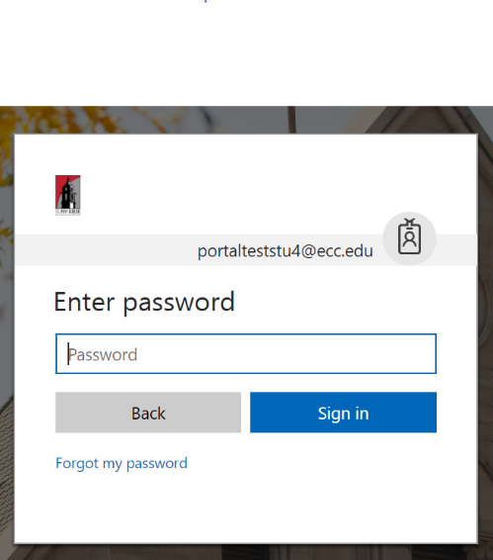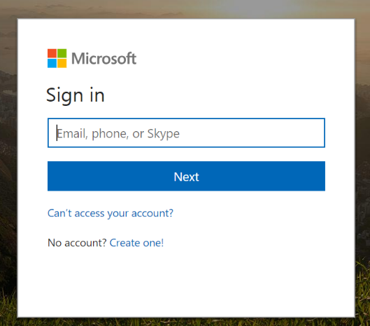You will be redirected to NCCC’s login page. Login with your NCCC TWolves email and password.
5. Once logged in, click ‘Download’.

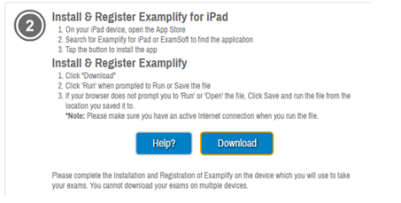

1. Follow the on-screen prompts within the Examplify installer wizard.

# How to Log-in to Examplify

1. Begin by opening Examplify.
2. Enter your Institution ID: Niagara County Community College on this first screen, and click **Next.**

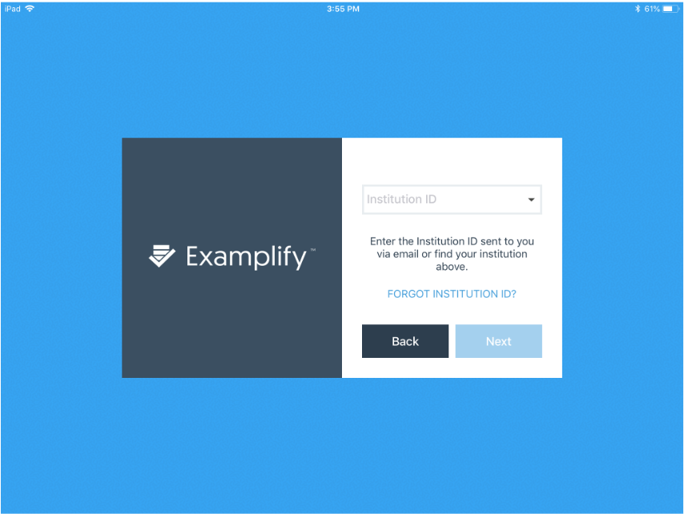

1. Once the Institution ID is accepted, the next step for you will be to authenticate on your institution's login page. Depending on your browser's settings, a new browser window or tab will open your institution's login page. If not, you can click the **Launch**button or the **Copy Link** button. The **Launch** button will prompt a new browser window to open, navigating you to your institution's login page. The **Copy Link** button will copy this unique URL to the clipboard. You can then paste this address into the address bar to navigate to the login page.

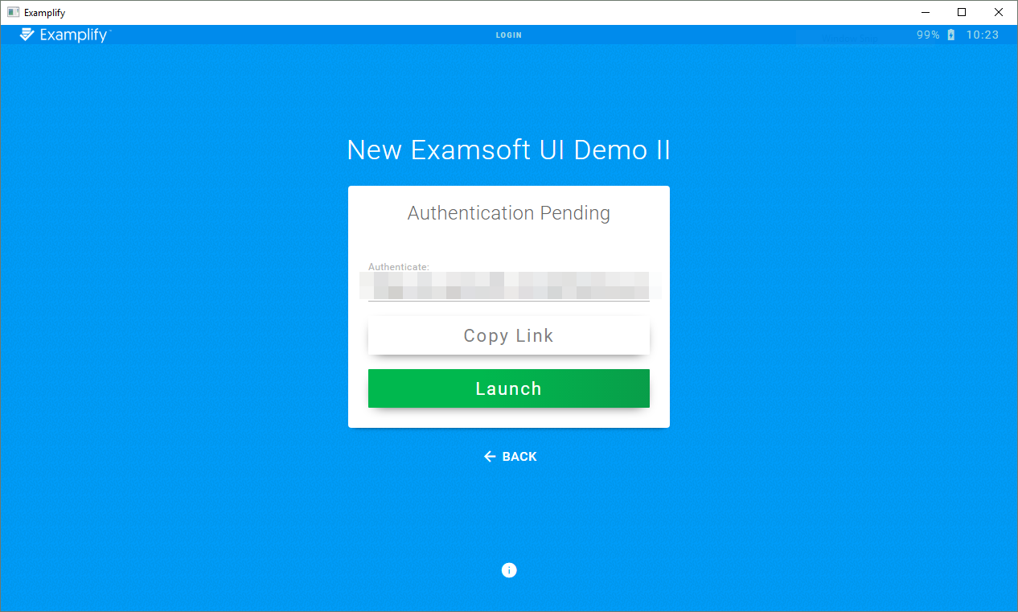

1. 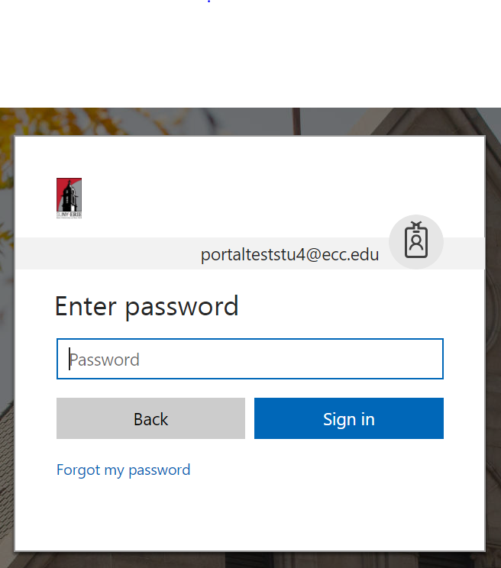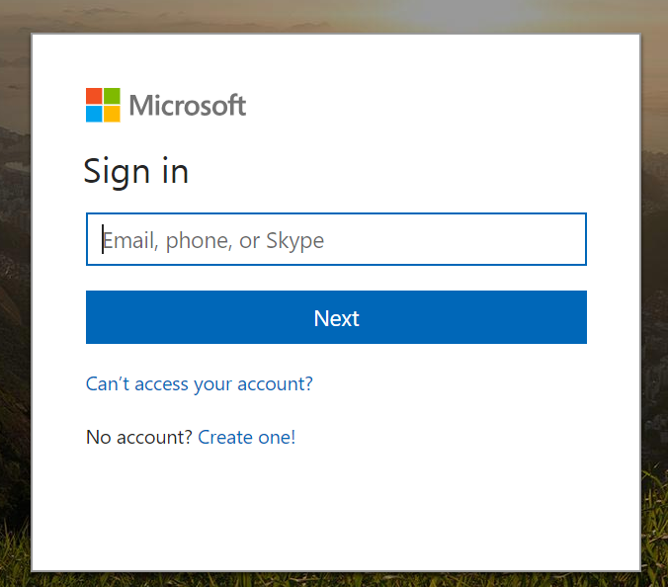Once on the login page, enter your NCCC TWolves email and password.

**\*Note, if you were already logged in, you may not need to log in again and will be automatically returned to Examplify.**

1. Once you successfully authenticate on your institution's login page, you will receive a confirmation message. At this point, you can close your browser and return to Examplify.
2. Examplify will have moved on to the Home Page where you can download and take your exam.

# Examplify Home Screen Fields & Buttons

The Examplify Home Screen contains several fields. Each is displayed and described below:  
  
 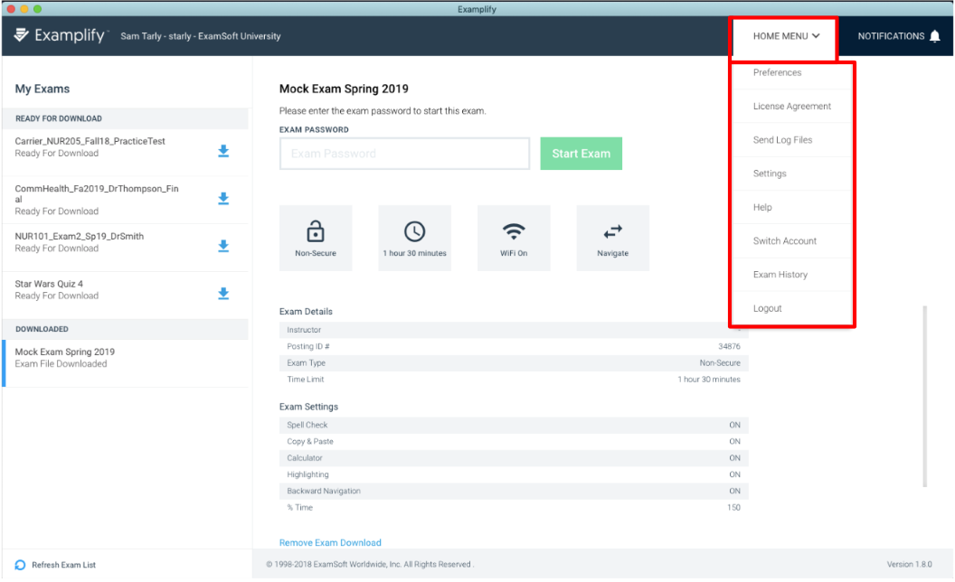

**6**

**5**

**4**

**3**

**2**

**1**

1. **Exam List**: The exam list will display all available exams.
2. **Exam Name & Exam Password**: The information displayed here will reflect which exam was chosen within the Exam List: The exam password will be provided to you on exam day. Note, this password is case-sensitive.
3. **Exam Details and Settings**: This section provides you with information on the exam file that you've selected. The details and settings will include a summary of all parameters set for the exam and the features available to you during the exam.
4. **Home Menu**: From this drop-down menu, you may set your Exam Preferences, view the End User License Agreement, Send Log Files to ExamSoft Support team, Change Settings, view Help documents, Switch Accounts and Logout.
5. **Refresh Exam List**: This feature may be used to populate their Exam List.
6. **Remove Exam Download**: In the event that you experience technical difficulties and need to remove exam downloads from your device, utilize this option.

***\*****Please note: Exam History is not a feature that we are able to use.*

# Examplify Preferences Window Options

The Examplify Preferences Window provides three customization features.  
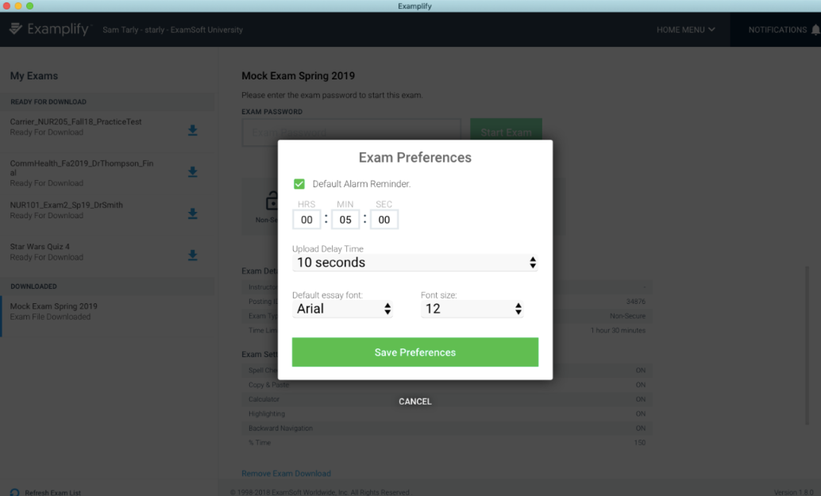

1. **Default Alarm Reminder**: Here you may set a default alarm reminder that will alert you after a certain amount of time has elapsed. You may also choose to disable this feature.
2. **Upload Delay Time**: Here you may set an interval of time to delay an answer file attempt. This time will allow for your computer exit out of a secure exam and restart Wi-Fi services on your device.
3. **Default Essay Font and Font Size**: Here you can preset the default font type and size for your responses.

# Downloading an Exam File on Examplify

1. After logging in to Examplify, students will be taken to the Enhanced Examplify Dashboard, where they can see available exams, downloaded exams, suspended exams, and recently uploaded exams. The exam list will be organized by the status of the assessment.

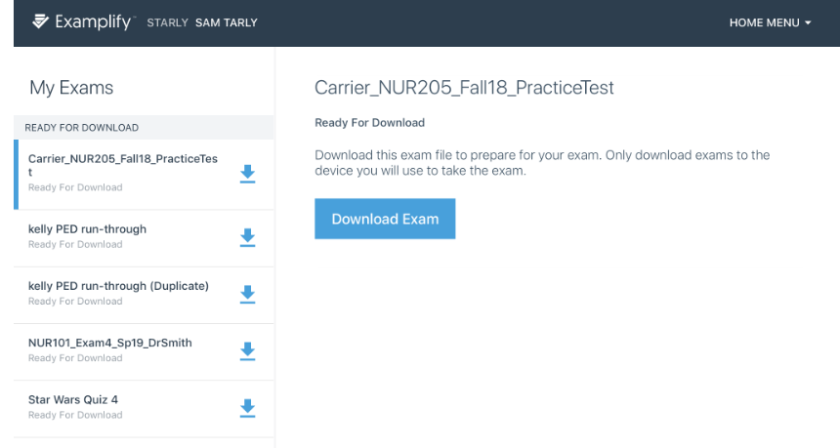

1. Select an exam from the list, and click "download exam". Note, you must have an active internet connection in order to download. Doing so will download the exam file to your device.
2. The download progress will begin to show. Once downloaded, the exam settings will appear on the right hand side when the exam is selected. Type in the exam password provided by your proctor to start the exam. Take a moment to review the exam options and settings, as they will populate beneath the window.

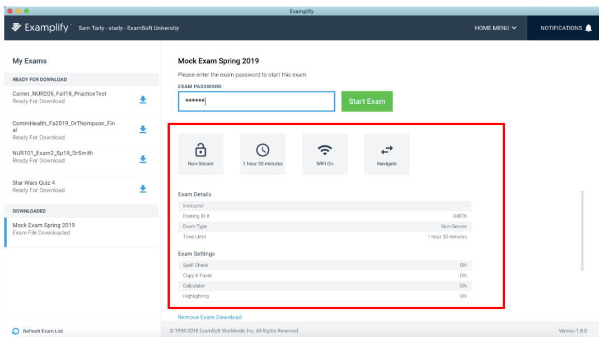

# Taking an Exam

1. Locate the scheduled exam in the list
2. Enter the exam password. This password will be given out at the start of the exam. (Note, this password is case-sensitive, and will need to be entered exactly as shown). Click **Start Exam.**

If the exam is secure, and any Microsoft applications are open, you will be asked to close out of those programs before starting the exam. We recommend saving any work, then manually closing out of any Microsoft program.

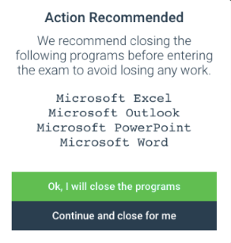

1. If instructed, you will need to wait at this yellow screen.
2. 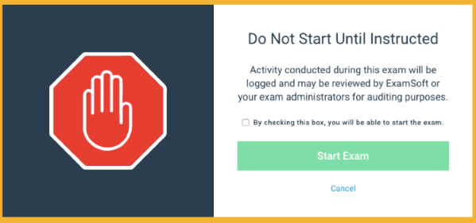When instructed, check the box so that you may start the exam.
3. Once you have been instructed to begin your exam, click the green **Start Exam** button. Or, click **Cancel** to return to the list of exams if you've chosen the incorrect exam. (Note, activity conducted during this exam will be logged. ExamSoft or your exam administrators may review this information at any time for audit purposes to verify exam integrity)

# Exam Controls

1. The navigation panel on the left will allow you to see the question numbers on the assessment and navigate through them. You can also click the Next and Previous buttons at the bottom of the screen to navigate.

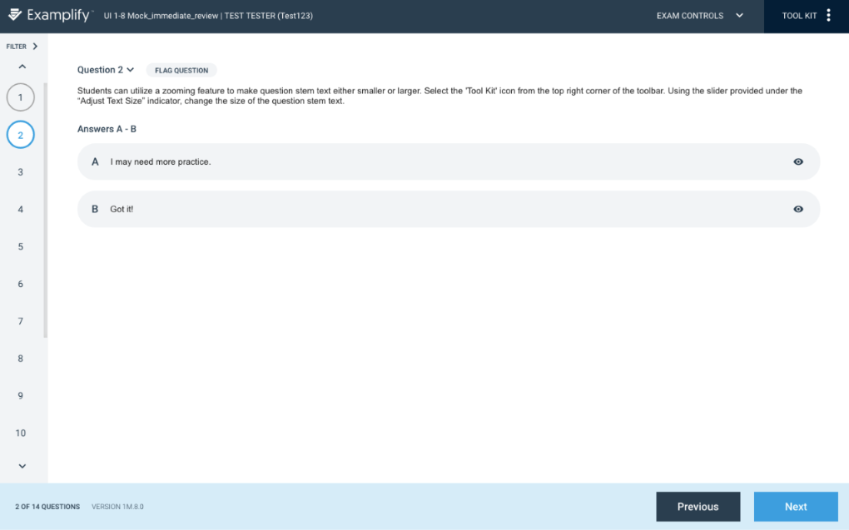

1. You will see the 'exam controls' option at the top on the right hand side of your screen. Within this menu, you will see the following possible options; ‘Exam Attachments’, 'hide exam'and 'submit exam'*.*Hide exam will hide the entire exam, but leave the Examplify application running. The submit exam option will prompt the exam taker to confirm this action.

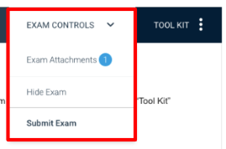

1. To access available exam features, including highlighters, notes, alarms, and calculator, click 'Tool Kit' in the upper right hand corner.

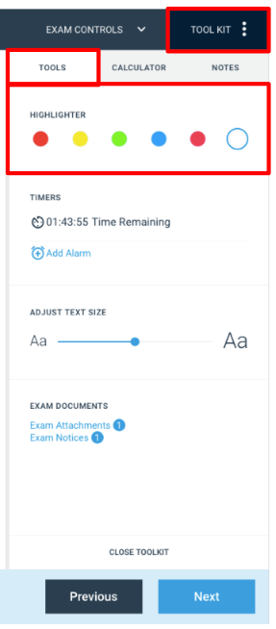

# Multiple Choice Questions

1. ​​​​​​​To answer a multiple choice question, click the answer choice. The circle will turn blue indicating that it has been selected. Some multiple choice questions will have multiple answers. In this case, click all the answer choices that you would like to select before proceeding.   
     
   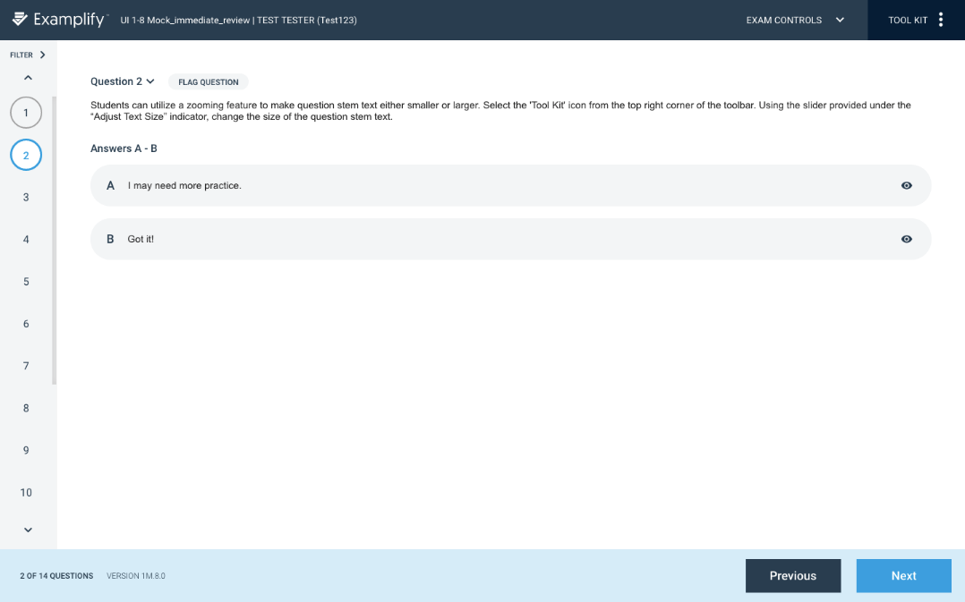
2. **Strike Out Tool for Multiple Choice Questions:** On the right side of the question area, there's an eye-shaped icon for each answer choice. You can use this icon to strike out the options that you consider to be wrong answers. Then you can focus more easily on the remaining options. When ready, **select the correct answer(s)**.

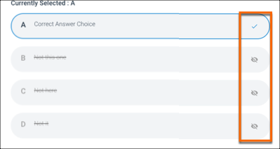

**Important:**Striking out answer choices is only for your convenience; **you must select the correct answer(s) to receive credit** for the question.

**Fill in the Blank Questions**

In the body of the question, you'll see numbers that represent the missing words or phrases. These numbers correspond to the numbered text fields in the Answers area. When you start typing in an answer field, your text also appears next to the corresponding number in the body of the question.

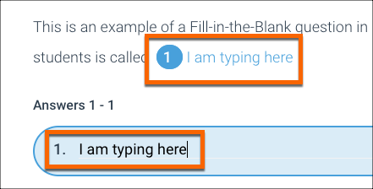

**Drop-Down Questions**

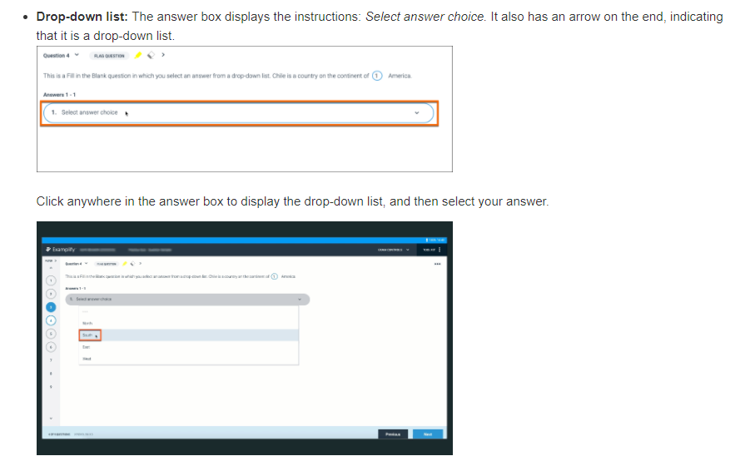

**Hot Spot Questions**

Within Examplify, students will see the question stem, and the hot spot image below. As seen below, the answer location will be marked with a blue pin. To make a selection, students may click or tap on any location within the image denoting their answer. If students need to change their answer, they can click on other location on the image to change the answer. To delete a pin, hover over it and click the red "X".

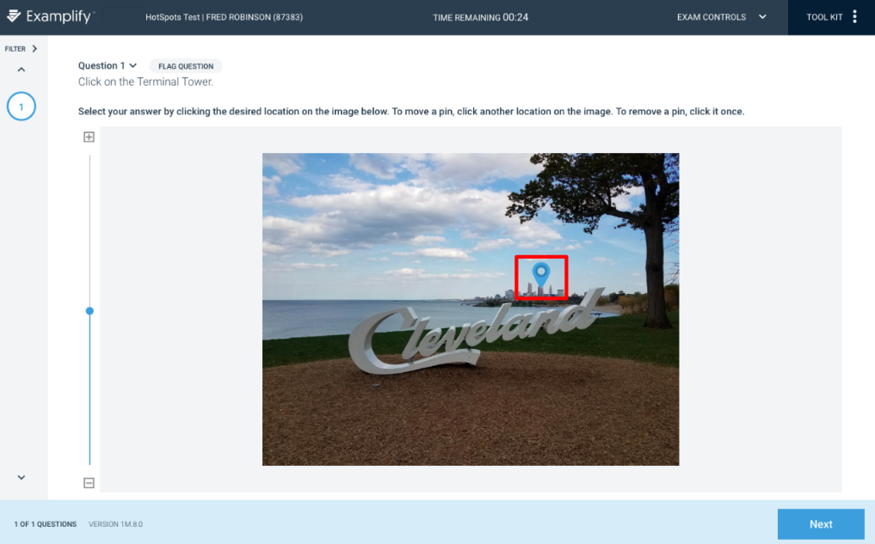

**Drag and Drop Questions**

Below the question text are two boxes: The box on the left contains the answer choices. The box on the right is where you'll place your response(s).

# 

* **Guessing is discouraged** because the exam-maker can set up the exam to apply penalties for incorrect answer choices.
* **Keyboard Shortcuts:**As an alternative to dragging and dropping, you can use keyboard shortcuts.
  + **To move the cursor to an answer choice:**Use the arrow key combinations below. This movement will include both boxes.

|  |  |
| --- | --- |
| Windows | Press **Ctrl+Shift** plus the **left arrow key** or the **right arrow key**. |
| Mac | Press **Shift+**⌘ plus the **left arrow key** or the **right arrow key**. |

* + When an answer choice is selected, it will have a thick border, as shown below.  
      
    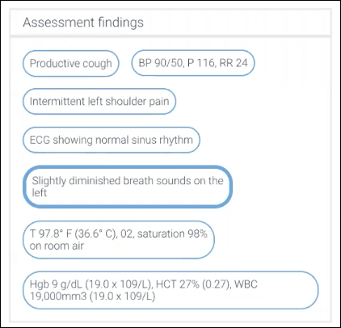
  + **To move the selected answer choice to the other box:** When an answer choice is selected (with a thick border), use the Spacebar key combination below to move it to the other box.

|  |  |
| --- | --- |
| Windows | Press **Ctrl+Shift+Spacebar**. |
| Mac | Press **Shift+**⌘**+Spacebar**. |

# How to use the Calculator in Examplify

# To open the calculator, Navigate to the ‘Tool Kit’ at the top right corner of the toolbar.

1. Click on the ‘Calculator’ tab.

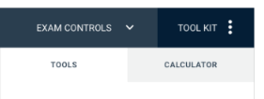

1. 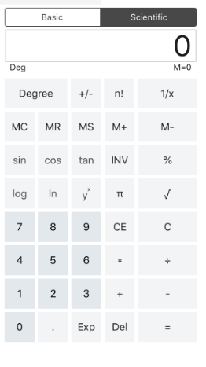This will open the calculator in a right pane on the screen. To close the calculator, click the menu icon again. A screenshot of the scientific calculator is displayed below:

# Highlighting Text in Examplify

You can use the highlight tool in Examplify to highlight portions of question-text.

1. Navigate to the ‘Tool Kit’ at the top right corner of the toolbar.
2. Click on the ‘Tools’ tab.
3. Select the color you would like to highlight the text
4. Select the text that you wish to highlight by clicking and dragging your mouse across it.
5. The selected text should now be highlighted whichever color you have chosen, as shown below:

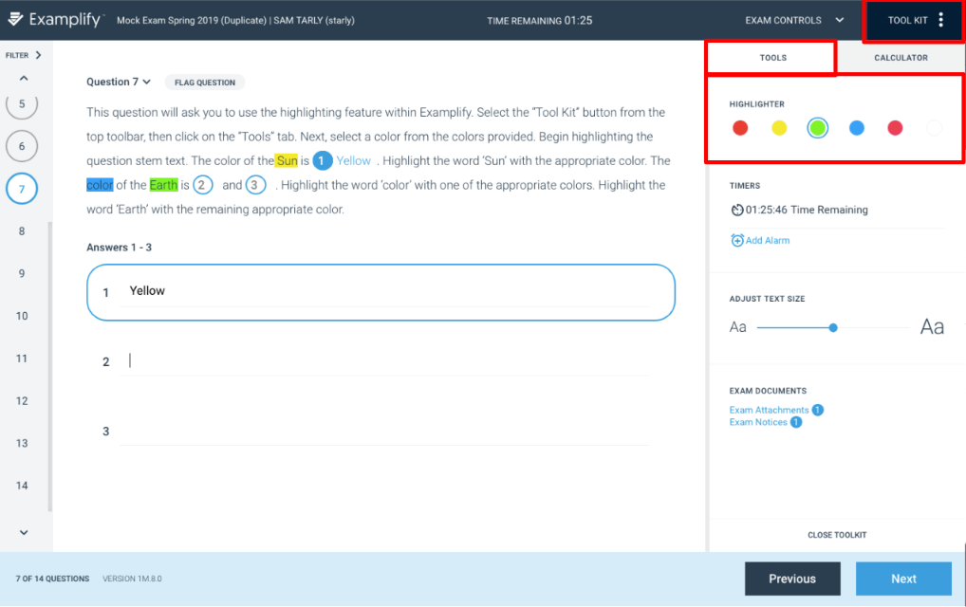

# Zoom In/Out Feature

You can use the ‘Adjust Text Size’ feature in Examplify to make question stem text either smaller or larger.

1. Navigate to the ‘Tool Kit’ at the top right corner of the toolbar.
2. Click on the ‘Tools’ tab.
3. Use the slider provided under the ‘Adjust Text Size’ indicator to change the size of the question stem text.

# 

# Hide/Expand Question Stem

Clicking on the question number will hide or expand the question stem as seen below:

# 

# Post Exam Actions

Once you’ve completed all the questions, you can now exit the exam.

1. Open the 'exam controls' menu, and select to "submit exam".



1. The application will exit out of the exam view, and you will be presented with a warning that you are closing out of the exam.

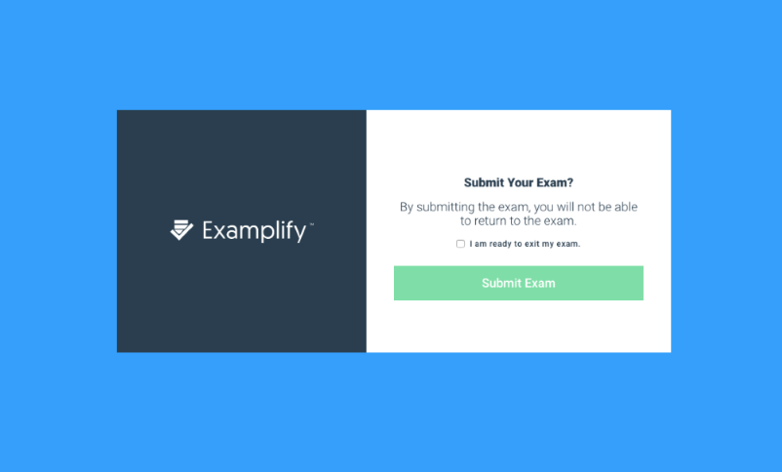

1. To confirm, select the checkbox to confirm that you’re ready to upload the exam file, and then select to "submit exam".
2. Your answer file will be automatically uploaded if you have a strong internet connection. Once the upload is complete, you will receive a confirmation message on the screen, as well as an email confirmation.

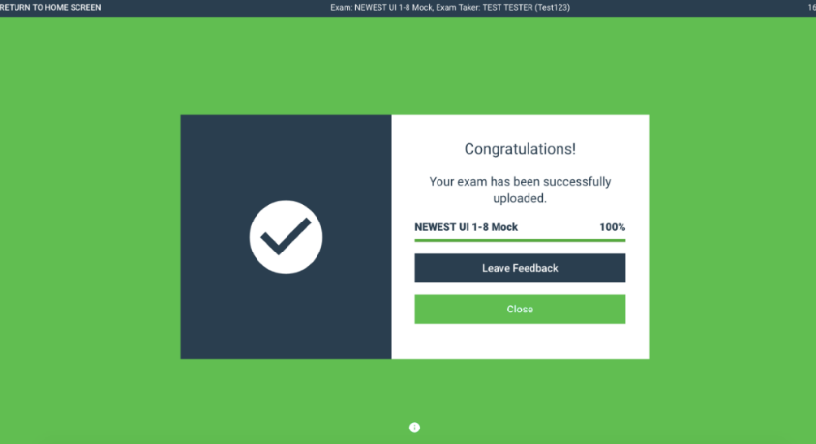

1. If you are not connected to the internet or have a weak connection, Examplify will notify you that the answer file could not be uploaded. **Note**, your answer file and all of its content has been saved to your computer.

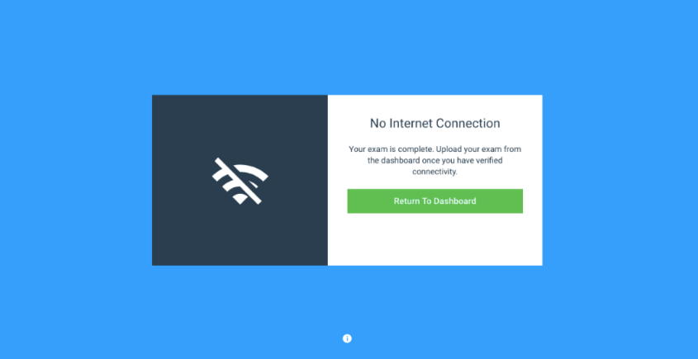

You may wish to **Retry Upload** from a local coffee shop, restaurant, or home. Upon reopening Examplify, the application will automatically attempt to upload the pending answer file(s). Once you see this confirmation message, your file has been successfully uploaded.

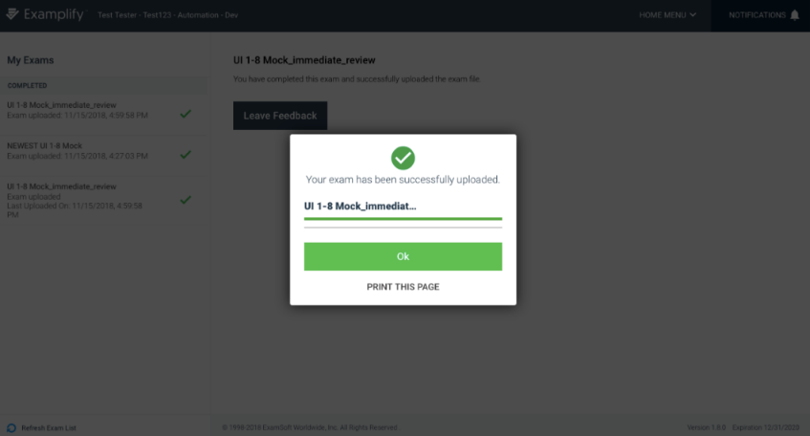

# Update Examplify Version

* Open Examplify. If there is an update available, you will be asked to **Update Now**or **Later**. If you choose the **Later** option, you will be asked to select a time when you would like to be reminded to update the application. 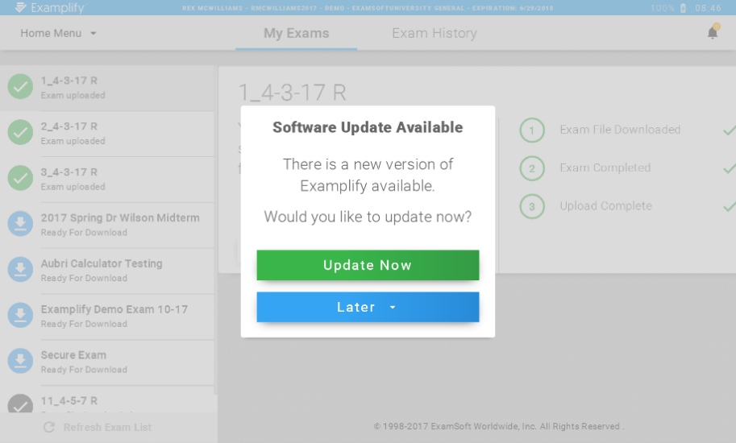
* If you wish to update the application prior to the reminder, click the **What's New** icon and you will see the option to update now. 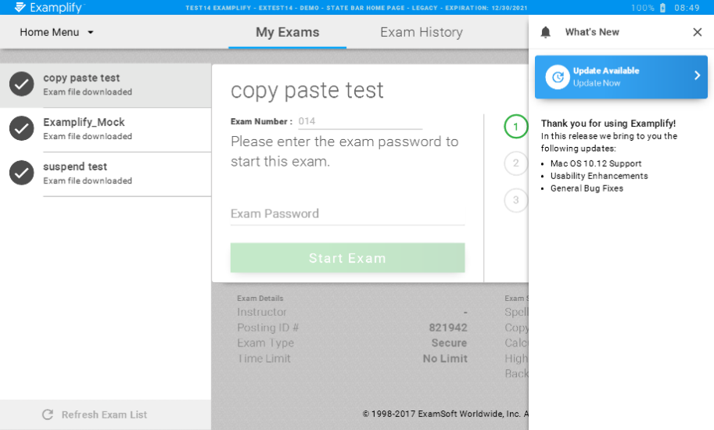
* Examplify will download the update once you click to update now. Note, you must have an active internet connection.
* Once the download is complete, click **Relaunch.**
* The updated application will now be installed on your device. Follow the on-screen prompts to complete this process. Please note, you may be required to restart your device once the installation is complete.

# Examplify: Silent Updates

Anytime a new version of Examplify is released, it's important that your device is updated to ensure that you are using the newest features and security options. When an update is made available, students will be prompted to complete the update when they open Examplify. Additionally, Examplify will continually check for updates when it is not running and update silently in the background. This guide reviews the process for this silent update.  
  
Examplify will check for an update to the application 10 minutes after Examplify is initially installed, or after a computer reboot if Examplify is already installed on the machine. After this time, Examplify will continue to check for updates every four hours.  
  
The update will not occur in the following instances:

* Examplify is running when the check occurs
* Internet is not available when the check occurs
* There is a pending exam upload in Examplify
* Exam is currently suspended

This updater will check for an update, download, and install without any user intervention.

# Windows - View Examplify Version Number

Open Examplify, and login if necessary. The version number will be displayed within the bottom bar of Examplify.  
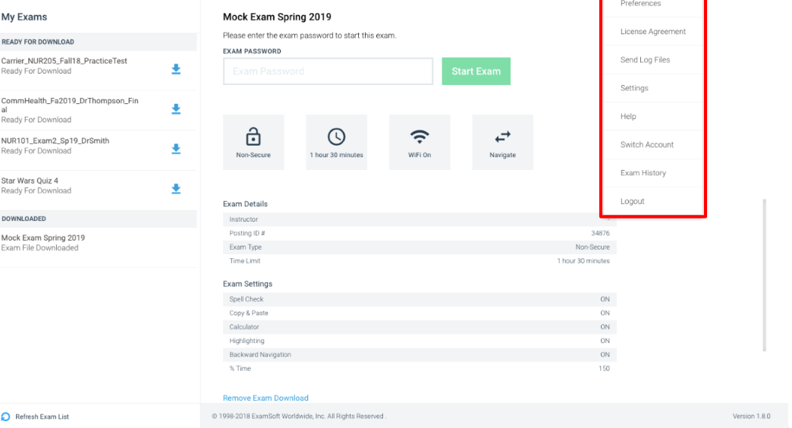  
  
If you do not see the version number, please follow the instructions below to locate it.

1. 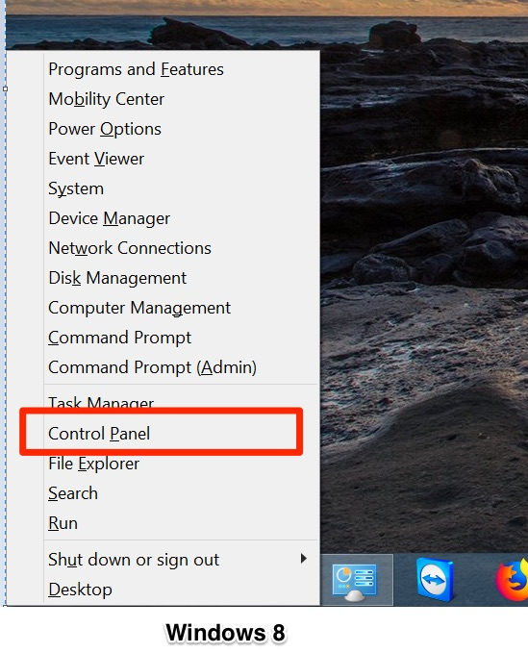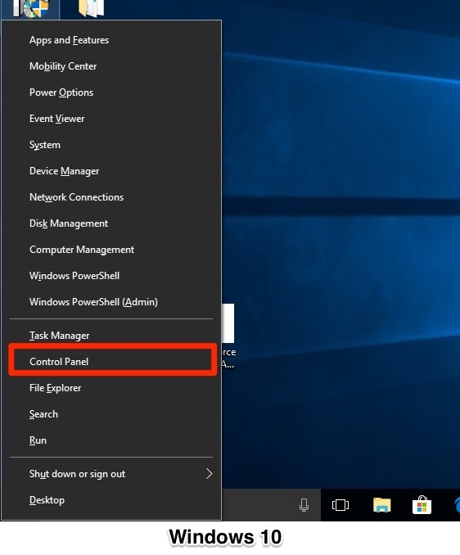Press the **Windows** key and **X**key simultaneously. A menu will appear from the Task Bar. Select **Control Panel** from this menu.

1. A new window will appear. Under the "Programs" section, click **Uninstall a Program**. Note, we will not be making any changes to the application or any stored files at this time.

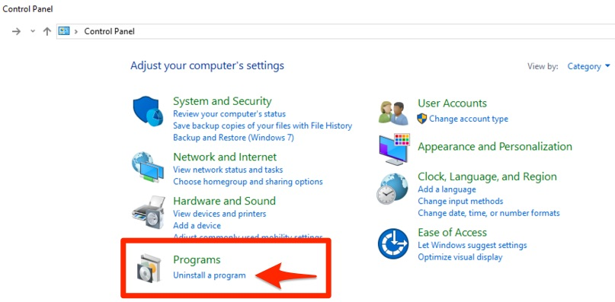

1. Locate the Examplify application within the list. To the right, you can check the version number within the **Version** column. *Note the version in the screenshot may not match the most recent version of Examplify.

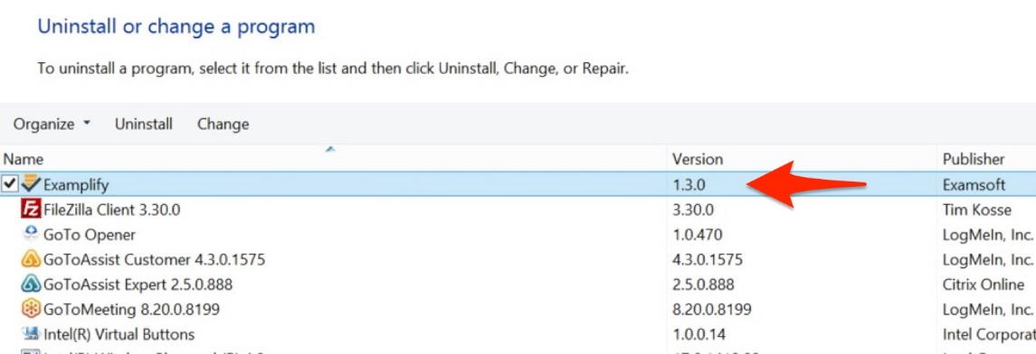

# Mac- View Examplify Version Number

To verify which version of Examplify you are using, follow these steps.

**How-To**

Open Examplify, and login if necessary. The version number will be displayed within the top bar of Examplify.  
User-added image

If you do not see the version number, please follow the instructions below to locate it.

**Checking your Examplify Version Number on Mac**

1. Open the application. Once the application is running, click **Examplify**in the upper left-hand corner (next to the Apple logo).

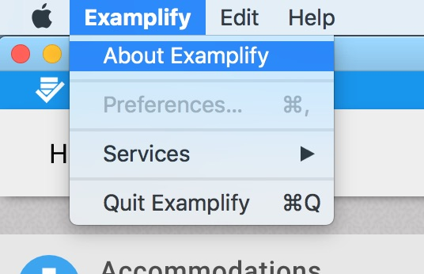

1. 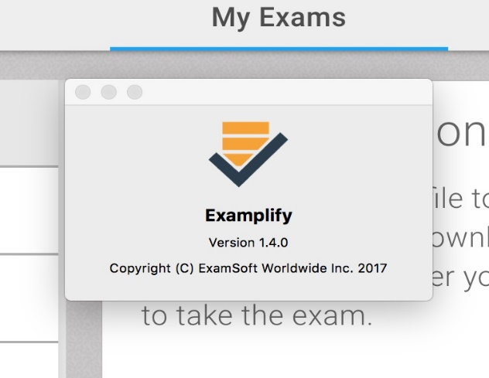Next, click **About Examplify**. A window will appear, displaying the application's current version number.

# Remove a Downloaded Exam

In some cases, you may need to remove a previously downloaded exam from your computer. If you need to re-download the exam, please verify that the download start and end times are still open prior to removing the download.

1. Open Examplify.

2. Click on the Exam File that needs to be removed from the Exam List.

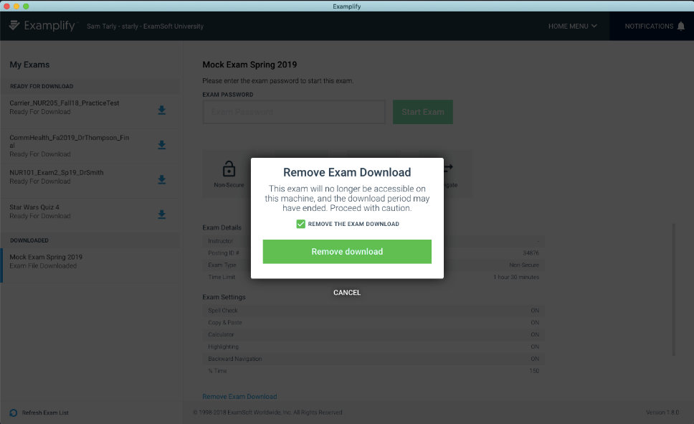3. Select ‘Remove Exam Download”.  
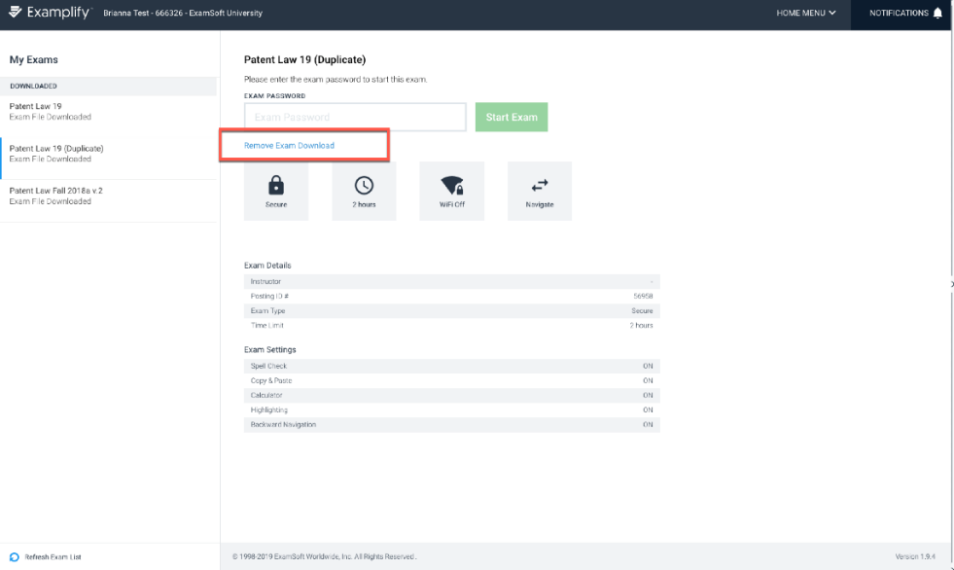  
  
4. From the next prompt, make sure to check the box for ‘Remove the exam download’, and next select the green ‘Remove Download’ button.

5. The exam will now be removed and no longer marked as downloaded.

ExamSoft Portal

# How to Log-in to the ExamSoft Portal

1. Begin by navigating to your ExamSoft Portal: <https://ui.examsoft.io/login?institutioncode=niagaracc>
2. **Login** within the "Exam Takers" section.
3. You will be redirected to your institution's login page. Enter your NCCC TWolves email and password.

*Note, if you were already logged in, you may not need to log in again and will be automatically returned to your ExamSoft Portal.

# Enabling SMS Text Notifications

ExamSoft offers the ability to receive their confirmation and reminder messages on your cell phone via SMS Text as well as in your email inbox. With this free service, exam takers will receive Download and Upload Reminders, Registration Confirmation for Examplify, Download Confirmations for Exam file downloads, and Upload Confirmations for ALL automatically uploaded answer files.

The SMS notification service is being offered to enhance convenience and comfort for exam takers. Exam takers will be notified within minutes of completing key steps in the exam taking process, such as the return of completed exams, in addition to delivering regular email notifications.  Should you wish to utilize this feature, follow the instructions below.

**To enable SMS Messaging:**

1. Log-in to your the ExamSoft Portal under Exam Takers
2. Click the Examplify tab at the top of the screen.
3. In the third step, “Setup Your Notifications,” you will see fields to input your cell phone information.

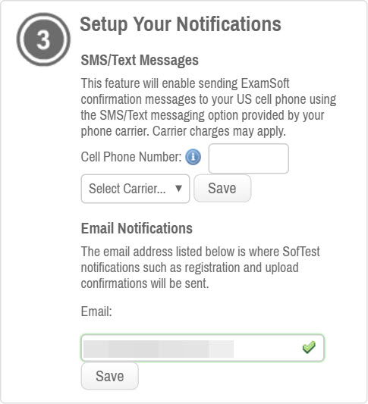

1. Enter your phone number, select your carrier, and then click save. You have now enabled SMS notifications with your account.

# View your Strengths and Opportunities Report

Your professor may choose to release a “Strengths and Opportunities Report” in the ExamSoft student portal. This report shows an individual Exam Taker’s category performance on a specified exam posting. Please follow the directions below on how to find your exam results.

1. 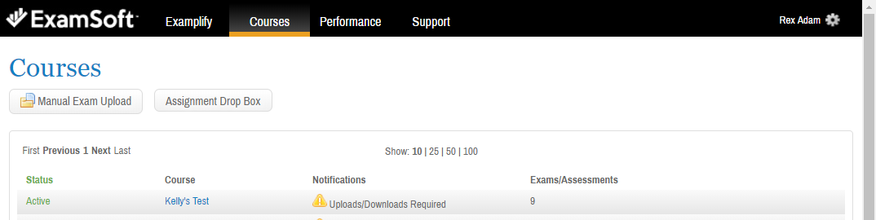Log into the ExamSoft portal and navigate to the tab at the top labeled **Courses.**
2. 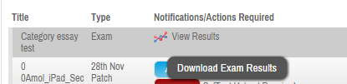Under the column labeled *Notifications/Actions Required*, you will see a graph that you can click to download your exam results.
3. 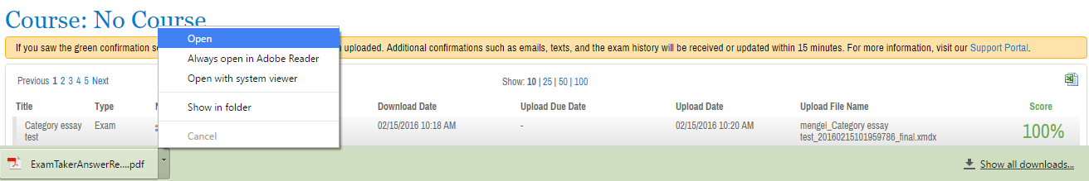Your Strength and Opportunities report will be downloaded as a PDF. In order to view the report open the downloaded PDF.

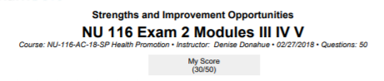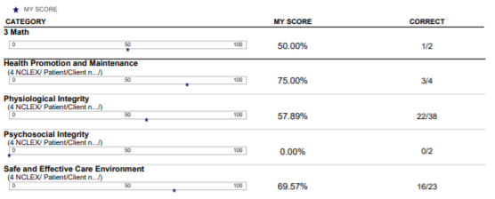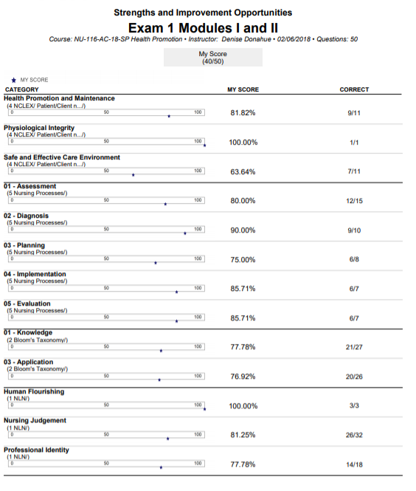

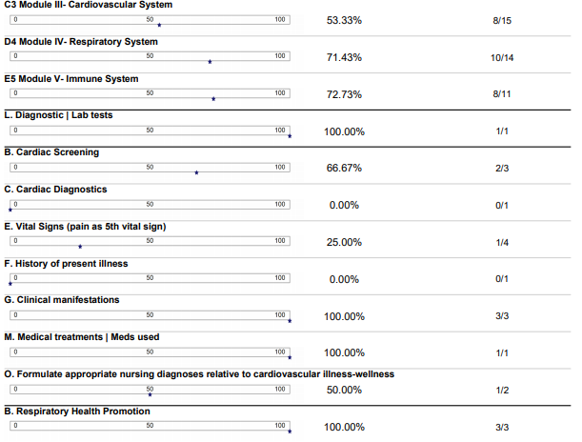

ATI

HOW TO CREATE A NEW ACCOUNT

On the Security Questions page, select three different security questions, one from each list and enter your answer for each. Be sure to record your questions and answers for your future reference, in case you need to recover your account or you cannot remember your password.

Click **Continue** to enter your personal information.

If you are not a current user on [www.atitesting.com](http://www.atitesting.com/), you must create a new account to access the student portal or to make a purchase from ATI's online store. Follow the steps below to create a new account.

From the atitesting.com home page, click **Create Account**.

The Sign In Info page displays.

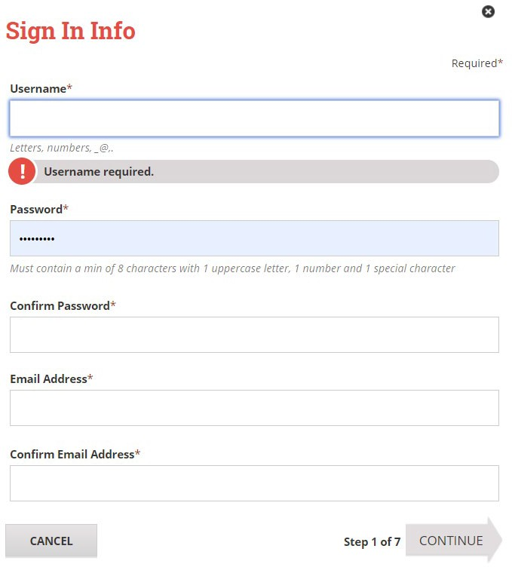

On the Sign In Info page, enter the account information that you will use to sign in to your account or to recover your account.

You must enter valid information into all the fields on this screen before you can proceed.

If your entry is not accepted, an error message similar to the one pictured below will display.

Reenter your information. When your entry is accepted, the message will disappear.

After you have entered all your account information, click

**Continue** to go to the Security Questions page.

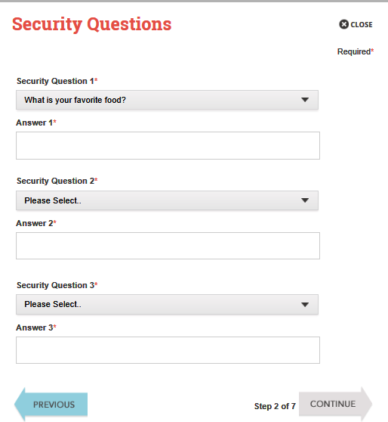

On the Personal Info page, enter your contact information. The following fields are required:

* First Name
* Last Name
* Address 1
* City
* Country
* State/Province
* ZIP/Postal Code
* Mobile Phone

Click **Continue** to enter your Institution information.

On the Demographic Info page, enter your *Gender*, *Birth Date*, *Race*, and *Primary Language* information. Only *Birth Date* is required.

Click **Continue** to go to Subscription, Updates & Notes.

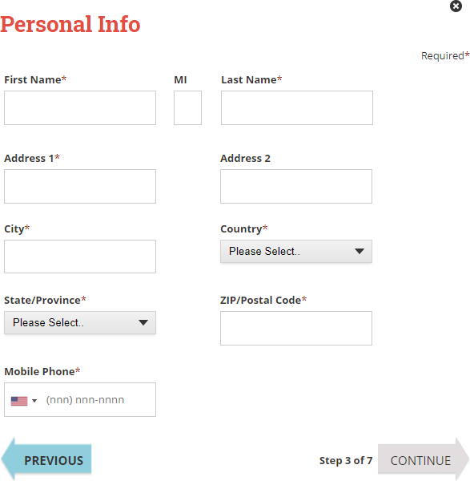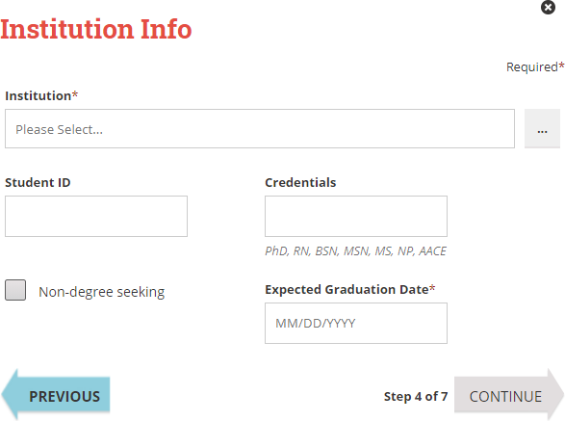

On the Institution Info page, select an Institution from the list and if you are seeking a degree, enter a date in *Expected Graduation Date*. All other fields are optional.

Click **Continue** to enter your Demographic Info.

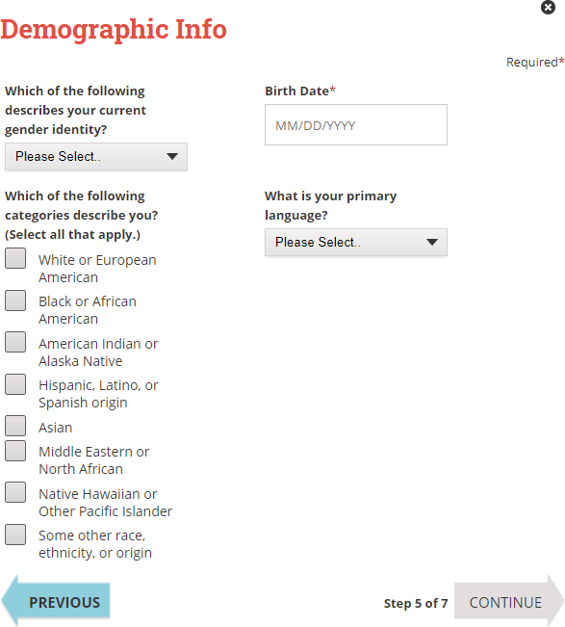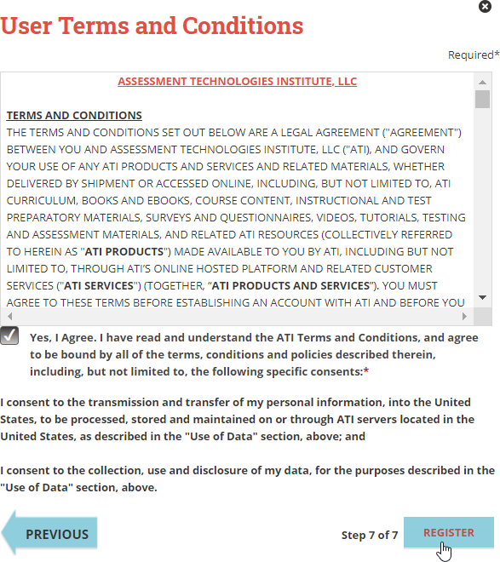

On the Subscription, Updates & Notes page, read the Subscription, Updates & Notes information.

If you agree to allow ATI to share your information under the terms presented on this screen, select the **Yes, I consent** check box.

Click **Continue** to go to User Terms and Conditions.

The Welcome to ATI window displays.

* Click **Get oriented to ATI as a student** to view orientation videos.
* Click **Sign In** to go directly to the student portal. (Skip the next step.)

Click **Register** when you are finished creating your account.

Click **Previous** if you want to change any of the information you have entered for your new account.

On the User Terms and Conditions page, read the information under User Terms and Conditions.

Then select the **Yes, I Agree** check box to acknowledge that you have read the ATI User Terms and Conditions and agree to be bound by them.

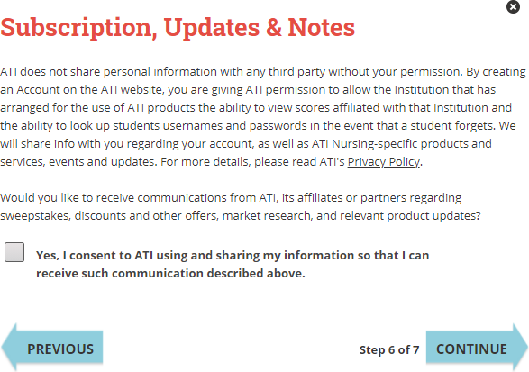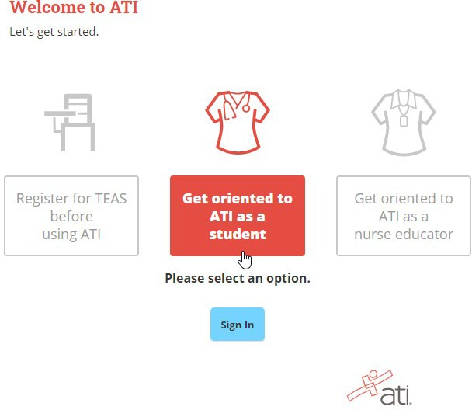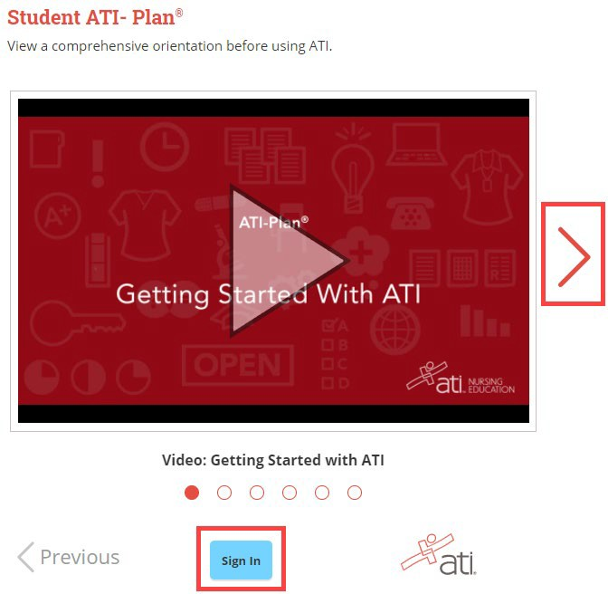

Click the video window to start a video. When you are finished viewing the videos, click **Sign In**.

**Note:** All the introductory videos, as well as other resources, are available on the **HELP** tab on the student portal.

A number of videos are available to help you get started. Click the **Red Arrow** icon to display titles to introduce you to ATI.

Enter your Username and password and then click **Sign In**.

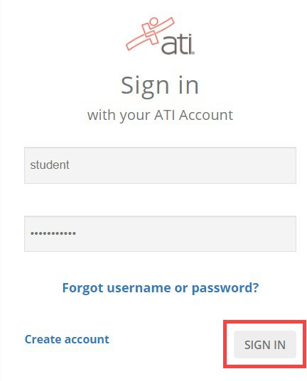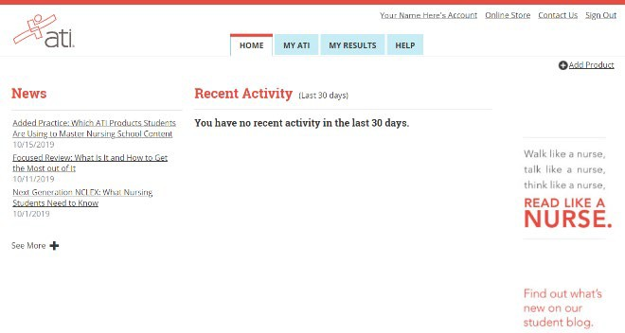

The Home page for the Student portal displays and your new Username displays in the upper right corner.

At ATI, we believe in the power of nursing. We believe in helping those who help others. We believe in listening and asking questions. We believe in leading the way for innovation, creating solutions, and delivering results for our nurse education partners.

It’s this idea that helped us shape our suite of programs and product solutions with focused attention toward nursing students and the nurse educators who work with them.

**Overview of Resources**

* **Learning Systems**: Offers a series of practice assessments that breaks content areas into smaller sections. Hints are offered to identify key components of the question and to ignore the distractors.
* **Critical Thinking Assessments**: Proctored assessments to compare baseline and end of program critical thinking capabilities.
* **Self-Assessment Inventory:** A tool to assist the new nursing student in identifying their own learning styles and understanding of the nursing profession.
* **Nurse Logic 2.0**: An online, multisensory tutorial that teaches students to “think like a nurse.” It gives a formal introduction to critical thinking methods, the nursing process, priority setting frameworks, and test-taking strategy. Nurse Logic is designed to increase student retention.
* **Content Mastery Series**: A series of proctored, standardized assessments based on the NCLEX-PN® test plan. Outcomes include topics to review (linked directly to Review Modules), QSEN Competencies, client need (NCLEX-RN®), and thinking skills. These assessments provide students with direct feedback on their deficiencies. Faculty receives group reports that help to address areas of strength and room for improvement with regards to curriculum and teaching. Nine proctored and over 50 practice exams are included. Content Areas are:
  + Fundamentals of Nursing
  + Adult Medical-Surgical
  + Nursing Care of Children
  + Maternal-Newborn
  + Mental Health
  + Community Health
  + Pharmacology
  + Leadership
  + Nutrition for Nursing
* **Focused Review**: Media-rich online study guide based on each student’s individual results on each content mastery assessment and linked to the Review Modules (below).
* **Review Modules:** Also part of the Content Mastery series,Review Modules are online and paper-based reference manuals based on the NCLEX-RN® blueprint. They contain the “need to know” for the NCLEX-PN®.
* **50 RN/ 42 PN Video Case Studies:** With multiple opportunities to learn from a single scenario, your students will find these interactive case studies a dynamic way to learn from experts and each other. That’s what these case studies can do – spark classroom conversations in real time, wherever your students may be.
* **Comprehensive Predictor**s (proctored and practice assessments): These are assessments that offer each student their individual probability of passing the NCLEX-RN® on the first attempt
* **Pulse:** is a tool that uses an algorithm to forecast the overall pass rate for a cohort and on a per-student basis.  It gives administrators an early warning system as we predict pass rates as soon as admission (if using TEAS) or as soon as the first Content Mastery Series exam is given.  Each time a CMS exam is administered, the forecasted pass rate adjusts until the Comprehensive Predictor is taken.  Faculty/advisors can use Pulse to guide advisement and direct attention to the students who are the most at risk.
* Students receive a customized dashboard that explains their forecasted NCLEX pass rate and directs them towards tools (Tutorials, Focused Review) to remediate.

**When can NCCC help me?**

* Wireless Network

Contact the NCCC HelpDesk at (716) 210-2505

**When can ExamSoft/Examplify help me?**

* Problems downloading an exam
* You have an ExamSoft background and no options to Shut down
* Problems uploading an exam
* Problems with the Examplify software
* You have a black screen and cannot access your desktop

<http://support.examsoft.com> US Toll- Free Phone: 866-429-8889

**When can ATI help me?**

**ONLINE SUPPORT**

* **Live Chat (click the red chat box on the right during office hours)**
* **Phone: (800) 667-7531**
* **Fax: (913) 661-6245**

**INTERNATIONAL**

* **00-800-4748-1111 (Philippines)**
* **1800-949-273 (Northern Ireland)**
* **0800-358-1850 (United Kingdom)**

**What problems am I responsible for?**

* Hardware issues
* Virus’s
* Microsoft Windows Problems: <http://support.micorosft.com/en-us>

# ExamSoft/Examplify Log-In Issues

1. Are you connected to the internet? Open a web browser and try to go to www.examsoft.com. If you are unable to connect to the internet, check to make sure you your wireless connection is active. Attempt another wireless network connection.

2. Ensure you are logging in at the correct place:

If you receive an error or are redirected to the ExamSoft homepage, please follow the instructions on pages 48 & 49 to clear the cache of your web browser.

# Clear your Browser’s Cache: Google Chrome

In the event you are encountering issues accessing Examplify or your ExamSoft Portal, the first troubleshooting step is to clear your browser's cache. This guide will go over how this can be done through various internet browsers.

**Google Chrome**

1. On your computer, Open Chrome.

2. At the top right, click More 

3. Click **More tools > Clear browsing data.**

4. At the top, choose a time range. To delete everything select **All time**.

5. Next to “Cookies and other site data: and “Cached images and files,” check the boxes.

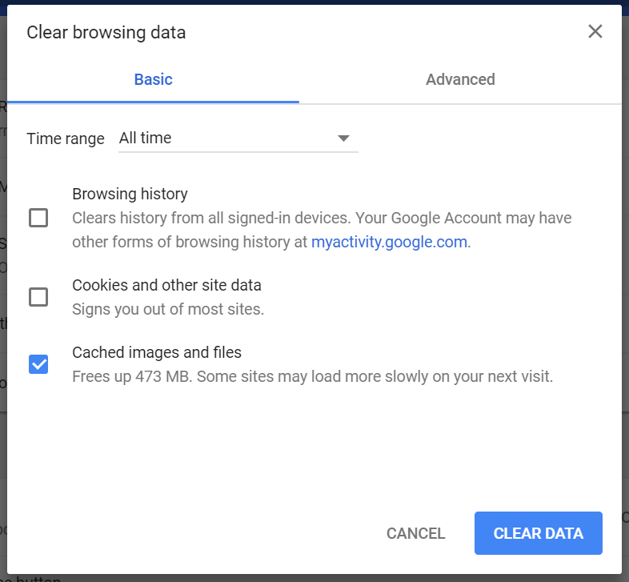

6. Click **Clear data**.

# Clear your Browser’s Cache: Firefox

1. Click the menu button Fx57Menuand choose Options.
2. Select the Privacy & Security panel.
3. In the **Cookies and Site Data** section, click Clear Data….

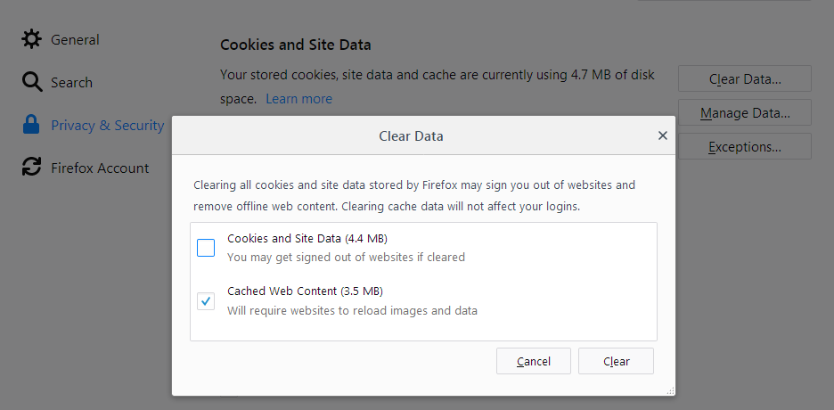

1. Remove the check mark in front of Cookies and Site Data.
2. With Cached Web Content check marked, click the Clear button.
3. Close the about:preferences page. Any changes you've made will automatically be saved.

# Clear your Browser’s Cache: Safari

1. Click on the Safari drop-down menu and select Preferences.
2. Click the Advanced tab. Select the Show Develop menu in menu bar checkbox and close the Preferences window.
3. Select the Develop drop-down menu. Click Empty Cache.
4. Note: You may want to also clear your browser history.