**KEY DATES**

**March 2025**

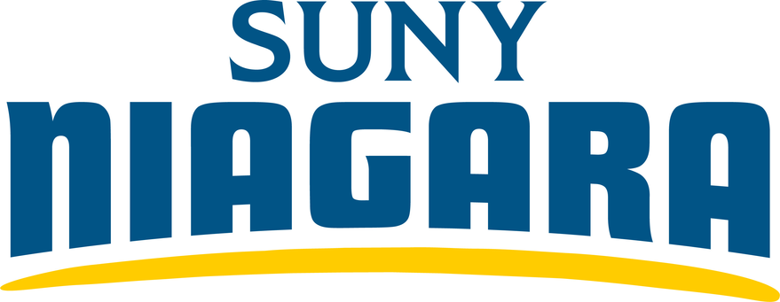



March 3rd : Sanborn Grad Fair – 9:00 AM to 12:00 PM in the

Learning Commons, on the Sanborn Campus.



March 4th : All Purpose Day – No classes, day or evening.



March 5th : NFCI Grad Fair – 1:30 PM to 4:00 PM in the NFCI Atrium, NFCI Campus.



March 6th : Sanborn Grad Fair – 1:00 PM to 4:00 PM in the Learning Commons, on the Sanborn Campus.



March 10th : Summer & Fall registration for current

students begins – Register before new students! Schedule an

appointment with your advisor to plan courses and register for next

semester. This is mandatory to register – don’t miss it! Visit

<https://www.niagaracc.suny.edu/registration-records/csreg/> for more

information.



March 17th – 23rd : Spring Recess – College Closed / No classes.



March 31st : Readmit Registration Begins – For Summer /

Fall 2025. Visit <https://www.niagaracc.suny.edu/accepted/> for more

information.

**Considering changing your major?**

**Not sure of your academic status?**

Stop by the Student Success Center

next to the Tripp Cafe or call

716-614-6290 for help!